** **

**Enhanced Intrusion Detection System (IDS)**

**By**

**LEE JUN LAM**

**TP055697**

**APD3F2302CS(CYB)**

A project submitted in partial fulfillment of the requirements of Asia Pacific University of Technology and Innovation for the degree of

**BSc (Hons) in Computer Science (Cyber Security)**

Supervised by Mrs. ZAIREEDA MOHD FAUZEE

2nd Marker: Mr. MOHD HANIS JENALIS

Sep-2023





# Acknowledgement

First and foremost, I want to express my sincere gratitude for the opportunity to share the thorough analysis report of my final project, 'Enhanced Intrusion Detection System (IDS).' This report has been carefully and comprehensively prepared after numerous days of continuous research, seeking consultations from various advisors, and unwavering commitment. At this exact moment, I am filled with appreciation for the individuals who have selflessly mentored, supported, and believed in me during this difficult path. Their persistent presence and significant contributions have been instrumental in defining my research and system development, directing me toward my aims. I am grateful for their persistent belief in my ability and dedication to my development.

At the forefront of my appreciation is my project supervisor, Zaireeda Mohd Fauzee. She has illuminated my path through this project by providing guidance and support during every consultation. Her extensive knowledge and expertise in cyber security fields has significantly enhanced the depth and quality of my project research and development. I consider myself extremely fortunate to have had her as my supervisor, as her consistent encouragement, assistance, and constructive feedback have not only kept me motivated throughout this project but have also driven me toward excellence. Furthermore, I extend my heartfelt gratitude to Mohd Hanis Jenalis, my second marker, for his unwavering commitment to excellence and his invaluable contributions. His attention to detail, insightful suggestions, and thorough evaluation have further enriched and elevated my project's quality. His support and dedication to maintaining the highest standards of evaluation have been instrumental in refining and improving the overall outcome.

In addition to my mentors, I deeply appreciate the Asia Pacific University of Technology and Innovation for providing me with the necessary resources, state-of-the-art facilities, and a conducive environment that facilitated the successful completion of my final year project. The guidance, cooperation, and support extended by other esteemed lecturers, particularly Associate Professor Dr. Jalil Bin MD Desa, Dr. Thomas Patrick O’Daniel, and Ts. Umapathy Eaganathan, have played an integral role in this project's accomplishment. Their support, invaluable insights, and profound expertise have provided me with a solid foundation and were crucial in shaping the success of this endeavor.

# Abstract

The abstract describes the utilization of machine learning algorithms for network intrusion detection systems. In the ever-evolving landscape of cybersecurity, the significance of robust threat detection mechanisms cannot be overstated. This abstract encapsulates the essence of a mission undertaken by a dedicated developer in the realm of Machine Learning Intrusion Detection Systems (IDS). In response to the rapid evolution of cyber threats, the developer navigates the complex cybersecurity landscape armed with a profound understanding of the pressing need for efficient detection and mitigation strategies. Harnessing the power of cutting-edge machine learning algorithms and data-driven insights, this endeavor seeks to empower organizations to proactively identify and thwart cyber threats. This abstract serves as a prelude to a comprehensive exploration of the developer's journey in advancing the field of cybersecurity through the development of innovative IDS solutions

Table of Contents

Acknowledgement 4

Abstract 5

Chapter 1: Introduction to the study 13

1.1 Background of the Project 13

1.1.1 The Importance of Cyber Security 13

1.1.2 Intrusion Detection System in Cyber Security 14

1.2 Problem Context 15

1.2.1 Traditional Intrusion Detection System has high false negatives and false positives. 15

1.2.2 Traditional Intrusion Detection System unable to detect unknown vulnerabilities without updates. 16

1.2.3 Traditional Intrusion Detection Systems have become inadequate in the face of today's ever-evolving threat landscape. 17

1.3 Rationale 18

1.4 Potential Benefits 19

1.4.1 Tangible Benefits 19

1.4.2 Intangible Benefits 20

1.5 Target Users 21

1.6 Scope and Objectives 22

1.6.1. Aim 22

1.6.2. Objectives 22

1.6.3. Deliverables – Functionality of the proposed system 23

1.6.4. Nature of Challenge 25

1.7 Overview of this investigation report 27

1.8 Project Plan 29

Chapter 2: Literature Review 30

2.1 Introduction 30

2.1.1 Intrusion Detection System (IDS) History 30

2.1.2 Classification of Intrusion Detection System 32

2.1.3 Machine Learning Technology 34

2.1.4 The Current trend of Artificial Intelligence in Cyber Security Market 37

2.1.4 How FinTech is using the benefits of Machine Learning Technology to enhance Cyber Security Technology for fraud detection. 38

2.2 Domain Research 40

2.2.1 Integrating Machine Learning with IDS 40

2.2.2 How to integrate Machine Learning with IDS 42

2.2.3 Implement Enhanced IDS with Machine Learning through CICDdos2019 Dataset 45

2.3 Similar System 48

2.3.1 Suricata (NIDS) 48

2.3.2 Snort (NIDS) 48

2.3.3 Zeek (NIDS) 48

2.3.4 OSSEC (HIDS) 49

2.3.5 Sagan (HIDS) 49

2.3.6 Splunk (HIDS) 50

2.3.7 Comparison Between the Similar Systems 51

Chapter 3: Technical Research 53

3.1 Programming Language 53

3.1.1 Python 53

3.1.2 Java 55

3.1.3 Comparison between Java and Python 56

3.2 IDE (Interactive Development Environment) Chosen 57

3.3 Libraries/Tools chosen. 59

3.4 Operating System Chosen 60

3.5 Summary 62

Chapter 4: System Development Methodology 63

4.1 Scrum 63

4.1.1 How to apply Scrum Methodology in the proposed project. 65

4.1.2 Advantages of applying Scrum Methodology in the proposed project. 66

4.1.3 Disadvantages of applying Scrum Methodology in the proposed project. 66

4.2 Rapid Application Development (RAD) Methodology 67

4.2.1 How to apply RAD Methodology in the proposed project. 69

4.2.2 Advantages of applying RAD Methodology in the proposed project. 70

4.2.3 Disadvantages of applying RAD Methodology in the proposed project. 71

4.2.4 Comparison between Scrum and RAD Methodologies 71

4.3 Summary 72

Chapter 5: Research Methods 73

5.1 Introduction 73

5.2 Questionnaire 74

5.3 Questionnaire Design 75

5.4 Interview 89

Chapter 6: Requirements Validation 91

6.1 Introduction 91

6.2 Analysis of Data 91

6.3 Conclusion 115

Chapter 7: System Architecture 116

7.1 Introduction 116

7.2 Abstract Architecture 118

7.2.1 Use Case Diagram 118

7.2.2 Use Case Specification 119

7.2.3 Activity Diagram 125

7.3 User Interface Design 137

7.3.1 Upload Dataset Design 137

7.3.2 View Uploaded Dataset Design 137

7.3.3 Dataset Cleaning Design 138

7.3.4 Dataset Visualization Design 138

7.3.5 Dataset Manipulation Design 139

7.3.6 Dataset Training Design 140

7.3.7 Dashboard Login and Create User Design 140

7.3.8 Dashboard Simulator Design 141

7.3.9 Manage Files Design 141

7.4 Dashboard Login Database Design 142

Chapter 8: Project Plan 143

8.1 Features 143

8.1.1 Upload Dataset 143

8.1.2 View Uploaded Dataset 143

8.1.3 Dataset Cleaning 143

8.1.4 Dataset Visualization 143

8.1.5 Dataset Manipulation 144

8.1.6 Dataset Training 144

8.1.7 Dashboard Login 144

8.1.8 Dashboard Simulator 144

8.1.9 Create New User for Dashboard Login 145

8.1.10 Manage Files 145

8.2 Details of Release Plan 145

8.2.1 Enhance IDS Version 1.0 145

8.2.2 Enhance IDS Version 2.0 145

8.2.3 Enhance IDS Version 3.0 146

8.2.4 Enhance IDS Version 4.0 146

8.2.5 Enhance IDS Version 5.0 146

8.3 Test Plan 148

8.3.1 Upload Dataset 148

8.3.2 View Uploaded Dataset 148

8.3.3 Dataset Cleaning 149

8.3.4 Dataset Visualization 151

8.3.5 Dataset Manipulation 152

8.3.6 Dataset Training 154

8.3.7 Dashboard Login 155

8.3.8 Dashboard Simulator 156

8.3.9 Create User 157

8.3.10 Manage Files 158

8.3.11 User Acceptance Testing (UAT) 159

Chapter 9: Implementation 160

9.1 Screenshot 160

9.1.1 Upload Dataset 160

9.1.2 View Uploaded Dataset 161

9.1.3 Dataset Cleaning 162

9.1.4 Dataset Visualization 167

9.1.5 Dataset Manipulation 169

9.1.6 Dataset Training 172

9.1.7 Dashboard Login 174

9.1.8 Dashboard Simulator 174

9.1.9 Manage Files 175

9.1.10 Create User 175

9.2 Sample Code 176

9.2.1 Upload Dataset 176

9.2.2 Dataset Cleaning 177

9.2.3 Dataset Training 179

9.2.4 Dashboard Login 180

9.2.5 Dashboard Simulator 181

Chapter 10: System Validation 183

10.1 Unit Testing 183

10.1.1 Upload Dataset 183

10.1.2 View Uploaded Dataset 183

10.1.3 Dataset Cleaning 184

10.1.4 Dataset Visualization 185

10.1.5 Dataset Manipulation 186

10.1.6 Dataset Training 188

10.1.7 Dashboard Login 189

10.1.8 Dashboard Simulator 189

10.1.9 Create User 190

10.1.10 Manage Files 191

10.2 User Acceptance Testing 192

10.3 Summary 194

Chapter 11: Conclusion and Reflection 195

11.1 Critical Evaluation 195

11.2 Conclusion 197

12.0 References 199

13.0 Appendices 200

Poster 201

Log Sheet 202

Ethics Form 209

Gantt Chart 210

Figure 1: Semester 1 Project Plan 31

Figure 2: Semester 2 Project Plan 31

Figure 3: Classification of Intrusion Detection System 34

Figure 4: Types of Machine Learning 36

Figure 5:Fundamental of Artificial Intelligence, Machine Learning and Deep Learning 43

Figure 6: Machine Learning Stages 44

Figure 7: Scrum Methodology 65

Figure 8: Rapid Application Development Methodology 69

Figure 9: Comparison between Scrum and RAD 73

Figure 10: Enhanced Intrusion Detection System Questionnaire 78

Figure 11: Terms and Conditions 79

Figure 12: Demographic Profile – Age 79

Figure 13: Demographic Profile – Employment Status 80

Figure 14: Demographic Profile – Field of Study 81

Figure 15: Demographic Profile – Level of Cyber Security knowledge in general 81

Figure 16: What is Intrusion Detection System 83

Figure 17: (IDS General Question) Question 1 83

Figure 18: (IDS General Question) Question 2 84

Figure 19: (IDS General Question) Question 3 84

Figure 20: (IDS General Question) Question 4 85

Figure 21: (IDS General Question) Question 5 85

Figure 22: (IDS General Question) Question 6 86

Figure 23: (IDS General Question) Question 7 86

Figure 24: (IDS General Question) Question 8 86

Figure 25: (IDS General Question) Question 9 87

Figure 26: (IDS General Question) Question 10 87

Figure 27: (Proposed Project Title) Question 1 88

Figure 28: (Proposed Project Title) Question 2 88

Figure 29: (Proposed Project Title) Question 3 89

Figure 30: (Proposed Project Title) Question 4 89

Figure 31: (Proposed Project Title) Question 5 90

Figure 32: (Proposed Project Title) Question 6 90

*Figure 33: Interview Questions* 92

Figure 34: Terms and Condition Response 93

*Figure 35: Age Group Response* 94

Figure 36 Employment Status Response 95

Figure 37 Field of Study Response 95

Figure 38 Level of Cyber Security Knowledge in general Response 96

Figure 39 (IDS General Question) Question 1 Response 97

Figure 40 (IDS General Question) Question 2 Response 97

Figure 41 (IDS General Question) Question 3 Response 98

Figure 42 (IDS General Question) Question 4 Response 99

Figure 43 (IDS General Question) Question 5 Response 100

Figure 44 (IDS General Question) Question 6 Response 101

Figure 45 (IDS General Question) Question 7 Response 101

Figure 46 (IDS General Question) Question 8 Response 102

Figure 47 (IDS General Question) Question 9 Response 103

Figure 48 (IDS General Question) Question 10 Response 104

Figure 49 (Proposed Project Title) Question 1 Response 105

Figure 50 (Proposed Project Title) Question 2 Response 106

Figure 51 (Proposed Project Title) Question 3 Response 107

Figure 52 (Proposed Project Title) Question 4 108

Figure 53 (Proposed Project Title) Question 5 Response 109

Figure 54 (Proposed Project Tile) Question 6 Response 110

Figure 55: Activity Diagram 120

Figure 56: Upload Dataset Activity Diagram 127

Figure 57: View Uploaded Dataset Activity Diagram 128

Figure 58: Dataset Cleaning Activity Diagram 129

Figure 59: Dataset Visualization Activity Diagram 130

Figure 60: Dataset Manipulation Activity Diagram (Balanced Dataset) 131

Figure 61: Dataset Manipulation Activity Diagram (Combined Label) 132

Figure 62: Dataset Manipulation Activity Diagram (Drop Label) 133

Figure 63: Dataset Training Activity Diagram 134

Figure 64: Dashboard Login Activity Diagram 135

Figure 65: Simulate Real Time Attack Activity Diagram 136

Figure 66: Create User Activity Diagram 137

Figure 67: Manage Files Activity Diagram 138

Figure 68: Upload Dataset Design 139

Figure 69: View Uploaded Dataset Design 139

Figure 70: Dataset Cleaning Design 140

Figure 71: Dataset Visualization Design 140

Figure 72: Dataset Manipulation Design (1) 141

Figure 73: Dataset Manipulation Design (2) 141

Figure 74: Dataset Training Design 142

Figure 75: Dashboard Login and Create User Design 142

Figure 76: Dashboard Simulator Design 143

Figure 77: Manage Files Design 143

Figure 78: Upload Dataset Screenshot 162

Figure 79: View Uploaded Dataset Screenshot 163

Figure 80: Dataset Cleaning (1) Screenshot 164

Figure 81: Dataset Cleaning (2) Screenshot 165

Figure 82: Dataset Cleaning (3) Screenshot 166

Figure 83: Dataset Cleaning (4) Screenshot 167

Figure 84: Dataset Cleaning (5) Screenshot 168

Figure 85: Dataset Visualization (1) Screenshot 169

Figure 86: Dataset Visualization (2) Screenshot 169

Figure 87: Dataset Visualization (3) Screenshot 169

Figure 88: Dataset Visualization (4) Screenshot 170

Figure 89: Dataset Manipulation Screenshot 171

Figure 90: Dataset Manipulation (Balanced Dataset) Screenshot 171

Figure 91: Dataset Manipulation (Balanced Label) Screenshot 172

Figure 92: Dataset Manipulation (Combined Label) Screenshot 172

Figure 93: Dataset Manipulation (Drop Labels) Screenshot 173

Figure 94: Dataset Training Screenshot 174

Figure 95: Dataset Training Results Screenshot 175

Figure 96: Dashboard Login Screenshot 176

Figure 97: Dashboard Simulator Screenshot 176

Figure 98: Manage Files Screenshot 177

Figure 99: Create User Screenshot 177

Figure 100: Upload Dataset Code 178

Figure 101: Dataset Cleaning Code (Partial) 180

Figure 102: Dataset Training Code 182

Figure 103: Dashboard Login Code 182

Figure 104: Dashboard Simulator Code 184

# Chapter 1: Introduction to the study

## Background of the Project

### 1.1.1 The Importance of Cyber Security

In today's digital age, the internet's continuous evolution has reshaped our lives, offering new business prospects through various channels, and enhancing social connections. However, the internet's continuous evolution also comes with the drawback of cybercrime, where malicious actors take granted to exploit system vulnerabilities to gain unauthorized access to sensitive information. This heightened risk is a consequence of the internet's rapid growth and widespread usage in recent decades. With the increasing dependence on the internet and digital processes, the risk of becoming a victim of cyber threats is high (Dummanaboyina, 2020). According to Cristea Lavinia Mihaela (2020), large-scale businesses experienced a 63% increase in cybercrime in 2018, while small-scale companies witnessed a 50% rise during the same period. These numbers continued to grow to 67% in 2019 for large-scale business, increasing the urgent need to implement stronger cybersecurity measures to protect sensitive data.

The term "cybersecurity" is introduced in the 1970s when the ARPANET project needed for protecting sensitive information from unauthorized access. During this time, a program called CREEPER was used to trace network footprints, prompting the development of the first computer worm by Ray Tomlinson, who also created email services. In response, a defense program called REAPER was developed, marking the beginning of a continuous evolution of cybersecurity techniques to combat cybercrimes on national and international scales (Murphey, 2019).

In the cyber world, cybersecurity plays a crucial role as it encompasses various methods, processes, and techniques aimed at safeguarding data, information, computer systems, software applications, and networks from malicious cyber-attacks. Our modern society, economy, and crucial infrastructures heavily depend on secure networks and robust IT solutions. As technology continues to progress, it is difficult to keep up the security of data, networks, and applications as new vulnerabilities can occur during technology design and development (Li & Liu, 2021). Cybersecurity encompasses a combination of physical and non-physical measures to defend against both internal and external threats. Physical attacks can cause harm to hardware, software, and sensitive data, while non-physical threats like viruses and piracy arise from unauthorized system access. Protecting the physical domain, which includes hardware, software, and networks, is crucial in establishing a resilient cyber infrastructure (Fatima et al., 2020).

### 1.1.2 Intrusion Detection System in Cyber Security

According to Maseno et al. (2022), computer security os to protect computing systems against potential threats that may compromise confidentiality, integrity, and availability. Confidentiality ensures that information is disclosed in line with established policies, integrity maintains the accuracy of data, and availability guarantees that system services remain accessible when needed. Security threats can originate from various sources, including natural phenomena, accidents, service disruptions, and unauthorized individuals commonly referred to as intruders. These intruders can be categorized as either external or internal, each with varying levels of access permissions. Traditional preventive measures like user authentication, data encryption, firewalls, and the avoidance of programming errors serve as the initial line of defense. However, these methods have limitations in addressing specific threats such as malicious mobile code, insider attacks, and unsecured modems (Aslan et al., 2023). To fortify the defense of computer systems, intrusion detection serves as an additional layer of protection by identifying potential attempts to compromise the integrity, confidentiality, or availability of resources. In addition to detecting successful intrusions, intrusion detection systems also furnish valuable information for timely countermeasures.

Due to the widespread use of the internet, the imperative to detect and prevent intrusions has become a paramount concern. According to the insights of Afnan Alotaibi and Murad A. Rassam (2023), conventional intrusion detection approaches have demonstrated weaknesses in accurately classifying new attacks or adapting to evolving environments, thereby affecting their precision, and leading to an increase in false alarms. In response to this challenge, researchers have advocated for the integration of machine learning techniques within intrusion detection systems to enhance their effectiveness. Machine learning methods are expected to autonomously discern the key distinctions between normal and malicious data, even in the case of novel attacks, with a high degree of accuracy. Nonetheless, the deliberate introduction of adversarial input perturbations during the training or testing phases can significantly impact the predictions and classifications of these machine learning-based systems. Therefore, this investigative report seeks to delve into the current advantages and limitations of existing intrusion detection systems and shed light on the benefits offered by machine learning-based approaches to intrusion detection. The investigation will also further explore the benefits and drawbacks of integrating machine learning methods with IDS. The primary objective of the project is to develop functional machine learning in intrusion detection by utilizing machine learning algorithms. The outcomes of this work are expected to contribute to the creation of efficient IDS empowered by ML algorithms, demonstrating their effectiveness in identifying attacks.

## Problem Context

### 1.2.1 Traditional Intrusion Detection System has high false negatives and false positives.

According to Shah & Issac (2018), signature-based intrusion detection systems such as Snort and Suricata use pre-defined rules to detect malicious network traffic. If malicious traffic patterns match with the rule set, then both IDSs will trigger alerts, which can be true positive, false negative or false positive alerts. Snort and Suricata alongside all the other IDSs have a common problem which is triggering false positive alarms. The author had evaluated the performance of traditional IDSs such as Snort and Suricata that are relying on predefined rules to identify potentially malicious activities in network traffic. However, their effectiveness is often compromised by an inability to accurately differentiate between legitimate and malevolent network behavior. This shortcoming results in a higher prevalence of false positives and false negatives. The assessment reveals that while Suricata can handle higher network speeds more effectively while Snort showcases superior detection accuracy. However, the experiment on Snort brings to light a significant issue which is its tendency to generate a substantial volume of false positive alarms. This drawback not only lowers the efficiency of the IDS but also requires considerable attention to filter out non-malicious alerts.

Besides that, according to a survey conducted by Jack Naglieri among security practitioners to better understand the state of threat detection and response, there is a general discontent among security teams with the efficacy of traditional monitoring and detection tools like IDS, IPS, and others. More than 50% of the respondents detected at least half of the alerts as false positives, highlighting the limitations of traditional IDS approaches that depend on predefined rules or signatures to identify known threats. In response to this dissatisfaction, over half of the participants have created their own customized in-house tools to meet their specific needs (Naglieri, 2023).

### 1.2.2 Traditional Intrusion Detection System unable to detect unknown vulnerabilities without updates.

A range of cybersecurity counter measures are employed to detect and prevent cyber-attacks, including firewall, antivirus techniques and intrusion detection systems (IDSs). These systems play a crucial role identical to antivirus software such as detecting any malicious attacks before they access the system and classifying them as malicious activities. Nevertheless, the traditional IDS approaches are prone to certain limitations, such as misclassifying new attacks or struggling to adapt to emerging environments, thus significantly impacting their accuracy and increasing the incidence of false alarms (Alotaibi & Rassam, 2023).

Traditional intrusion detection systems (IDS), particularly those based on signatures, encounter an avoidable drawback in their reliance on predefined rules or signatures for threat identification. Traditional IDS rules tend to be static due to the static nature of the monitored systems, whereas node groups have steady characteristics that have been recognized through time (Heidari & Jabraeil Jamali, 2022). This inherent limitation restricts their effectiveness in detecting novel and emerging threats that lack documented patterns. The consequence of this constraint poses a substantial challenge to cybersecurity practitioners, as malicious actors perpetually devise new tactics and techniques to bypass detection. Signature-based IDSs grapple with scalability issues and the constant need for signature database updates. Consequently, their ability to promptly detect all forms of attacks, particularly newly surfaced vulnerabilities like unknown CVEs, becomes compromised (Zhong et al., 2020).

Conversely, anomaly detection uses the standard activities within a system to construct profiles representing normal operations. It pinpoints anomalies by flagging behaviors that stray from these established norms. These approaches hold appeal as they have the potential to detect various types of attacks, both known and unknown, including zero-day attacks. Nevertheless, the drawback of anomaly detection methods is their need for tuning due to generating a substantial number of false positives (Pu et al., 2021). (Pu et al., 2021).

### 1.2.3 Traditional Intrusion Detection Systems have become inadequate in the face of today's ever-evolving threat landscape.

While traditional intrusion detection systems (IDS) have long been vital for safeguarding organizational security, it is necessary to acknowledge the current obstacles they confront. These systems often generate a significant volume of alerts, including false positives, and typically require substantial investments for both initial acquisition and ongoing management. Additionally, the ever-changing threat landscape, the proliferation of specialized security tools, and the exponential growth in network traffic have created an environment where traditional intrusion detection approaches may result in an even higher number of alarms. In this context, security teams, often understaffed, may become overwhelmed by alerts, struggling to effectively prioritize their investigations. Clearly, there is a need for a more streamlined and cost-effective approach (Kumar et al., 2023).

For instance, the SANS Institute estimates that implementing automated tuning could potentially save a significant amount, up to $39,720 annually for an enterprise with 7,500 personnel and 10,000 nodes. To address these challenges and enhance intrusion detection's effectiveness, the next generation of IDS must incorporate features like automated tuning, event correlation, and simplified deployment models. These innovations aim to overcome frustration, reduce costs, and ultimately provide organizations with more efficient and responsive security measures (Gold, 2017).

## Rationale

Discussions about cybersecurity and safeguarding against various cyber-attacks have become common. The surge in computer networks and their diverse applications, catering to personal and business needs, largely drives this concern. While current solutions like hardware and software firewalls, user authentication, and data encryption are employed, they fall short in adequately addressing the growing demand and protecting against the multitude of cyber threats that computer networks face. Traditional security measures are no longer sufficient due to the increasing complexity of intrusion systems (Mohammadi et al., 2019).

Firewalls, for instance, manage network access but do not identify internal attacks. This is where Intrusion Detection Systems (IDS) are deployed and integrated with firewalls. An IDS is a tool or system that monitors networks or systems for unusual activities and policy violations. By detecting inconsistencies and abnormal behavior, it generates alerts. Its functionality extends to identifying potential network security risks, such as denial-of-service (DoS) attacks, as well as unauthorized system behavior like unauthorized access, changes, and deletions. For robust cybersecurity, IDS must accurately identify threats and provide prompt updates (Alqahtani et al., 2020).

However, machine learning based IDSs, like their traditional counterparts, encounter certain challenges during development and implementation. A noteworthy challenge is the occurrence of false positives, where legitimate actions are mistakenly tagged as malicious. This leads to unnecessary alerts and investigations, imposing significant time and financial burdens on organizations (Ahmad et al., 2020). Moreover, these false alerts can erode trust in IDSs, causing them to be disregarded when genuine threats arise. Additionally, constructing machine learning IDSs introduces the chances of vulnerable to adversarial attacks and data poisoning. These tactics are designed to outwit machine learning algorithms, thereby evading detection, or generating inaccurate outcomes (Li et al., 2018).

Adversarial attacks involve manipulating data to deceive machine learning algorithms. These attacks exploit system vulnerabilities by inserting malevolent code or patterns that mimic normal behavior, confusing the machine learning IDS and blurring the distinction between genuine and manipulated data. Data poisoning, on the other hand, entails introducing corrupted data during the training phase. The aim is to mislead machine learning algorithms into learning erroneous patterns. This compromises the system's effectiveness in identifying and preventing attacks, rendering it more susceptible to future breaches (Li et al., 2018).

## Potential Benefits

### 1.4.1 Tangible Benefits

**Cost Savings**: Implement an efficient data processing and storage mechanisms can result in substantial cost savings for organizations. By optimizing hardware and infrastructure, operational expenses can be significantly reduced, allowing resources to be utilized more effectively. Moreover, the automation of data cleaning and transformation tasks further contributes to financial efficiency by lowering labor costs. These cost-saving measures free up valuable resources that can be directed toward critical areas of innovation and growth within the organization.

**Scalability and Flexibility**: The system architecture presents two key advantages: scalability and flexibility where it allows for seamless scalability without the need for major infrastructure overhauls as datasets grow. As data volume and complexity increase, the system readily accommodates the heightened demand, ensuring that the organization's data infrastructure remains agile and responsive. Furthermore, the system's flexibility empowers organizations to select data manipulation methods that align precisely with diverse data sources. This adaptability guarantees efficient and effective data processing, regardless of data nature or origin, an invaluable asset in today's data-rich landscape.

**Enhanced Reliability and Efficiency**: The optimized data processing and storage mechanisms enhance the reliability and efficiency of the system. Users can depend on consistent and accurate data processing, reducing the likelihood of errors and data inconsistencies. This reliability boosts confidence in decision-making processes, fostering trust among users. Additionally, the system's improved efficiency streamlines operations, allowing users to accomplish tasks more swiftly and with fewer resources. This newfound efficiency can lead to increased agility and responsiveness in addressing business challenges, ultimately contributing to improved organizational performance.

### 1.4.2 Intangible Benefits

**Enhanced Decision-Making**: A streamlined data processing and storage system empowers organizations to make quicker and more informed decisions. This efficiency in data access and analysis equips decision-makers with timely insights across various business aspects. Such improved decision-making agility allows organizations to seize opportunities, manage risks, and respond swiftly to shifts in the market. It cultivates a culture of data-driven decision-making, which can lead to competitive edges and refined strategic planning.

**Increase User Productivity**: The implementation of graphical user interface (GUI) is a unique enhancement to improve user productivity. Thus, any user can easily navigate the system. In the meantime, developing graphical user interface machine learning IDS can foster collaboration and knowledge sharing among team members. Equally significant is the automation of repetitive tasks, which significantly elevates user productivity. By automating routine operations, users can redirect their focus toward more strategic data analysis and enhance their overall effectiveness.

## Target Users

A machine learning-based Intrusion Detection System (IDS) can extend its benefits across a diverse spectrum of users, encompassing:

**Educational Institutions:** Educational establishments frequently house substantial volumes of sensitive information, spanning student and faculty records. The incorporation of a machine learning IDS presents a formidable line of defense against potential cyber-attacks, ensuring the safeguarding of this critical data. By fortifying their security posture, educational institutions can cultivate an environment of uninterrupted operations, fostering stakeholder confidence and preserving institutional integrity.

**Individuals:** The advantages of a machine learning IDS are equally pertinent to individuals, particularly those harboring personal data within their devices or actively engaging with online services for either professional or personal endeavors. Through the adoption of an machine learning IDS, individuals proactively mitigate the risks associated with identity theft, data breaches, and various other cyber threats, thereby safeguarding their privacy and digital assets.

**Business Organizations, Including Small and Medium Enterprises (SMEs):** Entities reliant on technological infrastructure and digital operations stand to gain substantial advantages from the implementation of a machine learning IDS. This proactive security measure serves as a robust shield, bolstering the protection of critical data, intricate systems, and overarching operational continuity. With the usage of a machine learning IDS, business organizations, regardless of scale, can significantly curtail the susceptibility to data breaches, theft, and other cyber incidents. For instance, healthcare organizations, entrusted with the custodianship of patient data, can harness the capabilities of machine learning IDS to erect robust defenses that ensure the confidentiality and integrity of sensitive medical records.

## Scope and Objectives

### 1.6.1. Aim

The aim of this investigative report is **to conduct a comprehensive examination of issues regarding Intrusion Detection Systems (IDS) and the realm of Machine Learning**. The reason behind the aim is to craft and implement an Enhanced IDS embedded with Machine Learning, advancing the precision and effectiveness of cyber-attack identification through supervised learning. This system seeks to harness the capabilities of machine learning technology to enhance accuracy and operational efficiency. The system is developed utilizing the Python programming language to furnish an enhanced network security solution that not only bolsters robustness but also elevates the overall user experience. The success of this endeavor will be predicated upon diverse benchmarks. These include the Enhanced IDS's ability to adeptly discern cyber-attack through the optimization of its functionality and resourcefulness, and the discernible enhancement it introduces to user satisfaction. By gauging the efficacy and efficiency of the augmented IDS in the context of cyber-attack detection and classification, coupled with an assessment of its user-friendliness and the system’s usability, the project's success will be decisively determined.

### 1.6.2. Objectives

* To conduct a detailed analysis of the current Intrusion Detection Systems (IDS) and identify the limitations and challenges of current IDS.
* To implement machine learning algorithms to improve the accuracy of intrusion detection.
* To test and evaluate the performance of the developed system by using datasets.

### 1.6.3. Deliverables – Functionality of the proposed system

**Core**

**Dataset Uploading and Exploration:** This core functionality enables users to upload CSV datasets with ease. Upon uploading, users can delve into the datasets to gain insights into their structure, preview data samples, and assess overall data quality. The system provides an intuitive and user-friendly interface for these tasks.

**Dataset Cleaning:** The system's data cleaning module is robust and comprehensive. It starts by concatenating datasets, ensuring that all selected datasets share the same columns. Subsequently, it automates the identification and handling of issues such as duplicate rows, missing values, infinity values, and the removal of features that can lead to model overfitting. This feature enhances the quality and integrity of datasets, rendering them well-suited for in-depth analysis.

**Dataset Visualization:** At the core of the system lies the ability to visually represent data. This includes displaying the labels, label counts and pie chart to allow the user to identify whether the dataset is a balanced dataset or unbalanced dataset.

**Dataset Manipulation and Transformation:** Users possess the capability to manipulate and transform datasets using an extensive set of feature engineering operations. This includes the ability to balance datasets, combine labels for simplification, and drop unwanted labels. Such flexibility empowers users to tailor their data precisely to meet the specific requirements of their analysis.

**Dataset Training:** The system seamlessly supports machine learning model training. Users can choose from a diverse range of machine learning algorithms to train models on their datasets. Once the training is completed, the system will generate confusion matrix and heatmap to display the modal trained results. Users can also download the trained model by selecting the download button.

**Dashboard Simulator**: As an extension to the core features, the Dashboard Simulator offers a unique and interactive simulation environment. Users can upload datasets and trained models, enabling them to simulate real-time intrusion detection scenarios. This feature allows users to observe how the trained model performs on new data, providing valuable insights into its effectiveness and helping users make informed decisions about deploying the model in production environments.

**Enhance**

**Password hashing**: Implementing password hashing for login is a fundamental security practice that protects user credentials by storing them as hashed values rather than plain text, enhancing overall application security. This approach should enhance data protection, particularly in the event of a security breach, where attackers would need to spend time to decode the original passwords from hashed representations. It not only safeguards user privacy but also aligns with stringent security standards like GDPR and OWASP guidelines. The incorporation of salted hashes further fortifies security, preventing precomputed dictionary attacks and ensuring adherence to robust data protection regulations.

**File Upload Handling:** Restricting file upload handling to specific file types is equally essential for the application's integrity and security. This restriction prevents malicious files, malware, viruses, or harmful scripts from infiltrating the system through uploads. It ensures data consistency, shielding the application from accidental or deliberate disruptions caused by incompatible file types. Additionally, it safeguards against vulnerabilities present in certain file types, such as executable files or scripts, which attackers might exploit. Compliance with legal and regulatory requirements related to file uploads, depending on the application's nature and users, is also facilitated by this practice, thus upholding both security and compliance standards.

**Special:**

**Graphical User Interface (GUI):** The implementation of a graphical user interface (GUI) as a special feature sets this system apart. While many researchers develop machine learning intrusion detection systems (IDS) are typically command-line-based or developed in JupyterLab environments, this GUI provides a user-friendly and intuitive way to interact with the system. It simplifies complex data analysis processes and streamlines workflows for a broader range of users, including those with varying technical expertise. The GUI offers interactive data visualization options, making it easier for users to interpret data insights effectively. This special feature enhances accessibility and usability, making the system a valuable tool for analysts and professionals in the field of intrusion detection.

### 1.6.4. Nature of Challenge

**Imbalanced Dataset Impact on Detection Rates for Specific Attacks:** Intrusion Detection Systems (IDS) face a significant challenge when dealing with imbalanced datasets. The typical network environment contains a vast majority of normal activities and only a small fraction of malicious ones. This imbalance can introduce bias and hinder the IDS's performance (Megantara & Ahmad, 2021). One common consequence is an elevated false alarm rate, where legitimate activities are incorrectly flagged as malicious incidents. While Machine Learning IDS systems offer promise in reducing false alarms compared to rule-based systems, achieving the right balance demands intensive training and fine-tuning. To be effective, the model must be exposed to a wide range of network scenarios and attack patterns, which can be resource intensive. Striking the right balance involves continuous optimization, model evaluation, and iterative refinement (Megantara & Ahmad, 2021).

**Machine Learning Vulnerability to Data Poisoning:** Implementing a Machine Learning IDS also brings the challenge of susceptibility to data poisoning attacks. These attacks involve malicious actors injecting deceptive samples into the training dataset to manipulate the model's behavior. Adversaries aim to insert seemingly benign network activities that resemble normal behavior but evade detection by the trained model. Detecting these subtle attacks is challenging because the model learns from both authentic and manipulated data. Preventing data poisoning requires a multi-faceted approach, including vigilant data validation, outlier detection techniques, robust model architectures, and ongoing collaboration between data science and cybersecurity teams (Lin et al., 2021).

**Machine Learning can still be prone to False Negatives and False Positives:** Although Machine Learning IDS systems tend to be more effective than conventional IDS system, it is not immune to false negatives and false positives. False negatives occur when the system fails to detect actual attacks, potentially resulting in security breaches. False positives, on the other hand, happen when normal activities are incorrectly flagged as malicious, leading to unnecessary alerts and operational disruptions (Ayo et al., 2020). Achieving a balance between minimizing both types of errors is an ongoing challenge. It demands continuous optimization, model evaluation, and iterative refinement to adapt to evolving threats and network conditions. Maintaining a high level of accuracy in attack detection while minimizing false alarms remains a top priority for organizations seeking to enhance their network security (Wei et al., 2018). Several researchers have suggested employing a combination of deep learning and rule-based techniques to decrease the number of false positives and false negatives to address this difficulty. Rule-based techniques may be used to define baseline behavior for valid activities, whereas machine learning can be used to detect abnormal behavior that deviates from the baseline (Ahmad et al., 2020).

**Evolving Threat Landscape**: One of the unavoidable challenges in intrusion detection is the constantly evolving threat landscape. Malicious actors continually develop new attack techniques and evasion strategies to bypass security measures. Machine Learning IDS systems may struggle to keep up with these changes, which requires not only periodic updates to the training data but also the ability to adapt the model in real-time. Therefore, staying ahead of emerging threats requires a proactive approach, involving threat intelligence, anomaly detection, and the integration of threat feeds to ensure that the IDS can effectively identify and mitigate novel attack vectors (Liu & Lang, 2019). To address these difficulties, several researchers have conducted research on both supervised and unsupervised machine learning methods to increase intrusion detection systems' capacity to detect novel threats. Unsupervised learning may be used to discover previously unknown threats whereas supervised learning can be used to educate the system on known attack patterns (Talaei Khoei & Kaabouch, 2023).

**Resource and Scalability Constraints**: Implementing a Machine Learning IDS can be resource-intensive, both in terms of computational power and storage requirements (Gyamfi & Jurcut, 2022). Training and maintaining complex models demand significant computing resources, which may pose challenges for organizations with limited budgets or infrastructure. Moreover, as network traffic volumes increase, scalability becomes a concern (Jemili & Korbaa, 2023). Ensuring that the IDS can handle high traffic loads without sacrificing detection accuracy is essential. Organizations must strike a balance between the resource investments required and the level of security they aim to achieve, which often involves optimizing model architectures and deployment strategies.

## Overview of this investigation report

The investigation report will be structured into multiple sections, with Chapter 1 laying the foundation by delving into the historical context of agricultural challenges. It underscores the significance of advanced technologies, particularly the utilization of a convolutional neural network approach, in the classification of fruits. This approach aims to enhance decision-making within the agriculture industry. Additionally, the chapter introduces the "Problem Context," discussing primary issues and presenting solutions with tangible and intangible benefits. It outlines the scope, aims, objectives, and potential challenges to be addressed during the project.

Chapter 2 centers on the Literature Review, where past research related to the proposed system's implementation is explored. It focuses on domain research within the proposed system's topic and investigates similar systems based on previous research, providing valuable insights into the existing landscape.

Chapter 3 shifts its focus to technical research, delving into programming languages, IDEs, operating systems, libraries, and tools that will be utilized in the proposed system. The developer introduces and justifies their selection of programming languages, IDEs, operating systems, libraries, and tools, offering a comprehensive understanding of these choices.

In Chapter 4, System Development Methodologies are examined. The developer introduces and compares methodologies, such as the Rapid Application Development (RAD) and Scrum methodologies. The Rapid Application Development methodology is selected and explained in the context of the proposed system.

Chapter 5 delves into Research Methodology, providing an overview of qualitative, quantitative, and mixed methods. Quantitative research methodology, specifically the use of questionnaires and interviews, is chosen and detailed.

Chapter 6 focuses on Requirement Validation, explaining its purpose and highlighting the analysis based on participant responses.

Chapter 7 dives into System Architecture, outlining functionalities and presenting an abstract architecture with diagrams, including User Case Diagrams, Use Case Specifications, and Activity Diagrams. The system's storyboard is also discussed, offering insights into its framework. The chapter further details the model's development, encompassing data preprocessing, model building, and model evaluation.

Chapter 8 elaborates on features derived from the architecture, outlining a release plan for three system versions. It also delves into the test plan and user acceptance testing for evaluation.

Chapter 9 provides a visual presentation of the system, including screenshots and code snippets of main functionalities, each accompanied by detailed explanations.

Chapter 10 focuses on System Validation, encompassing Unit Testing Plans and User Acceptance Testing Plans. These sections offer valuable insights into the functionality and overall user feedback.

Finally, the Conclusion section in the last chapter synthesizes the overall project, highlighting key findings and insights derived throughout the investigation.

## Project Plan



Figure 1: Semester 1 Project Plan

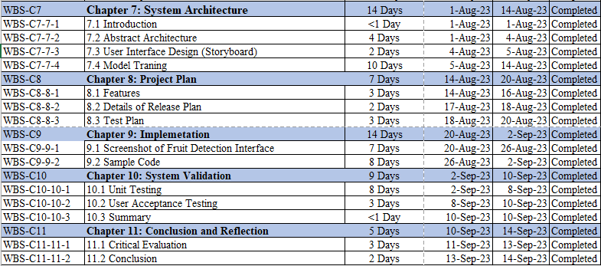

Figure 2: Semester 2 Project Plan

# Chapter 2: Literature Review

## Introduction

### 2.1.1 Intrusion Detection System (IDS) History

An intrusion detection system (IDS) is a

device or software application that monitors network or

system activities for malicious activities or policy

violations and produces reports to a Management

Station. Some systems may attempt to stop an intrusion

attempt but this is neither required nor expected of a

monitoring system. Due to a growing number of

intrusion events and also because the Internet and local

networks have become so ubiquitous, organizations are

increasingly implementing various systems that monitor

IT security breaches. This includes an overview of the

classification of intrusion detection systems and

introduces the reader to some fundamental concepts of

IDS methodology: audit trail analysis and on-the-fly

processing as well as anomaly detection and signature

detection approaches.

An intrusion detection system (IDS) is a

device or software application that monitors network or

system activities for malicious activities or policy

violations and produces reports to a Management

Station. Some systems may attempt to stop an intrusion

attempt but this is neither required nor expected of a

monitoring system. Due to a growing number of

intrusion events and also because the Internet and local

networks have become so ubiquitous, organizations are

increasingly implementing various systems that monitor

IT security breaches. This includes an overview of the

classification of intrusion detection systems and

introduces the reader to some fundamental concepts of

IDS methodology: audit trail analysis and on-the-fly

processing as well as anomaly detection and signature

detection approaches.

An intrusion detection system (IDS) is a tool or software application designed to actively monitor network or system activities, aiming to spot any malicious actions or breaches by applying predefined rules. Subsequently, the system proceeds to generate updates and reports that are transmitted to a management station. With the upsurge in the number of intrusion incidents and the widespread adoption of the Internet and local networks, organizations are increasingly embracing various systems to monitor IT security breaches (Elsadai et al., 2019). Network infrastructure attacks pose a significant challenge in today's interconnected world, with illicit activities in the networking realm on the rise. Nework security remains an ongoing challenge since the early days when firewalls stood as the primary line of defense. Notably, the first large-scale internet attack occurred on November 2, 1988, when the Morris Worm targeted the Sendmail program. Since then, significant advancements have been made in addressing these security challenges (Nalini et al., 2023). This section provides an overview of how intrusion detection systems are categorized and introduces key concepts in IDS methodology, including the analysis of audit trails, real-time event processing, and the utilization of anomaly detection, signature detection, and hybrid detection techniques (Safana Hyder Abbas et al., 2023).

The 1980s marked a pivotal era when James Anderson's influential paper was commissioned by a government organization to introduce the notion that audit trails contain valuable insights for tracking misuse and understanding user behavior. This seminal work laid the foundation for the detection of misuse and specific user activities, ultimately shaping the field of host-based intrusion detection methods and exerting a profound influence on intrusion detection systems (IDS) as a whole (Rajasekaran & Nirmala, 2020).

The commercial development of intrusion detection technologies experienced significant growth in the 1990s. Haystack Labs emerged as a pioneer in commercial IDS tools with its Stalker line of host-based products. Concurrently, SAIC was engaged in developing a host-based intrusion detection system known as the Computer Misuse Detection System (CMDS). In parallel, the Air Force's Cryptologic Support Center conceived the Automated Security Measurement System (ASIM) to monitor network traffic on the US Air Force's network. ASIM effectively addressed scalability and portability challenges that had previously plagued network intrusion detection (NID) products, innovatively combining hardware and software solutions for network intrusion detection. Remarkably, ASIM continues to be actively employed and managed by the Air Force's Computer Emergency Response Team (AFCERT) on a global scale. Notably, the development team behind the ASIM project went on to establish a commercial venture known as the Wheel Group in 1994. They introduced Net Ranger, marking the inception of the first commercially viable network intrusion detection device management system (Rajasekaran & Nirmala, 2020).

The intrusion detection market gained substantial momentum and revenue generation around 1997. In that year, Internet Security Systems (ISS) developed a network intrusion detection system named Real Secure. Cisco, recognizing the importance of network intrusion detection, acquired the Wheel Group a year later, thereby obtaining a security solution to offer its customers. Simultaneously, Centrex Corporation, the first prominent host-based intrusion detection entity, surfaced because of a merger between the development team from Haystack Labs and the CMDS team's departure from SAIC. This marked the expansion of the commercial IDS market, ushering in a dynamic era characterized by start-ups, mergers, and acquisitions (Rajasekaran & Nirmala, 2020).

### 2.1.2 Classification of Intrusion Detection System

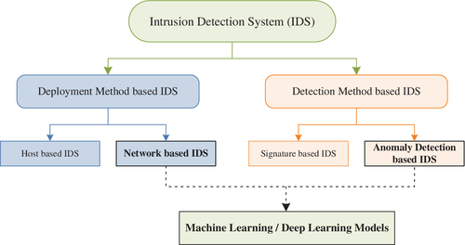

Figure 3: Classification of Intrusion Detection System

**Deployment Method based IDS.**

Intrusion Detection Systems (IDS) are a critical aspect of computer and network security, providing an extra layer of protection against potential security breaches. IDS involves the monitoring of events occurring in a computer system or network and analyzing them for signs of potential incidents. The effectiveness of IDS depends on their deployment, which can either be network-based or host-based.

Network-based IDS (NIDS) are deployed at strategic points within a network, such as at the network perimeter or at critical network segments. The primary function of NIDS is to monitor network traffic passing through these points and alert security administrators of any suspicious activity. The system detects anomalous traffic or activity by analyzing network packets and compares them to known patterns of attack signatures, which are usually contained in a database of known threats. Meanwhile, Host-based IDS (HIDS) is installed on individual hosts or devices, such as servers or workstations to monitor activity on the host including system calls and log files. The primary function of HIDS is to detect any signs of malicious activity on the host, such as the modification or deletion of critical system files, suspicious logins, or other unusual activities that may indicate a security breach. (Ahmad et al., 2020).

|  |  |  |  |
| --- | --- | --- | --- |
| **IDS Type** | **Analysis Method** | **Strengths** | **Weaknesses** |
| Network-based IDS | Analyzes data packet flow between computers | Detects a wide range of network-level attacks, including DoS attacks, port scans, and unauthorized access | May miss attacks that occur at the host level, such as file system tampering or malware infections; may produce false positives or false negatives |
| Host-based IDS | Monitors individual computer systems, analyzing system logs | Can detect application-level attacks, such as SQL injection or XSS; can also detect file system tampering | Limited to monitoring activity on individual hosts; may not detect attacks that occur at the network level, such as DoS attacks; can be resource-intensive and may produce false positives or false negatives |
| Hybrid-based IDS | Combines both network-based and host-based intrusion detection | Provides more complete security coverage; can detect attacks that may be missed by using only one type | May require more resources than using only one type of IDS; may produce false positives or false negatives; may be more complex to implement and maintain than using only one type of IDS |

**Detection Method Based IDS**

Intrusion detection systems (IDS) use several methods to monitor and detect any abnormalities. IDS can be classified into two main categories: Signature-based Intrusion Detection (SIDS) and Anomaly Detection-based Intrusion Detection (AIDS). SIDS, also known as Misuse Intrusion Detection or Knowledge-based Intrusion Detection, relies on the creation of attack patterns or signatures. The system compares incoming data patterns with the stored signatures in a database to detect potential attacks. This approach is efficient in detecting known attacks as it relies on comparing the current behavior of the network with previously identified attack patterns. However, it may not be effective in detecting new or novel attacks that do not have existing signatures. Additionally, SIDS requires a large database of signatures to be compared with incoming data packets, which can be resource intensive (Ahmad et al., 2020).

Meanwhile, AIDS is also known as Behavior-based IDS, defines a clear profile of normal activity and flags any deviation from this profile as an anomaly or abnormal behavior that may indicate a potential intrusion. The main advantage of AIDS is its ability to detect new and unknown attacks, making it ideal for detecting attacks that do not have existing signatures. The system can also create custom profiles for different networks and applications, providing flexibility in adapting to changing threat landscapes. However, the main drawback of AIDS is its high false alarm rate, as it can be challenging to distinguish between normal and abnormal behavior accurately. (Ahmad et al., 2020).

|  |  |  |  |
| --- | --- | --- | --- |
| **Detection Method** | **Description** | **Strengths** | **Weaknesses** |
| Signature-based detection | Compares network traffic to a database of known attack signatures. | Effective against known threats. Can quickly identify and block known threats. | Can be bypassed by new or unknown threats that don't match the signature database. |
| Anomaly-based detection | Identifies patterns of network traffic that deviate from normal behavior. | Effective against unknown threats and zero-day attacks. Can detect unusual traffic patterns that may indicate new types of attacks. | Can generate false positives, as some legitimate traffic may also appear unusual. May not detect attacks that blend in with normal traffic patterns. |

2.1.3 Machine Learning Technology

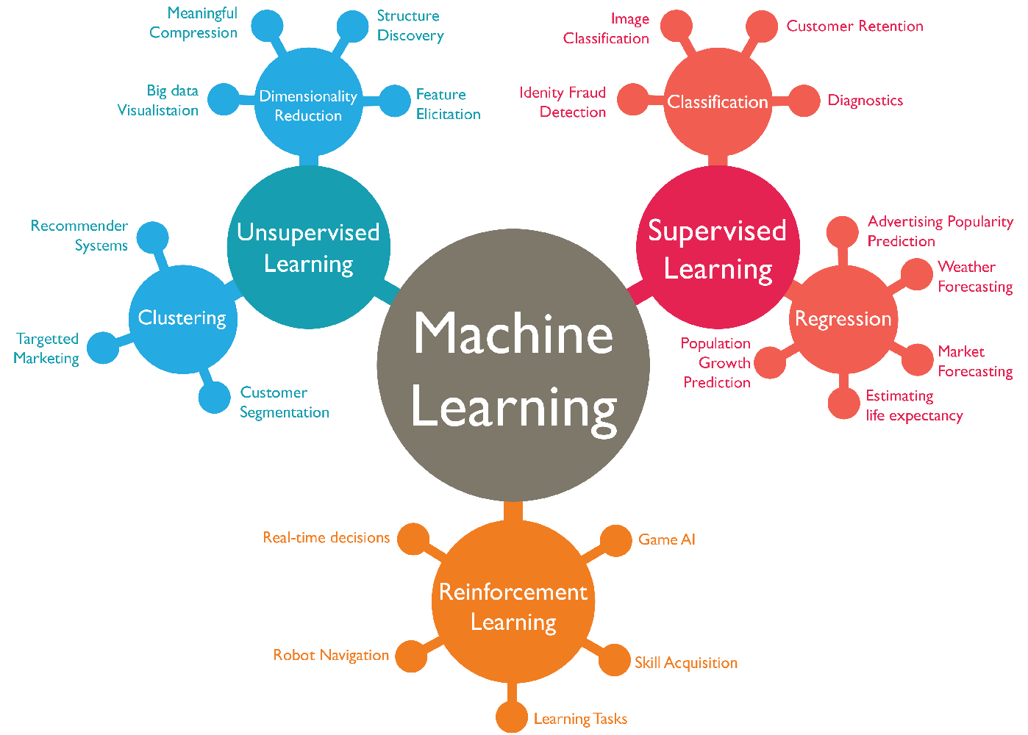

Figure 4: Types of Machine Learning

Machine Learning (ML) is a modern and highly sophisticated technological application that has become popular in the IT industry. Machine Learning is widely used in various applications by playing a vital role in many fields like Finance, Medical Science and Security. Machine learning allows computers to learn and improve without explicit programming (Haripriya & Jabbar, 2018). Researcher Mahesh (2019) suggests that machine learning can enhance data handling by resolving issues related to interpreting and extrapolating information. With increasing datasets, demand for machine learning is rising across many industries (Mahesh, 2019). Frank Rosenblatt's development of the "perceptron" machine, capable of recognizing alphabet letters, significantly influenced machine learning. The machine utilized both discrete and analogue signals, with a threshold component that converted analogue impulses into discrete ones (Fradkov, 2020). Machine learning and deep learning, both subfields of artificial intelligence, heavily contribute to the development of intelligent systems.

Based on the journal article, Aggarwal et al. (2022) highlights that machine learning included various functions, such as knowledge generation, algorithm teaching, correlation detection, and pattern recognition. By identifying correlations and patterns, machine learning can predict outcomes and improve processes for new datasets. Machine learning can be categorized into three main divisions: decision-making, error function, and model optimization process. The decision-making process involves using various techniques to forecast or classify data, regardless of whether it has been tagged or not, to identify patterns that aid decision-making. The accuracy of machine learning model predictions is assessed using an error function, which can also be used to compare multiple models. During the model optimization process, the weights of the proposed model are adjusted to minimize the difference between it and the training dataset until the model accurately predicts the data's outcome (Aggarwal et al., 2022).

A. Supervised Learning

Supervised learning involves a teacher-student type of learning where the algorithm is trained on labeled data. The primary technique of supervised learning is classification, and common algorithms used include SVM, ANN, KNN, Random Forest, Bayesian Networks, and Decision trees (Haripriya & Jabbar, 2018).

B. Unsupervised Learning

Unlike supervised learning, unsupervised learning does not require external supervision. The algorithm is trained on data with unknown labels and learns from the data based on similarity measures to form clusters. Clustering is the most common technique used in unsupervised learning, with K-means clustering and hierarchical clustering being the common algorithms used (Haripriya & Jabbar, 2018).

C. Reinforcement Learning

Reinforcement learning involves a computer being provided access to achieve a specific goal. In this learning, the algorithm approaches a domain expert to label instances from unlabeled instances (Haripriya & Jabbar, 2018).

### 2.1.4 The Current trend of Artificial Intelligence in Cyber Security Market

MarketsandMarkets Research Private Ltd has reported that artificial intelligence technology in cybersecurity market is expected to grow from USD 22.4 Billion in 2023 to USD 60.6 Billion by 2028, with a compound annual growth rate of 21.9%. This growth can be attributed to the increasing adoption of IoT and the rise in connected devices, as well as the growing number of cyber threats, concerns about data protection, and the vulnerability of Wi-Fi networks to security threats (MarketsandMarkets, 2019)

There has been a gradual increase in cyberattacks worldwide, targeting endpoints, networks, and data, causing significant financial losses for individuals, enterprises, and governments. Cybercriminals have various motives, including financial gain, political or international rivalry, reputation harm, and radical religious group interest. Ransomware attacks, such as WannaCry, Petya, NotPetya, and BadRabbit, have affected enterprises and government organizations on a large scale. According to the CISCO cybersecurity threat treads report 2021, a large percentage of organizations had experienced various types of cyberattacks, including phishing attempts, malicious browser ads, unsolicited crypto mining, and ransomware-related activity (MarketsandMarkets, 2019).

Cyber threats not only damage critical IT infrastructure and sensitive data but also impact businesses' daily operations. With the increasing frequency of cybercrimes due to the rapid rise in digital transactions across various industries, the market for cybersecurity products and services is growing. As a result, safeguarding against cyber threats has become essential for the growth of enterprises (MarketsandMarkets, 2019).

### 2.1.4 How FinTech is using the benefits of Machine Learning Technology to enhance Cyber Security Technology for fraud detection.

Internet fraud has become a significant problem for financial institutions, and numerous fintech companies have fallen trapped to this type of cyber-attack. There are two methods of detecting these attacks: traditional techniques, which are inconsistent, and artificial intelligence, which is continually evolving (Sotikare, 2023).

**Preventing identity theft incident occur**

Despite the prevalence of identity theft incidents, most fintech companies still rely on rule-based, traditional techniques rather than embracing artificial intelligence. However, many companies are now making the shift towards incorporating machine learning and AI to enhance their fraud detection capabilities. The digitization of financial activities has made users more susceptible to fraud when creating accounts, submitting applications, or filing tax returns. Digital information accessibility provides identity thieves with numerous opportunities to breach servers. For instance, they can exploit stolen identification data to create accounts in someone else's name, access benefits, or pilfer tax returns. Artificial intelligence has emerged as a vital tool in mitigating the impact of identity theft on the fintech industry. AI-driven identity theft detection systems, including pattern recognition, excel in identifying and preventing such scams. These systems can flag suspicious transactions, behaviors, or information that deviate from a customer's typical patterns, thus averting potential harm (Sotikare, 2023).

**Immediate detection of credit card fraud through identifying unusual transactions**

Customers employ various security measures to protect their credit card and account information, such as virtual private networks, virtual cards, or website certification checks. However, as fraudulent tactics become increasingly sophisticated, organizations must scrutinize credit card transactions and transfers to mitigate risks. AI techniques like data mining leverage extensive datasets containing both legitimate and fraudulent transactions to identify anomalous behavior. The model can detect warning signs by analyzing this data. Unusual transactions, such as sudden spikes in weekly or monthly transaction values or purchases from stores that do not typically ship to the account holder's country, can be swiftly identified with AI's assistance. This capability allows for the prompt detection and mitigation of fraud, thus preventing substantial losses (Sotikare, 2023).

**Detection of money laundering amidst account activities**

Fintech companies and banks have turned to deep learning AI algorithms like neural networks to uncover links between criminal behavior and account activity. Traditional methods struggle to identify money laundering due to its subtle nature. However, artificial intelligence has revolutionized the process by meticulously evaluating each transaction, as money laundering typically involves large sums and is often orchestrated by organized criminal entities camouflaged as legitimate entities (Sotikare, 2023). Even with robust systems in place, errors can occur, making it challenging to detect money laundering activities concealed within legitimate transactions. Fortunately, AI has excelled in identifying such activities. For example, a single suspicious fund transfer could unveil a series of illicit activities. Additionally, when scrutinizing multiple transactions within an individual's account reveals irregularities, AI systems can swiftly recognize these patterns, thereby preventing fraudulent activities in a timely manner (Sotikare, 2023).

**Early detection of fraudulent loan and mortgage applications**

Fraud detection AI technologies have assumed a pivotal role for fintech companies and banks in evaluating loan and mortgage applications. These institutions increasingly rely on these tools to aid their risk assessment processes. Machine learning forms a crucial component of fraud detection, enabling the extraction and analysis of pertinent data from applications. Models, trained on datasets encompassing both legitimate and fraudulent applications, aim to identify potential fraud indicators and raise alerts, even if not entirely precise. This empowers analysts to conduct further investigations, potentially averting fraud. Furthermore, AI assists fintech companies in predicting the likelihood of a customer engaging in fraudulent activities by analyzing consumer behavior data and forecasting trends (Sotikare, 2023).

* 1. Domain Research

2.2.1 Integrating Machine Learning with IDS

This investigation reports main objectives is to study the advantages and disadvantages of traditional intrusion detection system for detecting and preventing cyber-attacks and the advantages and disadvantages of machine learning technology, to propose a machine learning-based IDS approach that overcome the drawbacks of both studies. The study will utilize the network packet file generated by existing open-source IDS software and integrate with the proposed machine learning-based IDS approach in terms of detection accuracy, false alarm rate, and resource utilization. Furthermore, the study aims to investigate the impact of different factors, such as network size, traffic volume, and attack type, on the effectiveness of the proposed IDS method. The results of this investigation can provide valuable insights into the selection and deployment of machine learning-based IDS solutions for organizations of various sizes and industries and contribute to the development of more robust and efficient IDS technologies.

The main advantage of utilizing machine learning technology is their ability to adapt and improve over time as they learn from new data. This allows them to detect previously unknown attacks and stay up to date with the latest threats. Besides that, machine learning technology can also reduce false alarm rates and improve the accuracy of threat detection by leveraging advanced pattern recognition and anomaly detection techniques (Publication, 2020). However, the major drawback of machine learning technology is the need for large amounts of high-quality training data. This data needs to be diverse enough to capture a wide range of attack scenarios and should be carefully created to avoid bias and ensure accuracy is achieved. Additionally, machine learning technology may require significant computational resources and expertise to develop to minimize errors occurring (Publication, 2020).

Some of the unique features can be included in the proposed system:

1. Continuous learning: One of the unique features of machine learning IDS is its ability to learn and adapt continuously. The system can analyze new data and update its models and algorithms to improve its accuracy and effectiveness over time.
2. Behavioral analysis: Machine learning IDS can detect anomalies and attacks based on behavior analysis rather than relying on pre-defined signatures. This approach allows the system to detect new and emerging threats that have not yet been identified.
3. Pattern recognition: Machine learning IDS can identify complex patterns and correlations in network traffic that may be difficult for human analysts to detect. This enables the system to detect subtle indicators of a potential attack, which may go unnoticed by traditional IDS.
4. Scalability: Machine learning IDS can be scaled to handle large amounts of data and traffic, making it suitable for organizations with high traffic volumes and distributed networks.

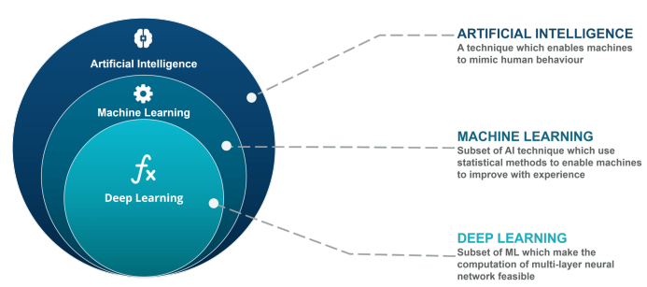

Figure 5:Fundamental of Artificial Intelligence, Machine Learning and Deep Learning

2.2.2 How to integrate Machine Learning with IDS

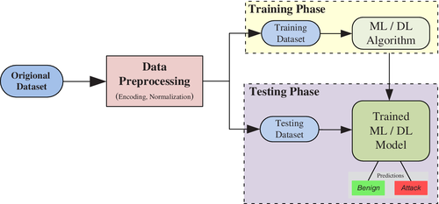

Figure 6: Machine Learning Stages

The integration of machine learning techniques into a system involves three major steps, as illustrated in the above figure: Data preprocessing, Training, and Testing (Ali et al., 2023). In the proposed project Enhanced Intrusion Detection System (IDS), the dataset gather from existing IDS software is first preprocessed, which involves converting it into a format that is suitable for the algorithm, and this may include encoding and normalization. The second step involves Data cleaning, such as removing missing and duplicate entries, may also be performed at this stage. The preprocessed data is then randomly divided into two parts, namely the training dataset, and the testing dataset, with the training dataset making up about 80% of the original dataset size and the remaining 20% forming the testing dataset (or 70% of the original dataset size and 30% of testing dataset). In the training phase, the ML or DL algorithm is trained using the training dataset, and the learning time depends on the dataset's size and the complexity of the model. Deep Learning (DL) models usually require more training time due to their complex and deep structure. After the model is trained, it is evaluated using the testing dataset based on the predictions made. (Ali et al., 2023).

**Recommended Machine Learning Algorithm for IDS**

Choosing the right machine learning algorithms for implementing machine learning Intrusion Detection Systems (IDS) requires a comprehensive exploration of various options that can effectively tackle the intricate aspects of network security. The first option is Decision Trees, which present a methodical approach to decision-making by representing choices and their outcomes in a structured tree-like graph. Within this graphical representation, nodes represent events or decisions, while edges signify the conditions or rules guiding those decisions. Decision trees prove particularly valuable in IDS, as each node can correspond to an attribute within a classification category, simplifying the identification and categorization of network anomalies (Ahmad et al., 2020).

Another algorithm to contemplate is Random Forests, which harness the power of ensemble learning. Random forests are formed by constructing multiple decision trees and amalgamating their outputs. This ensemble approach bolsters the algorithm's resilience, reducing the risk of overfitting, and enhancing its capacity to handle missing data. In the realm of IDS, random forests can be trained to classify network traffic based on a diverse array of features, encompassing source and destination IP addresses, ports, and packet payload analysis. By leveraging the collective intelligence of numerous decision trees, random forests offer a versatile and potent method for intrusion detection (Ahmad et al., 2020).

Additionally, another algorithm deserving consideration for IDS is k-Nearest Neighbors (KNN). KNN is a straightforward yet potent algorithm that classifies data points based on their proximity to other data points within a feature space. In the context of IDS, KNN can be applied to detect network intrusions by gauging the similarity between instances of network traffic. By evaluating the attributes of neighboring data points, KNN excels at recognizing suspicious patterns and appropriately classifying network traffic. This adaptability and ease of implementation position KNN as a valuable addition to the suite of machine learning algorithms for intrusion detection, complementing the capabilities of decision trees and random forests (Ahmad et al., 2020).

|  |  |  |  |
| --- | --- | --- | --- |
| Algorithm | Description | Advantages | Disadvantages |
| Decision Trees | - Hierarchical structure resembling a decision tree.  - Nodes represent events or decisions, edges signify rules.  - Provides structured decision-making approach. | - Interpretable and easy to understand.  - Effective for identifying network anomalies.  - Suitable for feature selection.  - Supports both classification and regression. | - Prone to overfitting, especially deep trees.  - Sensitive to small variations in the data.  - May not handle complex data well. |
| Random Forests | - Ensemble of multiple decision trees.  - Robust to missing data and noisy features.  - Suitable for diverse feature sets. | - Reduces overfitting by aggregating trees.  - High accuracy due to ensemble learning.  - Handles large datasets effectively. | - Can be computationally expensive to train.  - Complex models may be challenging to interpret.  - Slower prediction times compared to single tree. |
| k-Nearest Neighbors (KNN) | - Classifies based on proximity to data points.  - Considers neighbors' characteristics for classification.  - Flexible for various network traffic instances. | - Simplicity and ease of implementation.  - Effective at identifying similar instances.  - No model training required. | - Sensitive to the choice of distance metric.  - Can be computationally intensive for large datasets.  - May struggle with high-dimensional data. |

2.2.3 Implement Enhanced IDS with Machine Learning through CICDdos2019 Dataset

**The CICDdos2019 Dataset**

Distributed Denial of Service (DDoS) attacks pose a significant threat to network security by overwhelming target networks with malicious traffic. While various countermeasure have been developed for DDoS attack detection, creating a real-time detector with low computational overhead remains a major challenge. Additionally, the evaluation of new detection algorithms relies heavily on well-designed datasets. Recognizing the need to identify new attacks and develop fresh taxonomies, Canadian Institute for Cybersecurity has generated a dataset named CICDdos2019. In this dataset, it consist of various type of reflective DDoS attacks such as PortMap, NetBIOS, LDAP, MSSQL, UDP, UDP-Lag, SYN, NTP, DNS and SNMP alongside with and benign traffic with 88 features (University of New Brunswick, n.d.).

|  |  |  |  |
| --- | --- | --- | --- |
| Type of Attack | Description | Protocols Utilized | Illustrative Examples |
| Reflection-Based DDoS | These attacks aim to conceal the identity of the attacker by leveraging legitimate third-party elements. Attack packets are dispatched to reflector servers, with the source IP address manipulated to match the victim's IP address, causing the victim's network to be inundated with response packets. | TCP, UDP, or a combination of both | MSSQL, SSDP, CharGen, NTP, TFTP, DNS, LDAP, NETBIOS, SNMP |
| Exploitation-Based DDoS | These attacks also seek to hide the attacker's identity through legitimate third-party elements. Attack packets are directed to reflector servers with their source IP address altered to match the victim's IP address, leading to an overwhelming surge of response packets. These attacks can employ application layer protocols in conjunction with transport layer protocols such as TCP and UDP. | TCP and UDP | SYN flood, UDP flood, UDP-Lag |
| UDP Flood | A subtype of UDP-based exploitation attacks, UDP flood attacks overload remote hosts by continuously dispatching a large volume of UDP packets to random ports on the target machine at a high frequency. This depletes the network's available bandwidth, resulting in system crashes. | UDP | UDP flood |
| SYN Flood | A TCP-based exploitation attack that depletes server resources by exploiting the TCP three-way handshake. It commences by persistently sending SYN packets to the target machine until the server malfunctions or crashes. | TCP | SYN flood |
| UDP-Lag Attack | This attack disrupts the connection between a client and server, primarily used in online gaming to hinder or interrupt the movements of other players. It can be executed via a hardware switch known as a lag switch or by a software program that monopolizes network bandwidth. | N/A (Application layer attack) | UDP-Lag |

**How to conduct Data Preprocessing for CICDdos2019 before model training**

1. Eliminating Socket Features: According to (Laurens D’hooge et al., 2022) ,exclude socket-related attributes such as source and destination IP addresses, source and destination ports, timestamps, and flow IDs. These attributes tend to vary across different networks, making it essential to train the model solely on packet characteristics. Additionally, the presence of identical IP addresses for both intruders and legitimate users can lead to overfitting if socket information is incorporated into the machine learning model.
2. Data Cleansing: The original dataset may contain a considerable number of missing (NaN) and infinite values, which are deemed irrelevant. Therefore, it is recommend to systematically eliminate these values from the dataset (Gulati & Raheja, 2021).
3. Label Encoding: The model can be designed for binary classification, distinguishing between normal and malicious network traffic. Consequently, we classify all DDoS attack categories as part of the "attack" category, alongside the normal traffic class. Subsequently, we apply label encoding to represent the string values for "normal" and "attack" labels as binary values, with "0" denoting normal traffic and "1" signifying malicious. Alternatively, the model can be designed for multi label classification besides from distinguishing between normal and malicious network traffic, but also classify type of malicious network traffic (Jiang et al., 2020).
   1. Similar System

2.3.1 Suricata (NIDS)

Suricata is a direct competitor to Snort and utilizes a combination of signature-based, anomaly-based, and policy-driven intrusion detection methods. It provides real-time intrusion detection and prevention while monitoring network security. Many consider it a modern alternative to Snort due to its multi-threading capabilities, GPU acceleration, and statistical anomaly detection (Sen, 2023). It is also compatible with Snort's data structure and allows for the implementation of Snort policies. Additionally, Suricata can examine TLS/SSL certificates, HTTP requests, and DNS transactions. However, it is prone to false positives and can be system and network resource intensive (Bada et al., 2020).

2.3.2 Snort (NIDS)

Snort is a popular open-source NIDS (Network Intrusion Detection System) that is maintained by Cisco Systems. It is a versatile tool that can be run on various operating systems, such as Windows, Linux, and Unix, and analyzes real-time network traffic (Bada et al., 2020). The three modes of operation for Snort are packet sniffer mode, packet logger and intrusion detection. The intrusion detection mode is based on a set of rules that can be created by the user or downloaded from the Snort community. Using signature-based and anomaly-based detection techniques, Snort can detect various types of attacks, including OS fingerprinting, port scanning and SMB probes. However, Snort has a couple of drawbacks, such as the lack of a graphical user interface (although some community-developed add-ons exist) and the complexity of creating rules, which can lead to false positives (Sen, 2023).

2.3.3 Zeek (NIDS)

Zeek, formerly known as Bro, is another NIDS tool that runs on Unix, Linux, and Mac OS. It differs from Snort and Suricata in that it runs on the application layer, allowing for the tracking of various services from different OSI layers such as HTTP, DNS, SNMP, and FTP (Bada et al., 2020).. Zeek uses signature-based and anomaly-based detection methods and has a diverse user community. The platform can be tailored to a variety of network security use cases, in addition to NIDS. However, gaining proficiency in Bro DSL may require some programming experience and effort (Sen, 2023).

2.3.4 OSSEC (HIDS)

OSSEC is a free and open-source host-based intrusion detection system that uses agent-based deployment to monitor events and logs on individual hosts. It is designed to be cross-platform and supports a wide range of operating systems, including Linux, Windows, and macOS. OSSEC uses a rule-based approach to detect potential threats, with the ability to create custom rules or use pre-defined rules provided by the community. In addition to intrusion detection, OSSEC also includes file integrity monitoring and log analysis capabilities.

Despite its benefits, OSSEC has some limitations. One major limitation is its reliance on agent-based deployment, which may require additional resources and management overhead, especially in large environments. Additionally, OSSEC may have limited visibility into network-based attacks, as it primarily focuses on host-based monitoring. OSSEC's rule-based approach may also result in false positives, requiring additional effort from security teams to manage and analyze alerts. Finally, OSSEC's customizability may require a higher level of expertise to set up and configure compared to other IDS solutions, which may be a challenge for less experienced users (Cooper, 2022).

2.3.5 Sagan (HIDS)

Sagan is a Host-based Intrusion Detection System that is free to use and can be installed on Unix, Linux, and Mac OS. It employs both anomaly and signature-based detection methods and can collect Windows event log messages even though it cannot run on Windows. Sagan can distribute processing to reduce the load on the log server's CPU, and it includes automated response rules to act when it detects an intrusion. This tool has some unique features, such as allowing users to receive alerts when activities of different IP addresses originate from the same geographic location, as well as time-based rules to trigger alerts. Sagan was designed to be compatible with Snort, a network detection system, which gives it NIDS capabilities when combined with a network data collector. The tool includes a script execution facility, making it an IPS.

Despite being a free log analysis tool, Sagan has a steep learning curve for new users, and it cannot be installed on Windows operating systems. Additionally, it is considered more of a HIDS tool than a traditional IDS. However, Sagan is compatible with other open-source tools like Zeek and Snort, making it a versatile addition to a security stack (Cooper, 2022).

2.3.6 Splunk (HIDS)

Splunk provides both host-based intrusion detection system (HIDS) and network-based intrusion detection system (NIDS) capabilities. The tool's base package is free and solely focuses on HIDS without including any network-based data alerts. It is an excellent option for those seeking an anomaly based HIDS. Splunk Enterprise, the top edition of the tool, is available alongside a Software-as-a-Service (SaaS) version called Splunk Cloud. Between the free and enterprise editions of Splunk is Splunk Light, which comes with certain service limitations, and an online version called Splunk Light Cloud.

Splunk features an Adaptive Operations Framework module, which facilitates workflow automation and links automated scripts to trigger alerts, effectively making it an intrusion prevention system. However, this functionality is only available with the higher paid options of the tool. Splunk's dashboard is highly visual and includes attractive data visualizations such as line graphs and pie charts. The tool includes a data analyzer in all editions, allowing users to view records, sort, search, summarize, and be represented in graphs.

Splunk's advantages include its ability to utilize behavior analysis to detect threats that are not discovered through logs, its excellent user interface, and easy customization options. The tool is enterprise-focused and is available for both Linux and Windows. Its drawbacks include the need to contact sales for pricing, its higher cost that makes it less suited for small businesses, and its use of a custom Search Processing Language (SPL) for queries, which can be challenging for some users to learn (Cooper, 2022).

2.3.7 Comparison Between the Similar Systems

|  |  |  |  |
| --- | --- | --- | --- |
| **Features** | **Suricata** | **Snort** | **Zeek** |
| Detection methods | Signature-based, anomaly-based, and policy-driven | Signature-based and anomaly-based | Signature-based and anomaly-based |
| Network speed support | Real-time intrusion detection and prevention, monitoring network security | Analyzes real-time network traffic | Traffic logging and analysis |
| Customizability | Compatible with Snort's data structure, allows implementation of Snort policies, examine TLS/SSL certificates, HTTP requests, and DNS transactions | Can create own rules or download from Snort community, but creating rules can be complicated | Tailored to a variety of network security use cases, but gaining proficiency in Bro DSL may require some programming experience and effort |
| Rule set support | Can use Snort’s rulesets | Can create own rules or download from Snort community | N/A |
| Operating systems supported | Windows, Linux, Unix | Windows, Linux, Unix | Unix, Linux, Mac OS |
| Real-time analysis | Yes | Yes | No |
| Limitations | Prone to false positives, can be system and network resource intensive | Lack of GUI (although community-developed add-ons exist), complexity of creating rules leading to false positives, packet processing can be slow | Some programming experience is required. Gaining proficiency in Bro DSL can take some effort. |

|  |  |  |  |
| --- | --- | --- | --- |
| **Features** | **OSSEC** | **Sagan** | **Splunk** |
| Detection methods | Rule-based approach | Anomaly and signature-based detection methods | Anomaly-based HIDS |
| Operating systems supported | Linux, Windows, macOS | Unix, Linux, macOS | Linux, Windows |
| Real-time analysis | Yes | Yes | Yes |
| Customizability | Highly customizable | Highly customizable | Customizable with higher cost options |
| Rule set support | Custom rules or pre-defined community rules | Custom rules | Custom rules |
| Limitations | Reliance on agent-based deployment | Steep learning curve for new users | Higher cost, use of custom Search Processing Language (SPL) for queries |

# Chapter 3: Technical Research

## Programming Language

### 3.1.1 Python

Python is widely embraced high-level programming language employed across a spectrum of sectors within the IT industry, encompassing vital domains such as cybersecurity and artificial intelligence. Its prevalence in these realms can be traced back to a medley of factors that collectively contribute to its popularity. These factors include its attribute of having an straightforward syntax that facilitates seamless coding experiences, its adept integration of object-oriented programming principles that enhance code organization and reusability, and its extensive and inclusive library support that opens doors to diverse functionalities. The language's syntax, marked by its transparency and simplicity, creates an environment that accommodates both those taking their initial steps into programming and seasoned experts, effectively mitigating potential complexities. Python is also further fortified by the substantial assortment of libraries. These libraries cater to a wide spectrum of tasks ranging from the development of web-based applications to intricate data analysis, and even encompass the realm of scientific computing, thereby underscoring Python's exceptional versatility (Saabith et al., 2019).

Python extends adeptly into the domain of machine learning, captivating practitioners due to its inherently adaptable nature and its inherently user-friendly design. The language's straightforward and legible structure renders it an eminently suitable choice, particularly for novices embarking on their journeys into the complex realm of artificial intelligence. This attribute is particularly relevant in a landscape where the learning curve can appear daunting. Python's extensive array of libraries assumes a pivotal role in enhancing its attractiveness in the machine learning arena. Aided by a vibrant and engaged community, Python stands as a good selection for critical tasks such as the analysis of data and the preprocessing of information in machine learning. The continuous evolution of libraries like TensorFlow and Keras contributes to the sustained rise of Python within the echelons of AI development. The inclusive range of libraries and packages at Python's disposal underscores its versatility, firmly cementing its status as the language of choice for a multitude of AI endeavors, reflecting its dynamic and ever-evolving nature (Saabith et al., 2019).

**Advantages of using Python to develop proposed project.**

**1. Python's Preeminence in Machine Learning:** Python has emerged as a leading choice for machine learning due to its extensive library support for various interactive development environments which simplifies the implementation of machine learning algorithms. It also offers various tools for tasks like data preprocessing, data cleaning, feature selection, hyperparameter tuning and model evaluation.

**2. Python's Accessibility and Simplicity:** Python boasts a user-friendly and straightforward syntax, making it an easily accessible language for developers. This simplicity reduces the time and effort required to construct an Intrusion Detection System (IDS) based on machine learning.

**3. Python's Scalability and Performance:** Python harnesses the potential of distributed computing and parallel processing, enabling it to efficiently process substantial data volumes. This scalability makes it well-suited for constructing an IDS capable of handling large-scale networks.

**Drawbacks of using Python to develop proposed project.**

**1. Performance Limitations**: Python's interpreted nature can lead to slower execution compared to compiled languages like C and C++, particularly concerning extensive data processing or real-time network traffic analysis. Nevertheless, Python offers avenues to enhance performance, such as employing optimized libraries, parallel processing, and distributed computing.

**2. Memory Management Challenges**: Python relies on automatic memory management, which can lead to performance issues when managing large datasets or memory-intensive tasks concatenate many datasets at once.

**3. Debugging Complexity**: Debugging in Python can be more intricate when compared to compiled languages due to its dynamic characteristics. Runtime errors may arise, making it harder to trace them back to their source code.

### 3.1.2 Java

Java stands out as a statically typed, object-oriented, and concurrent programming language. Its compiled nature engenders strict syntax, setting it apart from dynamically typed counterparts like Python that offer more flexibility. While Java may entail a steeper learning curve and result in code that is more verbose, this strictness bears the advantage of preempting commonplace programming errors and elevating the dependability of the code. Furthermore, Java's strong emphasis on object-oriented principles imbues it with a structural framework where every element revolves around objects, thereby streamlining the management and organization of extensive codebases. An added advantage lies in the portability of the Java Virtual Machine (JVM), which ensures its availability across a multitude of platforms, thus underscoring its status as a highly versatile language (Khoirom et al., 2020).

Within the landscape of machine learning, Java emerges as an alternative for coding due to its performance prowess and scalability. The language boasts a notable aptitude for handling voluminous datasets and intricate algorithms, rendering it a pragmatic selection for crafting AI applications necessitating robust computational capabilities. Beyond its technical strengths, Java boasts a vibrant and expansive community of developers and users, a testament to its popularity. This extensive support ecosystem ensures a rich trove of resources and libraries tailored for AI development in the Java domain, thereby augmenting its utility and relevance (Khoirom et al., 2020).

**Advantages of using Java to develop proposed project.**

**1. Object-oriented programming**: Java is an object-oriented programming language that provides features like encapsulation, inheritance, and polymorphism. This makes it easier to organize code into reusable and modular components, which is important when developing a large and complex system like an IDS.

**2. High performance**: Java is a compiled language, which means that it can provide better performance than interpreted languages like Python. Additionally, Java provides built-in support for multithreading and parallel processing, which can help improve performance for machine learning tasks.

**3. Scalability**: Java provides features like memory management, which can help ensure that an IDS built in Java can handle large and complex datasets without running out of memory. Additionally, Java provides support for distributed computing and clustering, which can help scale an IDS to handle high volumes of network traffic.

**Drawbacks of using Java to develop proposed project.**

**1. Steep learning curve:** Java can have a steeper learning curve compared to other programming languages due to Syntax, which could make it more difficult for some developers to get up to speed. This could be a particular challenge for individuals without high experience in Java development.

**2. Limited control over memory management:** While Java's automatic memory management can be a benefit, it also means that developers have limited control over memory management, which could impact the application's performance in certain use cases.

**3. Garbage Collection**: Java's automatic garbage collection mechanism can lead to unpredictable pauses in the application, which could be a concern for the proposed project if it needs to be highly responsive.

### 3.1.3 Comparison between Java and Python



## IDE (Interactive Development Environment) Chosen

Visual Studio Code is the best choice for developing the Machine Learning Intrusion Detection System, given its remarkable versatility, comprehensive feature set, robust support for Python and Flask, and a community-driven ecosystem that fosters efficiency, collaboration, and adaptability. The use of Code Runner for efficient code execution underscores its status as the premier choice for this ambitious endeavor. The selection of Visual Studio Code as the preferred Integrated Development Environment (IDE) for the Machine Learning Intrusion Detection System (IDS) project is underpinned by a multitude of compelling reasons:

**Rich Ecosystem of Extensions and Plugins**: Visual Studio Code offers an expansive library of extensions and plugins that cater to a wide spectrum of programming languages, tools, and frameworks. This rich ecosystem ensures compatibility with the specific technologies required for the IDS project, including Flask for web development and Python for machine learning. The availability of extensions facilitates streamlined workflow integration and enhances productivity, allowing developers to customize their environments to the project's exact requirements.

**Seamless Python Integration**: Python stands as the cornerstone of machine learning and data analysis. Visual Studio Code provides unrivaled support for Python, offering features like code autocompletion and extensive libraries such as pandas and NumPy. This seamless integration not only streamlines development but also empowers data scientists and engineers to harness Python's full potential in building a robust IDS.

**Code Runner for Efficient Execution**: compared to traditional debugging, the use of Code Runner within Visual Studio Code enhances the development process by allowing for efficient code execution. Code Runner provides a quick and convenient way to run code snippets, test algorithms, and validate models. This rapid execution capability is invaluable for iterative development in a machine learning project.

**Flask Framework Support**: For web-based interfaces and API development, Flask is a widely preferred Python framework. Visual Studio Code offers robust support for Flask, simplifying the creation of web services and graphical user interfaces (GUIs) within the IDS project. The integrated Flask development tools enable efficient design and deployment of web-based components, providing a seamless user experience.

**Extensible and Customizable**: Visual Studio Code's extensibility is one of its most notable strengths. Developers have the flexibility to tailor the IDE to their specific requirements by selecting and configuring extensions. This high degree of customizability ensures that the IDE adapts seamlessly to the unique needs of the IDS project, enhancing its overall efficiency and aligning with the project's evolving demands.

**Cross-Platform Compatibility**: Visual Studio Code is renowned for its cross-platform compatibility, ensuring that developers can work on Windows, macOS, or Linux environments without restrictions. This flexibility is advantageous for teams with diverse hardware and operating system preferences, promoting collaboration and adaptability while minimizing compatibility issues.

**Performance and Responsiveness**: Visual Studio Code is designed to be lightweight, ensuring optimal performance even when handling resource-intensive tasks. This responsiveness is crucial for machine learning projects, where large datasets and complex algorithms demand an efficient IDE to maintain productivity and speed, ultimately accelerating the development process.

**Continual Updates and Improvements**: Microsoft, the developer behind Visual Studio Code, consistently releases updates and improvements to the IDE. This unwavering commitment to refinement ensures that developers continually benefit from the latest features, security enhancements, and performance optimizations. It guarantees that Visual Studio Code remains at the forefront of IDE technology, providing a reliable foundation for the IDS project's evolving requirements.

## Libraries/Tools chosen.

1. **Flask**: Flask is an essential library for building web applications and APIs. It allows the user to create a web interface for the machine learning model or any other functionality in the project. Flask provides routing, request handling, and templating, making it a versatile choice for web development (Hunt-Walker, 2018).

2. **Pandas**: Pandas are a vital library for data manipulation and analysis. It provides data structures like DataFrames and tools for cleaning, transforming, and exploring data (ActiveState, 2022).

3. **NumPy**: NumPy is fundamental for numerical computations in Python. It offers support for arrays and matrices, making it an essential tool for scientific computing and mathematical operations. It is an important library in data preprocessing and feature engineering (ActiveState, 2020).

4. **Scikit-Learn (sklearn**): Scikit-Learn is a machine learning library that provides a wide range of algorithms and tools for model training, evaluation, and deployment. Mention how it simplifies the implementation of machine learning models such as Decision Trees, Random Forests, and K-Nearest Neighbors, along with evaluation metrics like confusion matrices and classification reports (simplilearn, 2023).

5. **Seaborn and Matplotlib**: These visualization libraries are essential for creating informative plots and charts. Seaborn offers a high-level interface for statistical graphics, while Matplotlib provides fine-grained control over figure customization (Whitfield, 2023).

6. **Imbalanced-Learn (imblearn):** Imbalanced-Learn is crucial when dealing with imbalanced datasets, which are common in classification problems. It provides resampling techniques like Random Over-Sampling and Random Under-Sampling to address class imbalance issues, improving model performance and fairness (imbalanced-learn.org, 2023).

## Operating System Chosen

Windows is the chosen operating system for the Machine Learning Intrusion Detection System due to its compatibility, developer-friendly environment, machine learning library support, security, reliability, scalability, and robust support ecosystem. These factors collectively make Windows the ideal platform for developing a secure, efficient, and adaptable IDS that can effectively protect network integrity and respond to emerging threats.

**Compatibility and Versatility**: Windows is the chosen operating system due to its exceptional compatibility with a wide range of software and hardware components. This compatibility ensures that the Machine Learning Intrusion Detection System (IDS) project can seamlessly integrate various tools, libraries, and technologies required for its development. Whether it's machine learning libraries, web frameworks, or specialized network interfaces, Windows provides a versatile platform that accommodates the project's diverse requirements. This adaptability reduces potential integration challenges and enhances the project's overall efficiency and functionality.

**Developer-Friendly Environment**: Windows offers a developer-friendly environment that significantly enhances the efficiency of the IDS project's development cycle. With robust integrated development tools like Visual Studio and Visual Studio Code, developers benefit from powerful coding, debugging, and project management capabilities. These tools streamline the development process, reducing coding errors, expediting debugging, and simplifying version control. The user-friendly interface and feature-rich development environment empower the development team to focus on building a robust IDS without getting bogged down by cumbersome development tasks.

**Machine Learning Library Support**: Windows excels in supporting machine learning libraries and frameworks, which are at the core of the IDS project's functionality. The compatibility and optimization of these libraries for the Windows platform ensure that the project can efficiently leverage the full spectrum of machine learning tools. This compatibility minimizes potential development bottlenecks related to library integration and performance optimization. By choosing Windows, the IDS project benefits from a platform that seamlessly integrates with machine learning components, enabling the development team to harness the power of cutting-edge algorithms and techniques.

**Security and Reliability**: Security and reliability are crucial to develop an IDS tasked with safeguarding network integrity. Windows is chosen for its enterprise-grade security features, including built-in antivirus and firewall protection, user access controls, and regular security updates. These features provide a robust foundation for building a secure IDS that can effectively detect and respond to intrusion attempts. Additionally, Windows has a proven track record of reliability in enterprise environments, ensuring uninterrupted monitoring and detection capabilities. This reliability minimizes the risk of false positives and negatives, enhancing the IDS's overall effectiveness.

**Scalability and Network Integration**: Windows offers scalability and seamless network integration capabilities that align perfectly with the needs of an enterprise-level IDS. As network environments evolve and expand, the project can take advantage of Windows' scalability features to accommodate growing data volumes and network complexity. Moreover, Windows' integration with Active Directory for user management, Group Policy for centralized configuration, and compatibility with enterprise network technologies ensures that the IDS can be tailored to the specific requirements of large-scale network deployments. This adaptability ensures that the IDS remains effective and efficient as the network environment evolves.

**Documentation and Support**: Windows benefits from extensive documentation and a robust support network. Developers and IT professionals can readily access a wealth of resources, including official Microsoft documentation, community forums, and expert support services. This support ecosystem is invaluable for troubleshooting issues, optimizing performance, and ensuring the success of the IDS project. Whether it's finding solutions to technical challenges or staying updated on the latest Windows features and best practices, the wealth of available resources empowers the project team to overcome obstacles and achieve project objectives efficiently.

## Summary

Based on comprehensive technical research encompassing diverse programming languages, it has been ascertained that Python stands as the optimal choice for the development of the Enhanced Intrusion Detection System (IDS) integrated with machine learning. A pivotal rationale behind this preference is Python's inherent user-friendliness, rendering it a fitting language for both novices and experts. In contrast to Java, Python's syntax is designed for enhanced readability and comprehension. Moreover, Python boasts an extensive array of machine learning libraries, expediting the creation of machine learning models with efficiency.

Python's versatility spans across various domains, including data science, web development, scientific computing, and beyond. This adaptability translates into transferable skills that can be applied to diverse programming domains, thereby transforming the endeavor into a valuable investment of time and resources. The expansive community of Python developers ensures a wellspring of support, resources, and comprehensive documentation. This collaborative ecosystem not only guarantees ongoing enhancements to the language but also perpetuates its relevance and high demand.

Finally, both Windows operating systems have been chosen to develop the proposed project. Windows was chosen for its widespread familiarity and user-friendly interface. Windows is a good choice for developers striving to craft user-centric software seamlessly adaptable to existing infrastructures.

# Chapter 4: System Development Methodology

## 4.1 Scrum

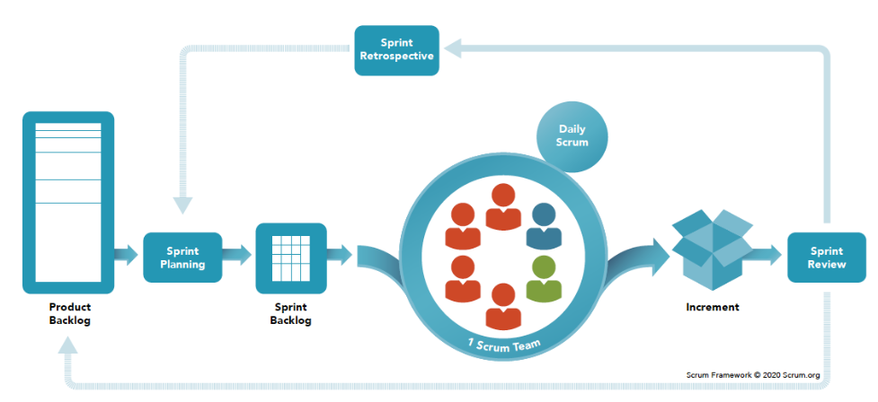

Figure 7: Scrum Methodology

**What is Scrum?**

Scrum is a widely used Agile software development methodology that prioritizes meeting and satisfying the needs of the customer by fostering a culture of open communication, shared accountability, and continuous improvement. The framework emphasizes iterative and incremental development, continuous improvement, and flexible responses to change. By breaking down projects into smaller subtasks called sprints, Scrum enables development teams to work towards delivering a potentially shippable product increment at the end of each sprint (nimble, 2022).

The Scrum process involves several roles, including a Product Owner, a Scrum Master, and a Development Team. The Product Owner sets the project's priorities, while the Scrum Master facilitates the Scrum process and helps the team overcome any obstacles. The Development Team works to deliver the product, and Scrum methodology also includes several events, such as daily stand-up meetings, sprint planning, sprint review, and sprint retrospective, to ensure effective communication, collaboration, and continuous improvement (Peek, 2023).

Scrum's adaptability, flexibility, and efficiency make it an ideal framework for managing and completing complex projects to provide value to customers throughout the project development process. The methodology promotes transparency, collaboration, and adaptability, which can help teams deliver high-quality products more efficiently (Peek, 2023). Overall, Scrum provides a robust framework that can help development teams meet the ever-changing needs of customers and stakeholders in a rapidly evolving technology landscape.

In the Scrum methodology, the first step is to create a product backlog, which outlines the project vision, aims and objectives. The project manager then compiles a list of all the necessary tasks, along with their priorities, based on the product backlog. The scrum team reviews this list and breaks down significant tasks into smaller, more manageable ones, creating a sprint backlog. At the sprint planning meeting, the team selects tasks from the product backlog to include in the sprint backlog, which helps to keep the team focused on specific tasks and prevent scope creep. The implementation phase focuses on carrying out production tasks, with daily meetings and burndown chart monitoring to track progress and address any issues. After each sprint, a review and retrospective phase takes place, where team members and customers provide feedback on accomplishments, flaws, and areas for improvement. This allows the team to evaluate and enhance their processes moving forward. Finally, the release phase involves preparing final deliverables for distribution to stakeholders, with a focus on ensuring the success of the project completion. Overall, the Scrum methodology promotes transparency, collaboration, and adaptability, allowing teams to deliver high-quality products more efficiently (Donato, 2023).

### 4.1.1 How to apply Scrum Methodology in the proposed project.

As the proposed project (Enhanced Intrusion Detection System (IDS)) is an individual project, few concepts from the standard Scrum methodology needs to be made a few modifications:

1. **Define the product backlog**: The first step starts by defining the product backlog, which is a prioritized list of tasks that need to be completed to deliver the final product. In the case of the Enhanced IDS project, the backlog could include tasks such as chosen data preprocessing method, feature extraction, model selection, model training, testing, and deployment.
2. **Set sprint goals**: Once the product backlog has been defined, the next step is to set sprint goals for each sprint. Since this is an individual project, it is recommended to set shorter sprint durations such as one or two weeks to ensure that the sprint goals are realistic and achievable within the sprint duration.
3. **Conduct regular stand-up meetings**: Hold regular stand-up meetings is essential to ensure that the project development is on track with the sprint goals. During the meetings, the developer of the proposed system should discuss what the individual has accomplished, what the individual plans to accomplish, and any roadblocks that the individual is facing.
4. **Adapt the sprint backlog**: As the individual progresses through the project, the individual may need to adjust the sprint backlog. This could include adding or removing tasks, reprioritizing tasks, or splitting tasks into smaller sub-tasks.
5. **Conduct sprint reviews and retrospectives**: At the end of each sprint, it is important to conduct a sprint review to demonstrate the work that the individual has completed and gather feedback. Conduct a sprint retrospective to reflect on what went well, what did not go well, and how to improve the process going forward.

### 4.1.2 Advantages of applying Scrum Methodology in the proposed project.

1. **Increased flexibility**: Scrum methodology allows for flexibility in adapting to changes, which is important in a project like a Enhanced IDS where data and requirements may change over time.
2. **Improved collaboration**: Scrum methodology emphasizes collaboration between project developer and supervisor, which can be beneficial in an individual project where the individual may need to seek consultant with the supervisor.
3. **Better risk management**: Scrum methodology encourages continuous feedback and testing, which can help to identify risks and issues early in the project, allowing the developer to make changes immediately.
4. **Increased transparency**: Scrum methodology promotes transparency by making the project progress and status visible to both project developer and the supervisor. This can help to increase accountability and ensure that everyone is on the same page.
5. **Speed up development progress**: By breaking the project into smaller, manageable stages and delivering increments at the end of each sprint, Scrum methodology can help to speed up the time to market for a Machine Learning IDS project.

### 4.1.3 Disadvantages of applying Scrum Methodology in the proposed project.

1. **Requires more time and effort**: Scrum methodology requires a significant amount of time and effort to implement, especially in an individual project where the individual may have to take on multiple roles.
2. **Requires active participation between the project developer and the supervisor**: Scrum methodology relies on the active participation of both project developer and the supervisor, and if one of the members are not committed or does not understand the process, it can negatively impact the project.
3. **Can be challenging to measure progress**: Since Scrum methodology focuses on delivering increments at the end of each sprint, it can be challenging to measure progress in terms of the overall project goals of an individual project like Enhanced IDS project.

## 4.2 Rapid Application Development (RAD) Methodology

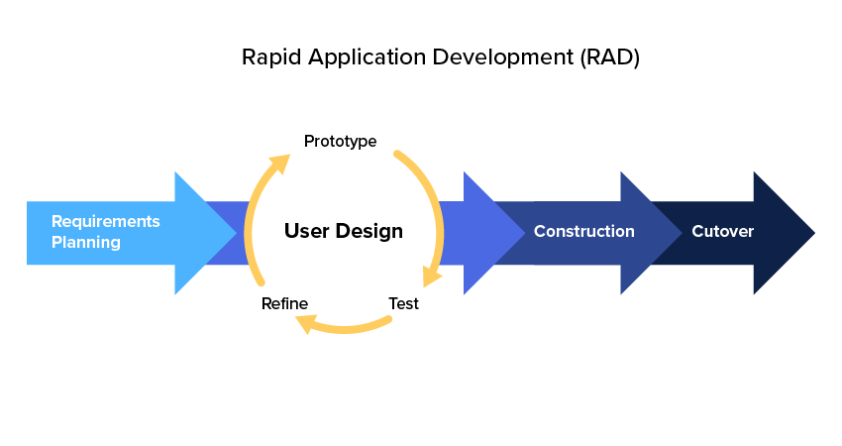

Figure 8: Rapid Application Development Methodology

**What is RAD?**

RAD methodology is a software development approach that is both iterative and incremental, with a focus on rapid prototyping and delivering functional software quickly. The RAD method was developed to address the shortcomings of more traditional, rigid approaches such as the Waterfall methodology, which can be slow to adapt to changing customer needs. Throughout each phase of the development process, the RAD method prioritizes flexibility and adaptability, allowing for adjustments to be made as needed (Chien, 2020).

User involvement is one of the key principles in RAD methodology, and end-users are actively engaged throughout the development process to ensure that the final product meets their needs. Rapid prototyping and iterative development are also key components of RAD methodology, with software components developed in small, iterative cycles that produce working prototypes for review and testing by end-users. Feedback from end-users is then incorporated into subsequent iterations, allowing for continuous improvement and refinement of the software (kissflow, n.d.).

Timeboxing is another important principle of RAD methodology, with development cycles typically lasting between two and six months (Taylor, 2022). This approach helps to keep the development process on track and ensures that a working prototype or version of the software is delivered within the specified timeframe. RAD methodology also emphasizes the reuse of components and modules to speed up development and reduce costs. By building on existing components and modules, developers can save time and effort and reduce the risk of errors and bugs (Chien, 2020).

Overall, RAD methodology is well-suited for projects with well-defined requirements and a limited scope, especially those that require a fast time-to-market. However, it may not be the best fit for larger or more complex projects that require extensive planning and documentation. The key advantages of RAD methodology include faster time-to-market, improved collaboration, reduced costs, increased flexibility, and higher quality software. Disadvantages of RAD methodology include a dependence on skilled personnel, limited scope, limited documentation, and limited testing (kissflow, n.d.).

### 4.2.1 How to apply RAD Methodology in the proposed project.

**Stage 1: Business Modelling**

The first stage of RAD is business modelling, where the developer gathers requirements from stakeholders and defines the scope of the project. In the case of the Enhanced IDS project, this stage may involve identifying the specific security threats that the system needs to detect and prevent, as well as defining the system's features and functionality.

**Stage 2: Data Modelling**

The second stage of RAD is data modelling, which involves identifying and defining the data structures and relationships needed to support the system. In the case of the Enhanced IDS project, this stage may involve identifying the different types of data sources needed to train the machine learning algorithms, as well as defining the data models and schema required to store and process this data.

**Stage 3: Process Modelling**

The third stage of RAD is process modelling, which involves identifying and defining the processes needed to support the system. In the case of the Enhanced IDS project, this stage may involve identifying the different steps involved in the detection and prevention of security threats, as well as defining the workflows and decision points required to support these processes.

**Stage 4: Application Generation**

The final stage of RAD is application generation, which involves developing the software code for the system in small, iterative cycles. In the case of the Enhanced IDS project, this stage may involve selecting the appropriate machine learning algorithms and data sources, as well as integrating these components into the system's architecture. During this stage, it's important to conduct regular testing and obtain feedback from end-users to ensure that the system meets their needs and expectations.

### 4.2.2 Advantages of applying RAD Methodology in the proposed project.

1. **Faster development**: RAD emphasizes rapid prototyping and iterative development, which can help to accelerate the development process and deliver working software more quickly.
2. **User involvement**: RAD places a strong emphasis on involving end-users throughout the development process to ensure that the final product meets their needs. This can help to increase user satisfaction and adoption of the system.
3. **Flexibility**: RAD is intended to be adaptable and flexible to accommodate changes and adjustments throughout the development process, which can help to ensure that the final product is better aligned with stakeholders' needs.
4. **Reduced risk**: By using RAD's iterative approach, developers can identify and fix issues and bugs early in the development process, reducing the risk of costly errors in the final product.

### 4.2.3 Disadvantages of applying RAD Methodology in the proposed project.

1. **Limited documentation**: RAD's focus on rapid development may result in less documentation, which can make it difficult to maintain and support the system in the long term.
2. **Incomplete features**: Since RAD emphasizes delivering working software quickly, some features or components may be incomplete or missing in early versions of the system.
3. **Limited scalability**: RAD's focus on rapid development may not be suitable for larger or more complex systems, which may require more planning and coordination.
4. **Limited control**: RAD's emphasis on user involvement and flexible development may result in less control over the project's direction and outcomes.

### 4.2.4 Comparison between Scrum and RAD Methodologies



Figure 9: Comparison between Scrum and RAD

## 4.3 Summary

After analyzing the project direction, the chosen software development methodology for the Enhanced Intrusion Detection System (IDS) will be the Rapid Application Development (RAD) methodology. This methodology was chosen due to its ability to accelerate the development process through rapid prototyping and iterative development cycles while maintaining high levels of end-user involvement and flexibility. The RAD methodology was chosen to address the limitations of more traditional software development methodologies such as the Waterfall model, which can be too rigid and inflexible to adapt to evolving requirements and customer needs. RAD's focus on user involvement throughout the development process ensures that the product aligns with the users' requirements. Each software component is developed in iterative cycles, and prototypes are reviewed and tested by the end-users to refine the software's design and functionality.

The RAD methodology aligns well with the project's goals of providing an IDS with the capability to detect and prevent security breaches in a timely manner while incorporating machine learning techniques. The critical aspect of RAD is timeboxing, which ensures that the development process remains on track and that the final product is delivered within the fixed timeframe. RAD methodology also emphasizes the reuse of components and modules to speed up development and reduce costs. By emphasizing a flexible and iterative approach to software development, the RAD methodology is capable of accommodating changes and adjustments throughout the development process and delivering a working product that meets the needs of stakeholders. The benefits of rapid prototyping, end-user involvement, and flexibility offered by the RAD methodology are expected to enable the development of a successful and effective Enhanced Intrusion Detection System.

# Chapter 5: Research Methods

## 5.1 Introduction

The research methodology for this Enhanced Intrusion Detection System (IDS) report will employ a combination of both quantitative and qualitative research methods. Qualitative research involves utilizing informal and participatory communication methods to gather insights into the "what" and "why" of people's thoughts and behaviors. This approach aims to delve into the fundamental causes and perceptions that shape their thinking. Various techniques such as in-depth interviews, focus groups, ethnographic research, content analysis, and case study research will be employed to generate descriptive data for the research findings. This is particularly valuable when the research problem is complex and requires a deeper understanding (Busetto et al., 2020).

Quantitative research, on the other hand, is a structured approach to collecting and analyzing numerical data to identify trends, correlations, and patterns. Leveraging statistical and mathematical methods, this approach enables predictions, hypothesis testing, and extrapolation to larger populations. This research method is focused on gathering and analyzing numerical data from sources such as surveys, questionnaires, and observations. By accurately collecting and analyzing data, it becomes possible to predict outcomes or consequences in a specific situation and uncover patterns or trends that inform decision-making. By integrating these two research methods, a more comprehensive evaluation of the research question is achieved by harnessing the strengths of one method to offset the limitations of the other. The primary data collection method will be interviews, which offer the flexibility to probe deeper and gather more precise data (University of Texas Arlington, 2023).

Given the researcher's current expertise in the field of the research issue, a judgement sampling technique will be employed to select appropriate participants (Office of the Comptroller of Currency, n.d.). Given the intricate nature of Intrusion Detection System and Machine Learning technology, the study will only include individuals with substantial experience and knowledge in these areas.

## 5.2 Questionnaire

A questionnaire serves as a research tool comprising a series of inquiries intended to extract data from individuals. Widely employed in research, it enables researchers to amass substantial data from a considerable number of participants within a relatively brief timeframe. Questionnaires can be dispensed through diverse formats, such as online platforms, paper-based documents, or face-to-face interviews, contingent on the research design (Bhandari, 2021).

Questionnaires find utility in both quantitative and qualitative research endeavors. In quantitative research, questionnaires are usually tailored to capture structured data, including demographic information or opinions on specific subjects. These data points are subsequently subjected to statistical analysis to derive conclusions. In qualitative research, questionnaires might encompass open-ended inquiries, granting participants the liberty to offer detailed and nuanced responses. These responses can then undergo analysis through a variety of qualitative methods. To analyze both quantitative and qualitative data, the most prevalent approaches encompass Statistics-by-theme and side-by-side comparison displays. In tandem, these presentations connect data to theoretical models or proposals (Stevens, 2022). Researchers adopting convergent, explanatory sequential, exploratory sequential, and intervention designs resort to joint displays. Scrutinizing the outcomes derived from these joint displays facilitates pinpointing instances of each design. Such examples spotlight the amalgamation of mixed methodologies, manifest integrated findings, and yield novel insights.

Questionnaires hold the advantage of being cost-effective and time-efficient for data collection from a broad spectrum of participants. Additionally, the standardized nature of questionnaires ensures that all participants are posed with the same set of questions, maintaining uniformity in the collected data. Nonetheless, a notable disadvantage pertains to the reliance on self-reporting, which can introduce biases or inaccuracies (Cleave, 2023). To counter this limitation, meticulous question design based on literature review studies is crucial. Utilizing multiple data sources to triangulate findings, distributing questionnaires to a suitable participant sample, and crafting a blend of closed-ended and open-ended questions all contribute to a comprehensive approach. Ensuring participant confidentiality and anonymity fosters an environment conducive to candid and accurate responses.

## 5.3 Questionnaire Design

The research methodology chosen for this study involves a combination of two methods: a questionnaire and interviews. The study's main focus is to explore and enhance an Intrusion Detection System to make it better at stopping cyber-attacks. The participants involved in this study will be students from Asia Pacific University, as well as individuals aged 18 and above who have some knowledge or interest in the IT field.

The questionnaire itself comprises of 21 questions, out of which four have been designed to allow for open-ended responses in Section 4. This approach aims to gather more detailed insights through participants' thoughts and experiences. The primary goal of these questions is to get a general idea about participants' familiarity with intrusion detection systems. On the other hand, the interview process will take a deeper dive, aiming to collect more elaborate and comprehensive information about participants' views and suggestions regarding the Enhanced Intrusion Detection System.

Furthermore, participants will be provided with a brief introduction to the Enhanced Intrusion Detection System (IDS). Their feedback and opinions will then be gathered to assess how well it works and how user-friendly it is. It's important to note that all the data collected through the questionnaire will be kept anonymous to prioritize and protect participants' privacy. This approach ensures that their personal information and responses remain confidential throughout the research process.



Figure 10: Enhanced Intrusion Detection System Questionnaire

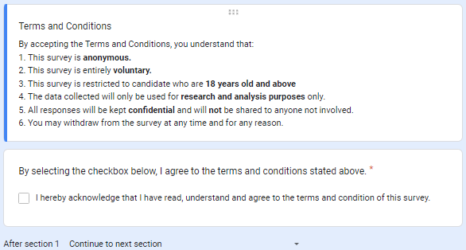

Figure 11: Terms and Conditions

**Section 1 of 4 Objective**

The purpose of this section is to offer a comprehensive background of the project and its proposed solution system, which will be implemented shortly. Through this section, the respondents' opinions will be collected to determine the system's potential benefits to the cyber security industry. Additionally, respondents will be required to acknowledge the terms and conditions, which state that the survey is anonymous, and only individuals who are 18 years and above are allowed to participate. It is essential to note that the data collected will only be used for research and analysis purposes, and responses will remain confidential and will not be shared with anyone not involved. Moreover, participants are free to withdraw from the survey at any time and for any reason they see fit.

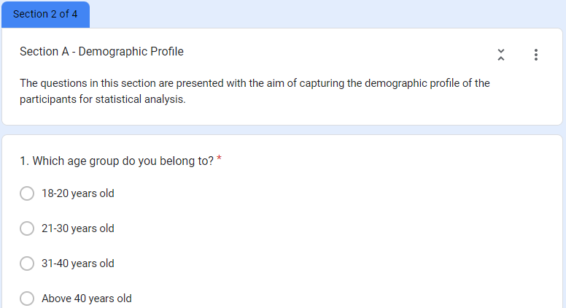

Figure 12: Demographic Profile – Age

Section 2 of 4 of the questionnaires focuses on gathering demographic information from the participants, such as age, employment status, and field of study. This information is essential in understanding the perspective of the respondents and in evaluating the relevance of the Enhanced IDS project to different demographics.

**Objectives**  
The age group of participants is an important demographic variable as different age group may have level of knowledge and experience. Understanding the different age groups' perspectives can help in identifying any knowledge gaps or potential knowledge biases that need to be addressed in the Enhanced IDS project. Additionally, it can assist in tailoring the project features to meet the specific needs and requirements of different age groups.



Figure 13: Demographic Profile – Employment Status

**Objectives**

The question regarding the participant's current employment status is crucial in obtaining information from different experiences and perspectives among the respondents. Different employment statuses may provide unique insights and suggestions on the Enhanced IDS project, depending on their industry exposure and working experience.



Figure 14: Demographic Profile – Field of Study

**Objectives**

The field of study of the participants can provide valuable information from their educational background and knowledge in related fields. This information can help in understanding the perspective of the participants and evaluating the relevance of the project to different fields of study. It can also be used to identify any patterns or trends in responses based on the field of study and to tailor the project's features to meet the specific needs of different fields.

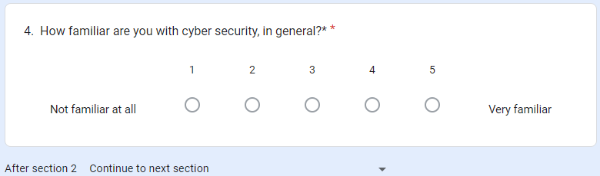

Figure 15: Demographic Profile – Level of Cyber Security knowledge in general

**Objectives**

Asking about the participant's familiarity with cybersecurity is to identify their level of cybersecurity knowledge and expertise. This information is crucial in determining any knowledge gaps or areas where more education is necessary. Additionally, the responses can be analyzed based on age group, employment status, and field of study to evaluate if there are any significant correlations between familiarity with cybersecurity and these demographics. These correlations can help in customizing the Enhanced IDS project features and developing education programs that cater to the different levels of cybersecurity knowledge and expertise based on these demographics.

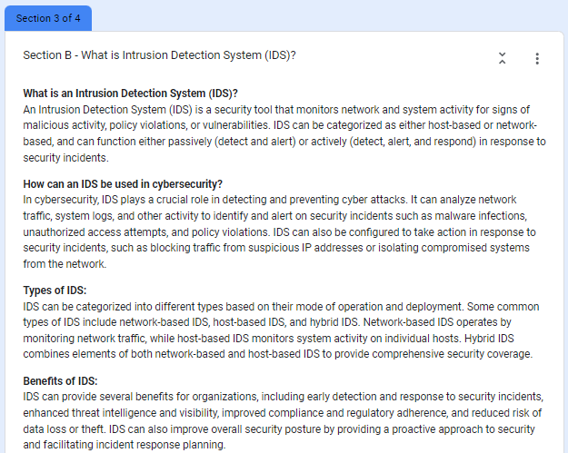

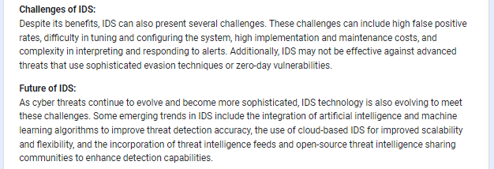

Figure 16: What is Intrusion Detection System

Sections 3 of 4 of the questionnaires aim to validate the hypotheses proposed in the literature review by asking general questions related to existing IDS technology. These questions seek to understand the participant's perspective and gather feedback to improve the Enhanced IDS project. The participants are also provided with information from the literature review conducted by the researcher to ensure its accuracy and gain insights from the participants.



Figure 17: (IDS General Question) Question 1

**Objective**

This question aims to assess the participant's prior knowledge of IDS technology, which can provide insight into their cybersecurity expertise and awareness.

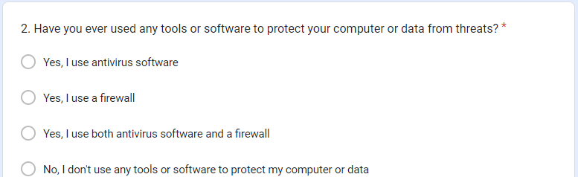

Figure 18: (IDS General Question) Question 2

**Objective**

This question aims to gather information on the participant's experience with cybersecurity tools and software, which can help in understanding their cybersecurity practices.

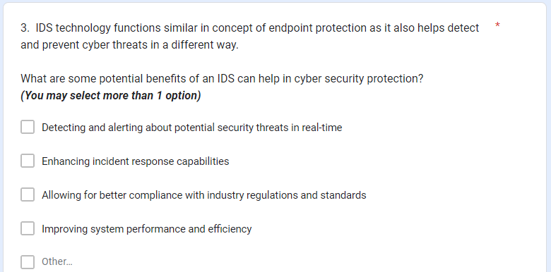

Figure 19: (IDS General Question) Question 3

**Objective**

This question asks the participant to identify potential benefits of using IDS technology in cybersecurity protection, which can help in evaluating the effectiveness of IDS technology from the perspective of the participant.

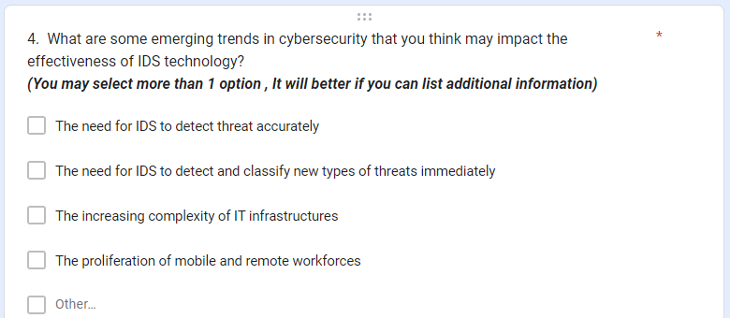

Figure 20: (IDS General Question) Question 4

**Objective**

This question asks the participant to identify emerging trends in cybersecurity that may impact the effectiveness of IDS technology, which can help in identifying areas for improvement and development of IDS technology.

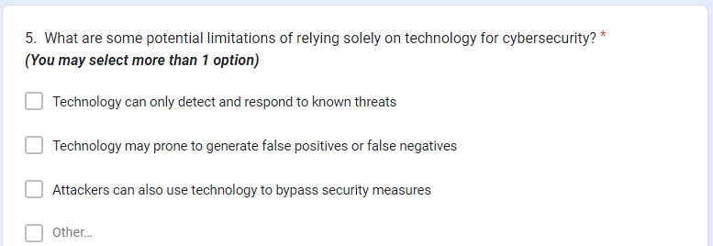

Figure 21: (IDS General Question) Question 5

**Objective**

This question asks the participant to identify potential limitations of relying solely on technology for cybersecurity, which can help in understanding the participant's perspective on the importance of improving cyber security technology.

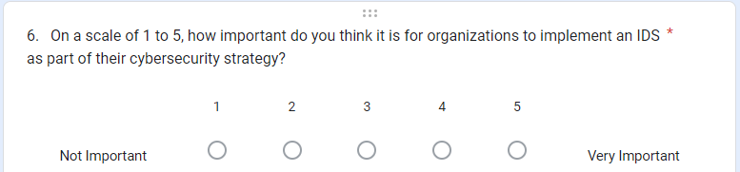

Figure 22: (IDS General Question) Question 6

**Objective**

This question aims to assess the participant's perception of the importance of implementing IDS technology as part of the cybersecurity strategy in organizations.

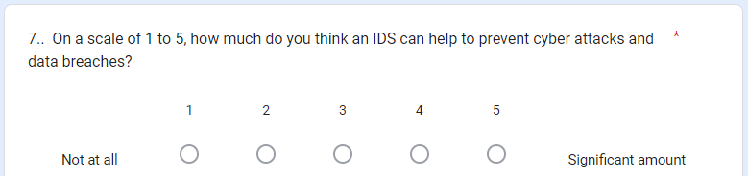

Figure 23: (IDS General Question) Question 7

**Objective**

This question aims to gather the participant's perception of the effectiveness of IDS technology in preventing cyber-attacks and data breaches.

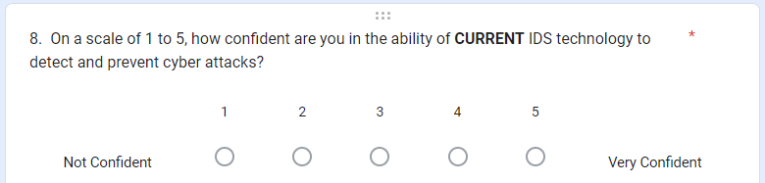

Figure 24: (IDS General Question) Question 8

**Objective**

This question aims to assess the participant's confidence in the ability of current IDS technology to detect and prevent cyber-attacks.



Figure 25: (IDS General Question) Question 9

**Objective**

This question aims to gather the participant's opinion on whether IDS technology needs improvement, which can help in identifying areas for further development.

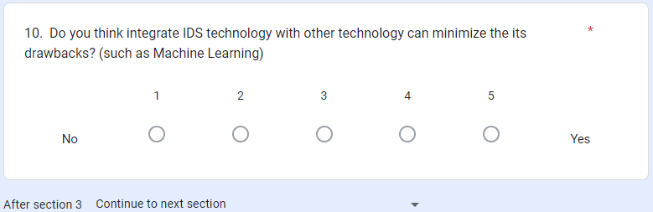

Figure 26: (IDS General Question) Question 10

**Objective**

This question asks the participant to identify whether integrating IDS technology with other technologies, such as Machine Learning, can help minimize its drawbacks.

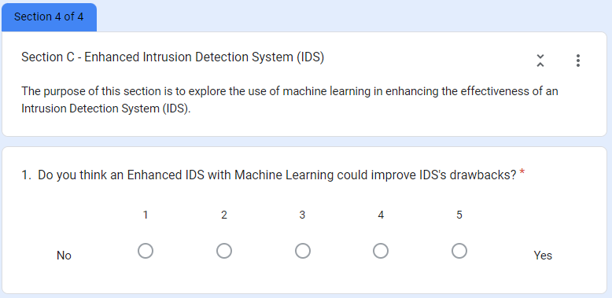

Figure 27: (Proposed Project Title) Question 1

Section 4 of 4 main objective is to propose the project title to the participant to explore the use of machine learning in enhancing the effectiveness of an Intrusion Detection System (IDS).

**Objective**

The question asks the participant's opinion on whether an Enhanced IDS with Machine Learning could improve IDS's drawbacks. The participants are asked to rate their opinion on a scale of 1 to 5.



Figure 28: (Proposed Project Title) Question 2

**Objective**

This open-ended question asks the participant to express their provides whether an Enhanced IDS with Machine Learning is more effective than a traditional IDS, and to provide reasons to support their answer.

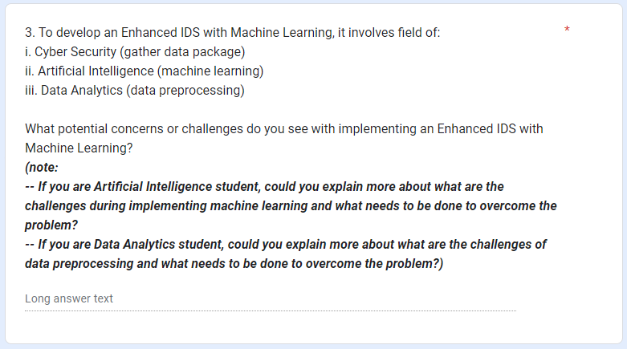

Figure 29: (Proposed Project Title) Question 3

**Objective**

This question identifies the three fields involved in developing an Enhanced IDS with Machine Learning: Cyber Security, Artificial Intelligence, and Data Analytics. The participant is asked to discuss any potential concerns or challenges they see with implementing such a system. If the participant is a student of Artificial Intelligence or Data Analytics, they are encouraged to provide more detailed insights into the specific challenges they see, and the steps needed to overcome them.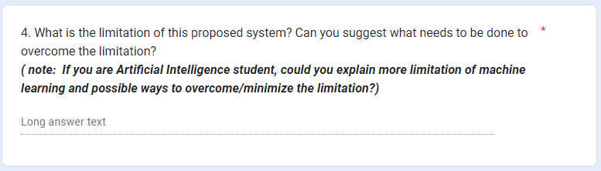

Figure 30: (Proposed Project Title) Question 4

**Objective**

The question asks the participant to identify the limitations of the proposed Enhanced IDS with Machine Learning and suggest ways to overcome or minimize these limitations. If the participant is a student of Artificial Intelligence, they are encouraged to provide more detailed insights into the limitations of machine learning and possible ways to overcome or minimize them.

Figure 31: (Proposed Project Title) Question 5

**Objective**

This open-ended question asks the participant to suggest any additional features they would like to see in an Enhanced IDS with Machine Learning.

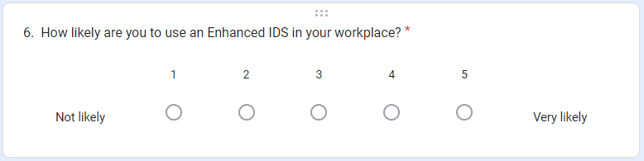

Figure 32: (Proposed Project Title) Question 6

**Objective**

This question asks the participant to rate their likelihood of using an Enhanced IDS in their workplace on a scale of 1 to 5.

## 5.4 Interview

An interview involves gathering information through a series of questions posed to an individual or a group. This method finds frequent application within research settings. To conduct formal interview, the researcher must possess a clear comprehension of the project's aims and objectives. Additionally, selecting appropriate participants is crucial, ensuring their expertise and experience align with the requirements to provide meaningful insights.

One notable advantage of utilizing interviews for research and development in the context of an Enhanced Intrusion Detection System pertains to the potential for participants to furnish in-depth opinions and insights. Unlike questionnaires, where respondents might skip or offer brief answers, interviews foster personalized and interactive engagement. This format potentially encourages participants to share more information (George, 2022). This attribute is particularly advantageous in the development of an IDS, as it facilitates identifying potential vulnerabilities and opportunities for improvement in a comprehensive manner.

However, conducting interviews in the context of researching and developing an Enhanced Intrusion Detection System also brings certain drawbacks. Not all individuals may be willing or capable of participating in interviews. Concerns about privacy or security might dissuade some individuals, while others might lack the requisite knowledge or expertise to provide valuable input. Furthermore, incomplete, or inaccurate responses from some individuals could limit the usefulness of collected data (Prasanna, 2022). To address this concern, participant selection for this study is confined to Degree students from Asia Pacific University, along with individuals aged 18 and above possessing expertise or interest in the Intrusion Detection System and Machine Learning field. This targeted approach aims to ensure that the interview process yields relevant and valuable insights.

*Figure 33: Interview Questions*

# Chapter 6: Requirements Validation

## 6.1 Introduction

In this chapter, the researcher begins reviewing and validating the respondents' requirements, preferences, and viewpoint by collecting data through the questionnaires. The collected data is reviewed and evaluated to draw conclusions on each inquiry. A total of 30 individuals participated in the survey, which was conducted using Google Forms. The outcomes of the inquiries are represented through pie and bar charts generated by Google Forms.

The questionnaire method was chosen as it allowed for a large amount of data to be collected from a significant number of participants in a relatively short period of time. However, this method can prone to few limitations, such as the potential for inaccurate or incomplete information from the respondents and the limited range of responses that can be obtained through pre-determined questions. Despite these limitations, the questionnaire method was appropriate for this research project as it provided a time effective and efficient way to collect data.

## 6.2 Analysis of Data

|  |  |
| --- | --- |
| A blue bar with white text  Description automatically generated  Figure 34: Terms and Condition Response | |
| **Description:** | First and foremost, the researcher has provided a disclaimer to caution participants that their involvement is voluntary, ensured data remain anonymous. Furthermore, the researcher has provided his contact information if participant have any issues or queries involving the investigation, and participants had agreed to the terms and conditions of the survey. |

|  |  |
| --- | --- |
|   *Figure 35: Age Group Response* | |
| **Description:** | According to the figure above, most of the participant are between 21-30 years old are 73.3% (22 response) while 18-20 years old and 31-40 years old are 10% (3 response for each = 6 response). Finally, above 40 years old are 6.7% (2 response). |

|  |  |
| --- | --- |
| A pie chart with a number of percentages  Description automatically generated  Figure 36 Employment Status Response | |
| **Description:** | According to the figure above, majority of the participants are belonging to Student/Intern category with 66.7% (20 responses) while the remaining participants are belonging to Employed category with 33.3% (10 response). |

|  |  |
| --- | --- |
| A colorful pie chart with numbers  Description automatically generated  Figure 37 Field of Study Response | |
| **Description:** | According to the figure above, most of the participants belong to Cyber Security category with 26.7% (8 responses). The second most participants belong to Intelligent System and Computer Science category with 20% (6 responses from each = 12 responses). The third most participants belong to Information Technology and Software Engineering category (3 responses from each = 6 response).  The remaining category are belonging to other category such as Master in Cyber Security, Master's degree in Communication and Networking and so forth. |

|  |  |
| --- | --- |
| A graph with blue squares  Description automatically generated  Figure 38 Level of Cyber Security Knowledge in general Response | |
| **Description:** | According to the figure above, most of the participants have solid level of knowledge on cyber security (in general). It is reasonable to assume that the responses provided by these individuals would be informative and valuable. |

|  |  |
| --- | --- |
| A screenshot of a computer screen  Description automatically generated  Figure 39 (IDS General Question) Question 1 Response | |
| **Description:** | The figure provided above suggests that most of the participants have some familiarity with Intrusion Detection System (IDS). As such, it may be worth to review participant’s existing knowledge and recommendations. |

|  |  |
| --- | --- |
| A pie chart with text  Description automatically generated  Figure 40 (IDS General Question) Question 2 Response | |
| **Description:** | The figure above indicates that most of the participants with a total of 60% (18 respondents) use both antivirus software and a firewall. Additionally, 30% (9 respondents) of the participants reported using only antivirus software. These findings may suggest that it would be easier to explain to the participants how traditional Intrusion Detection System (IDS) operates, as it shares similarities with antivirus software. |

|  |  |
| --- | --- |
| A graph with blue bars  Description automatically generated with medium confidence  Figure 41 (IDS General Question) Question 3 Response | |
| **Description:** | Based on the responses, 30 out of 30 participants agreed that detecting and alerting about potential security threats in real-time is an important benefit of using an intrusion detection system (IDS). Additionally, 22 participants agreed that an IDS enhances incident response capabilities, while 14 participants agreed that it allows for better compliance with industry regulations and standards and improves system performance and efficiency. This highlights the significance of having an IDS in place for cybersecurity. |

|  |  |
| --- | --- |
| A graph with blue bars  Description automatically generated with medium confidence  Figure 42 (IDS General Question) Question 4 Response | |
| **Description:** | According to the figure above, the most response was "The need for IDS to detect threat accurately," with 29 participants selecting this option. The second most popular option was "The need for IDS to detect and classify new types of threats immediately," with 25 participants selecting this option. The remaining three options were less popular, with "The increasing complexity of IT infrastructures" and "The proliferation of mobile and remote workforces" being selected by 18 and 13 participants, respectively. The extra option about the speed of IDS technology to detect and respond quickly was selected by only one participant. This highlights that the accuracy of IDS technology are important in the ever-evolving landscape of cybersecurity threats. |

|  |  |
| --- | --- |
| Figure 43 (IDS General Question) Question 5 Response | |
| **Description:** | According to the figure above, the most selected potential limitation is that technology can only detect and respond to known threats, with 26 respondents selecting this option. This is followed closely by the potential for technology to generate false positives or false negatives, with 23 respondents selecting this option. Another significant limitation identified is that attackers can also use technology to bypass security measures, with 22 respondents selecting this option. Additionally, one respondent has added on a new suggestion which is the high false positive or false negative rates of traditional IDSs. This highlights the importance of not relying solely on technology for cybersecurity and it is important considering other factors such as human expertise and risk management strategies. |

|  |  |
| --- | --- |
| A graph with blue squares and black text  Description automatically generated  Figure 44 (IDS General Question) Question 6 Response | |
| **Description:** | Based on the responses from 30 participants, 19 of them rated the importance of implementing an IDS as part of their cybersecurity strategy as 5 on a scale of 1 to 5, while 11 participants rated it as 4.  This highlights that most the of respondents believe that implementing an IDS as part of a cybersecurity strategy is very important (rated 4 or 5 on a scale of 1 to 5). |

|  |  |
| --- | --- |
| A graph with blue squares  Description automatically generated  Figure 45 (IDS General Question) Question 7 Response | |
| **Description:** | Based on the figure above, out of the 30 participants, 10 chose 5, indicating that they strongly believe an IDS can help minimize cyber-attacks and data breaches, while 14 chose 4, indicating a high level of confidence in the effectiveness of IDS. Only 1 participant chose 2, suggesting low confidence in the effectiveness of IDS, while 5 participants chose 3, indicating a moderate level of confidence. Overall, most participants believe that IDS can play a significant role in preventing cyber-attacks and data breaches. |

|  |  |
| --- | --- |
| A graph with blue bars  Description automatically generated with medium confidence  Figure 46 (IDS General Question) Question 8 Response | |
| **Description:** | Based on the figure above, there is a mixed level of confidence in the ability of current IDS technology to detect and prevent cyber-attacks. While many respondents chose either 4 or 5 on the scale, there were also a significant number of respondents who chose 3 and a few who chose 2. This indicates that there is a need to improve the technology to increase confidence in its effectiveness. |

|  |  |
| --- | --- |
| A graph with blue and white bars  Description automatically generated  Figure 47 (IDS General Question) Question 9 Response | |
| **Description:** | In the previous question, the participants were asked to rate their confidence in the ability of current IDS technology to detect and prevent cyber-attacks on a scale of 1 to 5. While some respondents had high confidence (4 or 5), others had mixed responses, indicating room for improvement.  In this question, the researcher wanted to know whether IDS technology needs improvement, most respondents (20 out of 30) indicated a strong need for improvement (rating of 5), with some also selecting 4. Overall, these responses suggest that while IDS technology is important and effective in preventing cyber-attacks and data breaches, there is also recognition that further improvements are needed to enhance its capabilities. |

|  |  |
| --- | --- |
| A graph with blue bars and text  Description automatically generated  Figure 48 (IDS General Question) Question 10 Response | |
| **Description:** | Based on the responses of the 30 participants, a majority (24 out of 30) believe that integrating IDS technology with other technologies, such as machine learning, can help to minimize its drawbacks. Specifically, 9 participants chose a rating of 5, indicating a high level of agreement, while 15 participants chose a rating of 4, suggesting a moderate level of agreement. Only 1 participant chose a rating of 2, indicating disagreement with this statement. These responses suggest that there is a belief among participants that combining IDS technology with other advanced technologies can help to improve its effectiveness in detecting and preventing cyber-attacks. |

|  |  |
| --- | --- |
| Figure 49 (Proposed Project Title) Question 1 Response | |
| **Description:** | According to the figure above, most respondents (24 out of 30) indicated that they believe an enhanced IDS with machine learning could improve the drawbacks of IDS technology. Specifically, 12 respondents rated their agreement as 5 and another 12 respondents rated their agreement as 4. This suggests that there is a chance that integrating machine learning with IDS technology could enhance its capabilities and improve its ability to detect and prevent cyber-attacks. However, there were also some respondents who were less certain, with 5 choosing a rating of 3 and 1 choosing a rating of 2. |

|  |  |
| --- | --- |
| Figure 50 (Proposed Project Title) Question 2 Response | |
| **Description:** | According to the figure above, most responses received indicated that an Enhanced IDS with Machine Learning would be more effective. Many respondents cited the ability of machine learning to detect and identify potential threats more accurately and quickly than traditional IDS. Others pointed out that machine learning can reduce false positives and negatives by accurately identifying anomalies in network traffic. Additionally, respondents noted that an Enhanced IDS with Machine Learning can continuously learn and improve over time, providing better protection against newly emerging threats. Overall, the responses suggest that there is a belief that integrating machine learning into IDS technology can significantly enhance its effectiveness. |

|  |  |
| --- | --- |
| Figure 51 (Proposed Project Title) Question 3 Response | |
| **Description:** | Developing an Enhanced IDS with Machine Learning requires expertise in several fields, including Cyber Security, Artificial Intelligence, and Data Analytics. The researcher asked about potential concerns or challenges with implementing such a system, respondents expressed various concerns. These included the high cost and time consumption involved, the need for more practical testing to avoid the system being used in reverse, and the challenge of collecting and implementing a large amount of relevant data into the AI model. Some also expressed concerns about potential security vulnerabilities if the system were targeted by attackers. |

|  |  |
| --- | --- |
| Figure 52 (Proposed Project Title) Question 4 | |
| **Description:** | The question asked about the limitations of a proposed Enhanced IDS system with machine learning and what can be done to overcome those limitations. Out of 30 responses, some mentioned concerns about compatibility with other safety measures, potential mistakes in detecting security threats, and the significant time and effort required for implementation. However, some respondents found the proposed system interesting and couldn't think of any limitations. One common suggestion to overcome limitations was to ensure reliable data is used to train the machine learning algorithm and to regularly monitor and update the system to reflect changes in attack methods and newly emerging threats. |

|  |  |
| --- | --- |
| A screenshot of a computer  Description automatically generated  Figure 53 (Proposed Project Title) Question 5 Response | |
| **Description:** | Based on the figure above, the responses to the question could vary depending on the individual's experience and knowledge. Some responses may suggest make it user friendly with additional features, some no suggestions and so forth. |

|  |  |
| --- | --- |
| A graph with blue rectangular bars  Description automatically generated with medium confidence  Figure 54 (Proposed Project Tile) Question 6 Response | |
| **Description:** | Based on the responses provided, most of the respondents (24 out of 30) seem to be open to the idea of using an Enhanced IDS in their workplace, with 13 of them indicating a likelihood of 5 out of 5 to use it, and 11 indicating a likelihood of 4 out of 5 to use it. However, there were also 5 respondents who chose a likelihood of 3 out of 5 to use it, which could suggest some hesitation or uncertainty about the technology. Only 1 respondent chose a likelihood of 2 out of 5, indicating a lower interest in using an Enhanced IDS in their workplace. Overall, most respondents seem to be positive about the potential benefits of an Enhanced IDS, but there are still some who may have concerns or reservations. |







## 6.3 Conclusion

After conducting a comprehensive survey that involved the distribution of a set of questionnaires to 30 participants, the survey generally received positive response and it has been determined that the proposed Enhanced IDS system can be effectively implemented to enhance the security of sensitive data in various industries. Based on the feedback received from the participants, it was revealed that most of them agreed that the proposed system has the potential to significantly improve the security measures for sensitive data in their respective industries. However, despite the positive feedback, the participants also highlighted some potential challenges that may arise during the implementation of the Enhanced IDS system and more than half of the participates are willing to corporate by providing recommendations and suggestions.

As a result, it is necessary to conduct further research and gain a better understanding of the potential challenges that may arise to ensure that the Enhanced IDS system is well-built and capable of meeting the needs of the industry it is being implemented in.

# Chapter 7: System Architecture

## 7.1 Introduction

In this chapter, the developer concentrates on the architectural design of the innovative Enhanced Intrusion Detection System (IDS). This system represents the culmination of extensive work within the Final Year Project, where a machine learning approach utilizing various algorithms has been harnessed. The primary objective behind developing this system is to establish a comprehensive taxonomy that encompasses interconnected intrusion detection systems and supervised machine learning algorithms. The developer recognizes the pivotal role played by dataset selection in shaping the model's construction, ensuring its alignment with the specific demands of intrusion detection. Within the realm of cybersecurity, the Intrusion Detection System (IDS) stands as a critical tool for detecting and identifying intrusion attacks, particularly with the escalating volume of data generation. The significance of feature selection is acknowledged to enhance IDS performance, with a keen eye on the dataset's structure, which directly impacts architectural efficiency. Additionally, the developer proactively addresses data imbalance concerns through the implementation of strategic sampling approaches. Hence, the proposed system emerges as a comprehensive initiative dedicated to reinforcing cybersecurity through meticulous dataset selection, feature optimization, and effective intrusion detection.

Below is an overview outlining the essential elements and constituents that compose this system:

1. **Data Management**: Within the Data Management component, a set of vital features, including "Dataset Selection," "Data Cleaning," and "Data Visualization," work cohesively. This holistic approach centers on the seamless handling and meticulous preparation of data to facilitate effective intrusion detection. "Dataset Selection" ensures the choice of relevant and representative datasets, "Data Cleaning" addresses data quality to enhance analysis accuracy, and "Data Visualization" provides insightful visual representations for improved data comprehension. Together, these features create a solid foundation for robust intrusion detection by optimizing the data utilized in the system.
2. **Classification of Intrusion Attacks**: At the core of the Enhanced Intrusion Detection System (IDS) lies the Classification of Intrusion Attacks element. This foundational component leverages a diverse array of machine learning algorithms to proficiently classify and identify distinct types of intrusion attacks. Serving as the IDS's backbone, it empowers the system to not only recognize but also respond proactively to evolving threats. By implement sophisticated machine learning algorithms, this element equips the IDS with the intelligence required to safeguard against a multitude of intrusion scenarios, ensuring comprehensive threat detection.
3. **Simulation Detection**: The "Simulation Detection" feature adds a crucial dimension to the Enhanced IDS. It offers a controlled testing environment, enabling the evaluation of the IDS's detection capabilities under various simulated attack scenarios. This invaluable tool allows for the assessment of the system's accuracy and responsiveness, facilitating fine-tuning and optimization for real-world intrusion detection scenarios. "Simulation Detection" serves as a critical bridge between theoretical model development and practical deployment, ensuring that the IDS is finely calibrated to address genuine threats effectively.

## 7.2 Abstract Architecture

### 7.2.1 Use Case Diagram

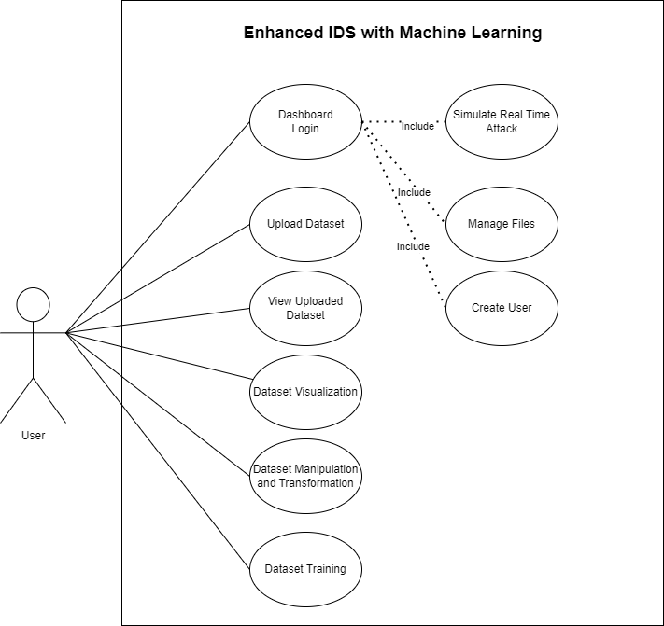

Figure 55: Activity Diagram

### 7.2.2 Use Case Specification

|  |  |
| --- | --- |
| Function Name | Upload Dataset |
| Description | Require user to upload at least one or more csv files into the system |
| Actor | User |
| Assumption | Users have access to the system and upload valid data file(s) |
| Default Workflow | The actor is required to select one or more csv files from their local storage. Once the actor selects the files, the system proceeds to validate the files' format and content to ensure it matches the require file format (csv). If the validation is successful, the system stores the dataset into the system storage folder (upload). The actor is then notifying that upload datasets successful, which become readily available for exploration, analysis, and transformation. |

|  |  |
| --- | --- |
| Function Name | View Uploaded Dataset |
| Description | Provides insights into dataset characteristics, including dimensions, column names, and data types. Users can preview the first 10 rows to verify data accuracy. |
| Actor | User |
| Assumption | Users have successfully uploaded datasets into the system. |
| Default Workflow | The actors are presented with an informative overview of the datasets they have previously uploaded into the system. The system retrieves and displays essential details, including dataset dimensions, column names and preview the first 10 rows of the dataset, facilitating a straightforward data assessment. |

|  |  |
| --- | --- |
| Function Name | Dataset Cleaning |
| Description | Require user to select at least one or more uploaded csv files to conduct dataset cleaning to remove unwanted features |
| Actor | User |
| Assumption | Users have successfully uploaded datasets with matching column names into the system. |
| Default Workflow | The actor, assumed to have successfully uploaded datasets with matching column names, initiates the process by selecting one or more CSV files from the system. Subsequently, the system combines the chosen datasets, computes statistics such as missing and infinity values, and identifies duplicate rows. The data cleaning procedure ensues, involving the removal of rows with missing or infinity values alongside with duplicate rows and the elimination of socket features columns and columns that displaying zero correlations to enhance dataset relevance. The user is then prompted to designate a name for the cleaned dataset, which is subsequently stored in the system's storage files under the provided name, facilitating efficient data management and accessibility. |

|  |  |
| --- | --- |
| Function Name | Dataset Visualization |
| Description | Allows users to visualize both the uploaded and cleaned datasets to assess label quantity disparities |
| Actor | User |
| Assumption | Users have successfully uploaded datasets (to visualize uploaded datasets) and perform dataset cleaning (to visualize cleaned datasets) |
| Default Workflow | Upon selecting the "Dataset Visualization" feature, the system renders visual representations of the uploaded and cleaned datasets. Users can identify any imbalances in label quantities and make informed decisions for the next step |

|  |  |
| --- | --- |
| Function Name | Dataset Manipulation |
| Description | Requires user to choose one out of three distinct manipulation options: "Balanced Dataset," "Combine Label," and "Drop Label." These options address varying label quantity disparities and inaccuracies in attack categorization during dataset training. |
| Actor | User |
| Assumption | User has successfully performed dataset cleaning |
| Default Workflow | The actor is presented with the three options: "Balanced Dataset," "Combine Label," and "Drop Label." They can choose the most suitable option based on their dataset's characteristics. "Balanced Dataset" implements Random Oversampling, "Drop Label" trims significant variations, and "Combine Label" addresses misclassification issues. |

|  |  |
| --- | --- |
| Function Name | Dataset Training |
| Description | Empowers users to create and train machine learning models using the cleaned datasets. Users can choose from a diverse range of algorithms |
| Actor | User |
| Assumption | User has successfully performed dataset cleaning and data manipulation (optional) |
| Default Workflow | Upon selecting "Dataset Training," the actor accesses an environment for model creation and training by selecting cleaned dataset and machine learning algorithm. This feature transforms the system into a versatile machine learning hub, facilitating various analytical tasks with precision and efficiency. |

|  |  |
| --- | --- |
| Function Name | Dashboard Login |
| Description | Involves the process of securely authenticating users to access the system's dashboard, ensuring that only authorized individuals can utilize the system's features. |
| Actor | User |
| Assumption | Users have registered accounts and credentials to the dashboard features. |
| Default Workflow | The actors are prompted to provide their username and password. The system then verifies the user's credentials against the stored account information. If the provided credentials are valid, the system grants the user access to the dashboard. However, if the credentials are invalid, the system displays an error message and returns the actors to the login page. |

|  |  |
| --- | --- |
| Function Name | Simulate Real Time Attack (Dashboard Simulator) |
| Description | A risk-free environment to explore and simulate model behavior, test various scenarios, and evaluate performance metrics. |
| Actor | User |
| Assumption | User has performed dataset cleaning progress, dataset training progress and download trained model |
| Default Workflow | The actors are required to upload clean csv files (with the same column names that are used to train the model). The system validates the file, loads it into a Data Frame, and conducts real-time attack simulation using a pre-trained model. The results are displayed for user review, and any errors are promptly addressed with corresponding error messages. |

|  |  |
| --- | --- |
| Function Name | Create User |
| Description | Allows individuals to create accounts with unique usernames and secure passwords for dashboard login. |
| Actor | User |
| Assumption | Users have logged in successfully to the system's dashboard. |
| Default Workflow | The actor enters the new user's details, including a unique username and a secure password. The system validates the provided information, and if it's valid, the system proceeds to create the new user account. The system then notifies the user of their account creation. |

|  |  |
| --- | --- |
| Function Name | Manage Files |
| Description | Empowers users to download and remove files from their workspace within the system. |
| Actor | User |
| Assumption | Users have logged in successfully to the system's dashboard. |
| Default Workflow | The actors are presented with their file workspace, which displays a list of uploaded and cleaned files and options to download and remove files from their workspace within the system. The user can select files for download or removal through check box follow by select the corresponding option. |

### 7.2.3 Activity Diagram

#### 7.2.3.1 Upload Dataset Activity Diagram

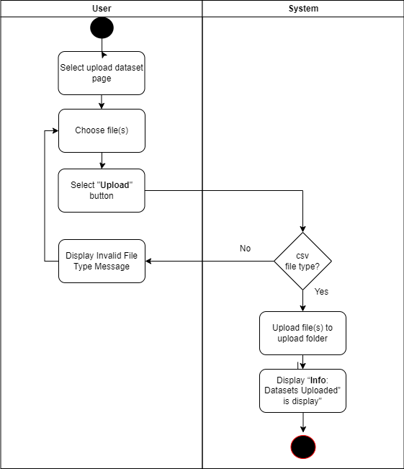

Figure 56: Upload Dataset Activity Diagram

#### 7.2.3.2 View Uploaded Dataset Activity Diagram

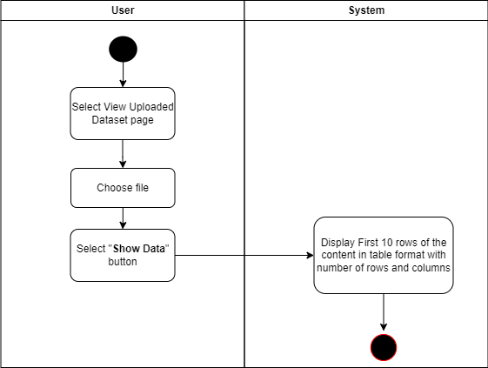

Figure 57: View Uploaded Dataset Activity Diagram

#### 7.2.3.3 Dataset Cleaning Activity Diagram

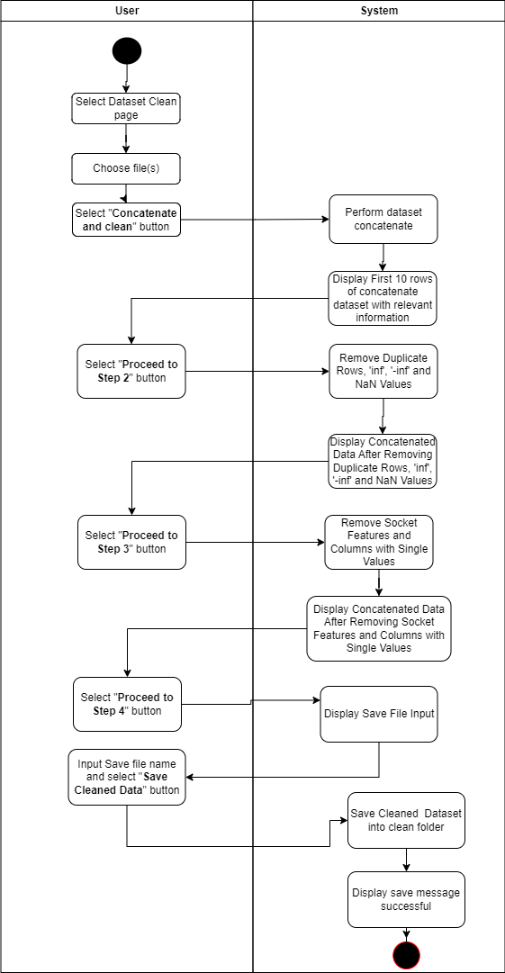

Figure 58: Dataset Cleaning Activity Diagram

#### 7.2.3.4 Dataset Visualization Activity Diagram

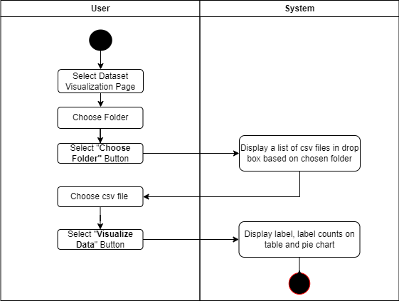

Figure 59: Dataset Visualization Activity Diagram

#### 7.2.3.5 Dataset Manipulation Activity Diagram (Balanced Dataset)

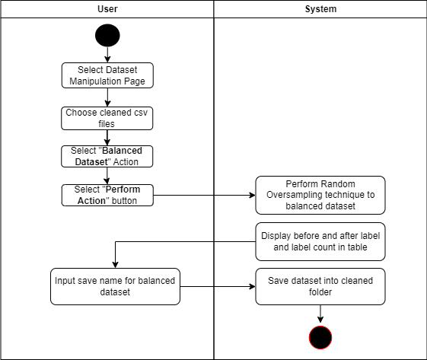

Figure 60: Dataset Manipulation Activity Diagram (Balanced Dataset)

#### 7.2.3.6 Dataset Manipulation Activity Diagram (Combined Label)

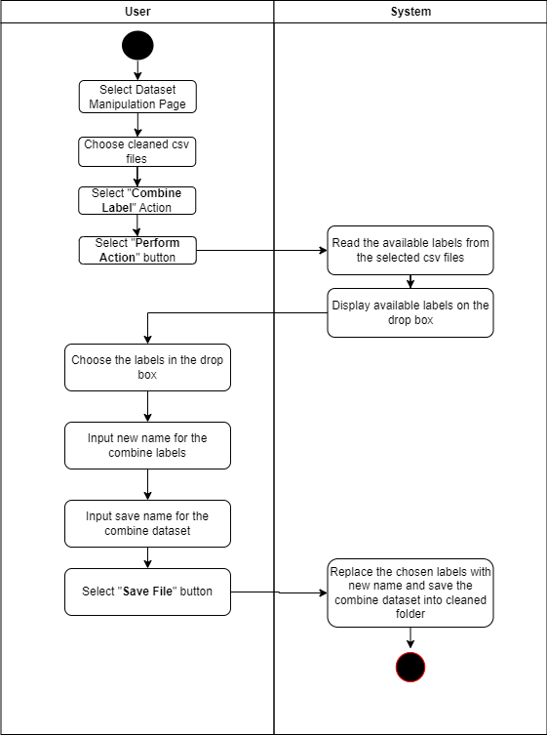

Figure 61: Dataset Manipulation Activity Diagram (Combined Label)

#### 7.2.3.7 Dataset Manipulation Activity Diagram (Drop Label)

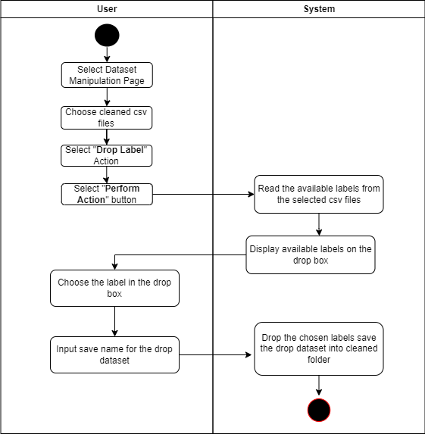

Figure 62: Dataset Manipulation Activity Diagram (Drop Label)

#### 7.2.3.8 Dataset Training Activity Diagram

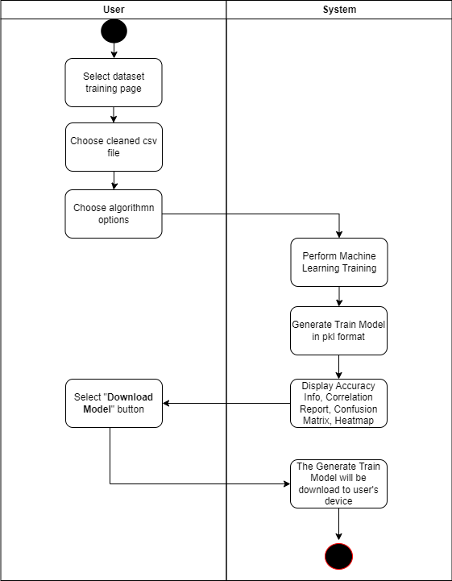

Figure 63: Dataset Training Activity Diagram

#### 7.2.3.9 Dashboard Login Activity Diagram

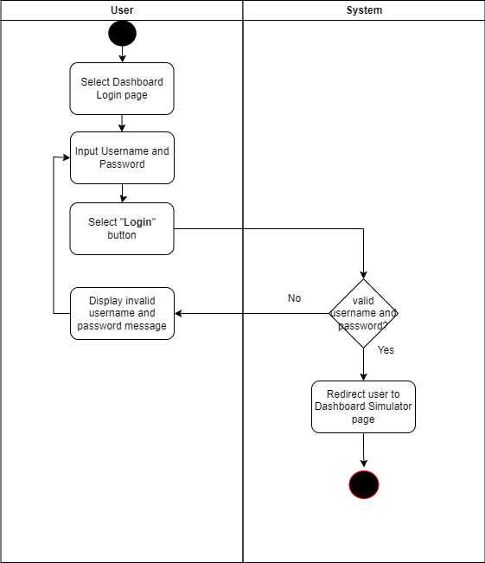

Figure 64: Dashboard Login Activity Diagram

#### 7.2.3.10 Simulate Real Time Attack Activity Diagram

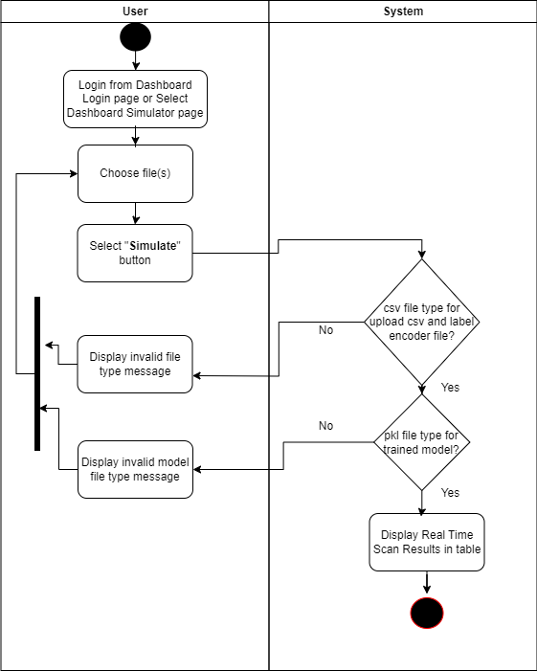

Figure 65: Simulate Real Time Attack Activity Diagram

#### 7.2.3.11 Create User Activity Diagram

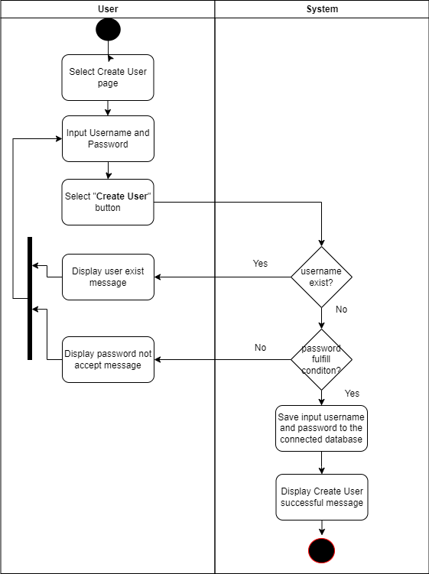

Figure 66: Create User Activity Diagram

#### 7.2.3.12 Manage Files Activity Diagram

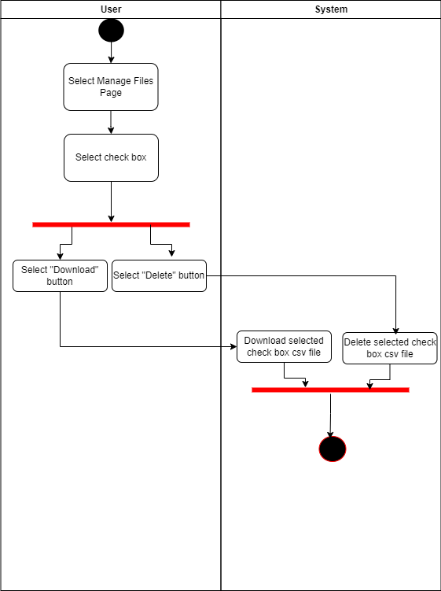

Figure 67: Manage Files Activity Diagram

## 7.3 User Interface Design

### 7.3.1 Upload Dataset Design

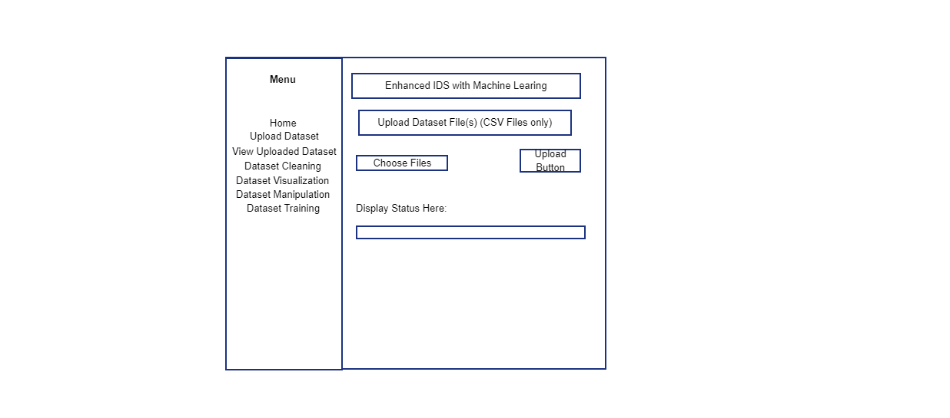

Figure 68: Upload Dataset Design

### 7.3.2 View Uploaded Dataset Design

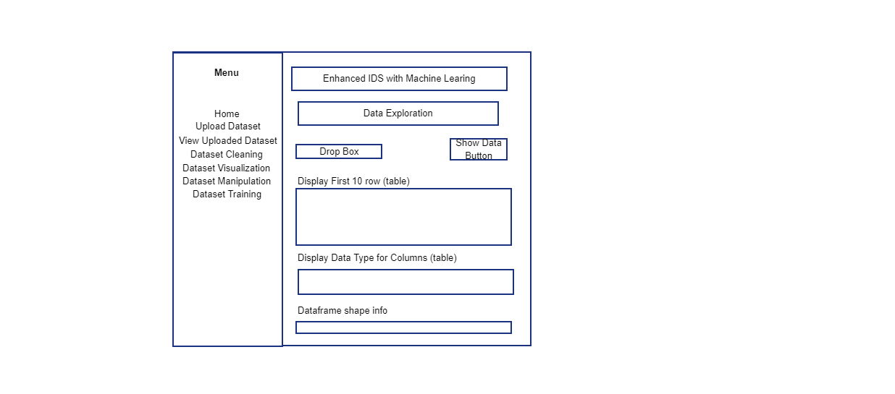

Figure 69: View Uploaded Dataset Design

### 7.3.3 Dataset Cleaning Design

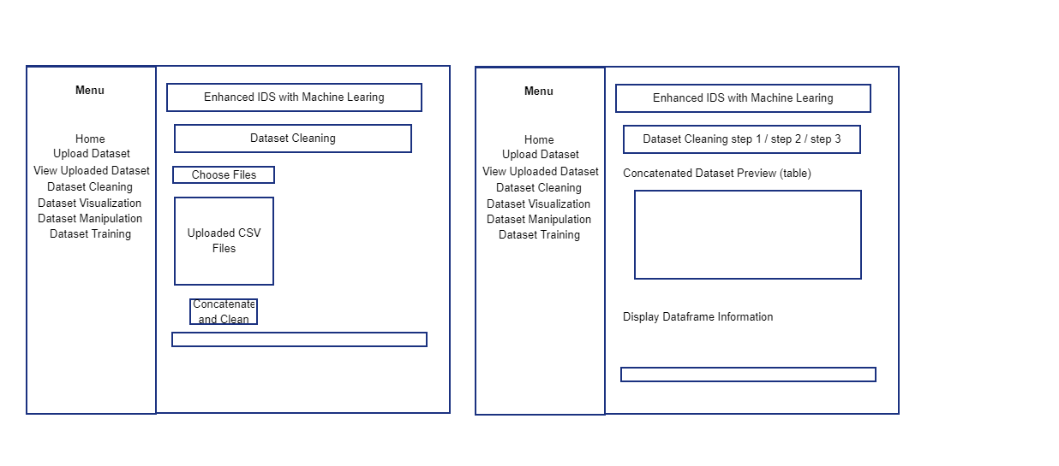

Figure 70: Dataset Cleaning Design

### 7.3.4 Dataset Visualization Design

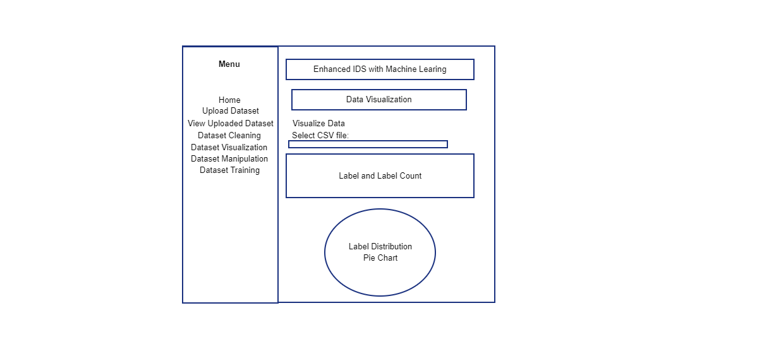

Figure 71: Dataset Visualization Design

### 7.3.5 Dataset Manipulation Design

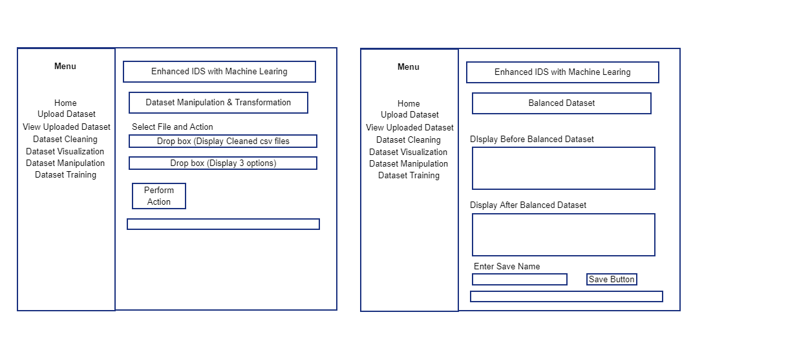

Figure 72: Dataset Manipulation Design (1)

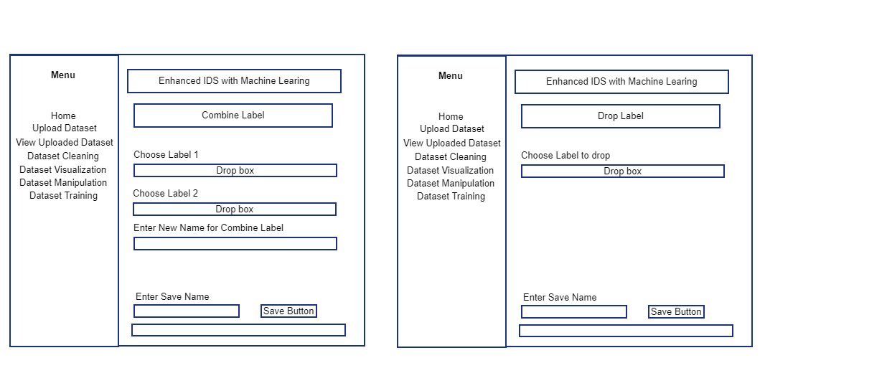

Figure 73: Dataset Manipulation Design (2)

### 7.3.6 Dataset Training Design

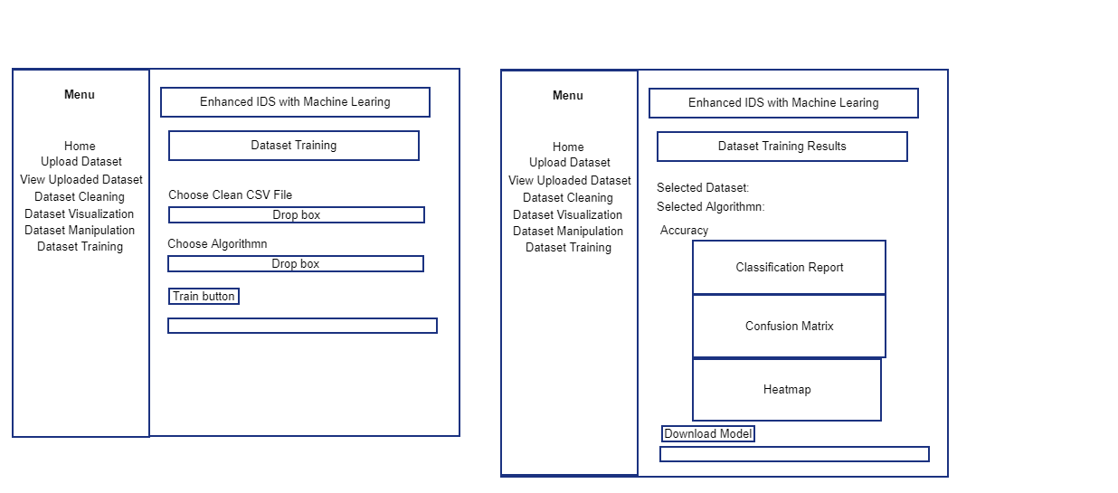

Figure 74: Dataset Training Design

### 7.3.7 Dashboard Login and Create User Design

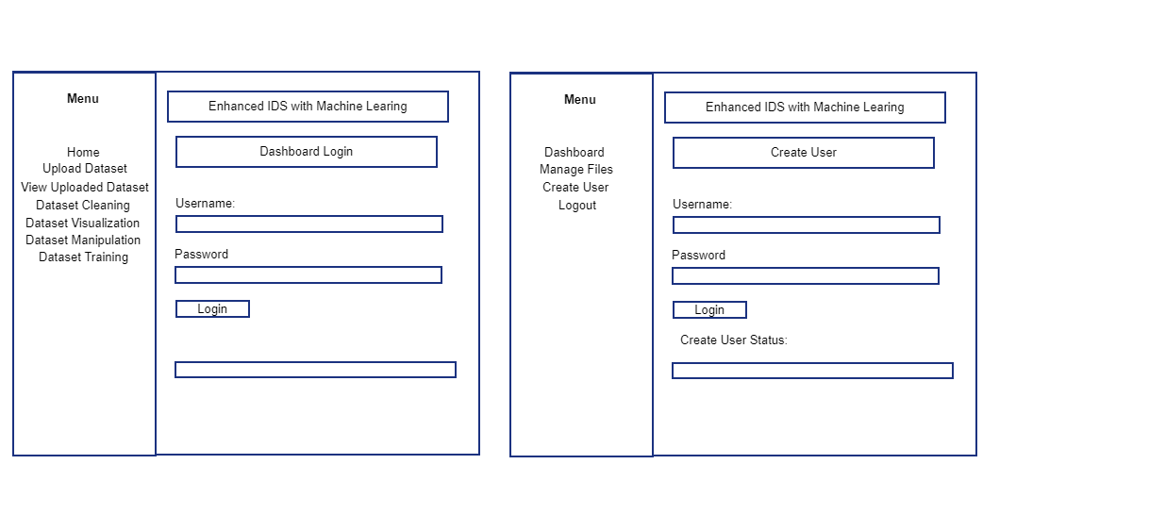

Figure 75: Dashboard Login and Create User Design

### 7.3.8 Dashboard Simulator Design

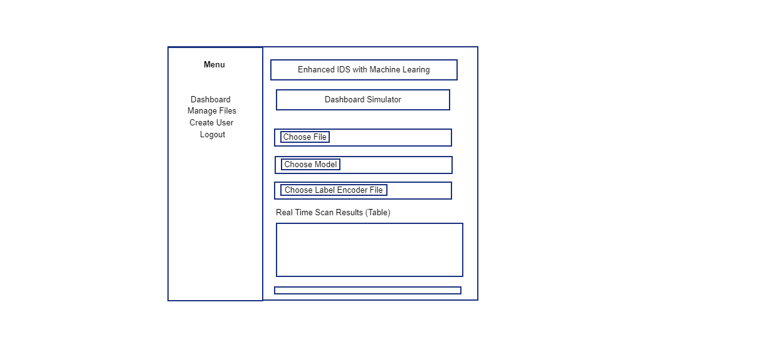

Figure 76: Dashboard Simulator Design

### 7.3.9 Manage Files Design

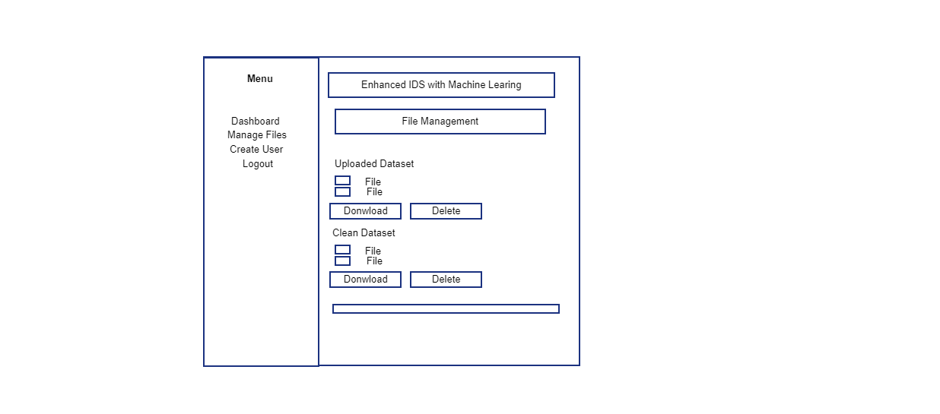

Figure 77: Manage Files Design

## 7.4 Dashboard Login Database Design

**Table Name: Dashboard**

|  |  |  |  |
| --- | --- | --- | --- |
| Column Name | Column Type | Description | Key |
| Id | Int | ID of the account | Primary Key |
| Username | Varchar (30) | Username of the account | - |
| password_hash | Varchar (255) | Hashing Password of the account | - |

# Chapter 8: Project Plan

## 8.1 Features

### 8.1.1 Upload Dataset

The "Upload Dataset" feature serves as the initial step and gateway for users to incorporate their data into the system. It provides a user-friendly and versatile means to upload datasets, including the option to upload multiple CSV files. This feature places a strong emphasis on ensuring a seamless experience, removing any hindrances for users as they import their data. Once uploaded, the datasets seamlessly integrate into the system, ready for exploration, analysis, and transformation.

### 8.1.2 View Uploaded Dataset

The "View Uploaded Dataset" feature offers users a comprehensive overview of their imported data. It surpasses mere data display by delivering valuable insights into the dataset's characteristics. Users swiftly access crucial details like data dimensions, column names, and data types. Additionally, it provides a preview of the first 10 rows, allowing users to verify the dataset's accuracy before proceeding.

### 8.1.3 Dataset Cleaning

Maintaining data quality is an essential prerequisite for meaningful data analysis. The "Dataset Cleaning" feature equips users with a toolkit to elevate data quality and reliability. It introduces a systematic approach that involves concatenating datasets and identifying and rectifying common data issues, such as missing values, duplicate records, and inconsistencies. By simplifying data cleaning procedures, this feature aims to enhance confidence in users about their dataset's integrity, enabling them to move forward with their analyses.

### 8.1.4 Dataset Visualization

The "Dataset Visualization" feature provides users with a straightforward tool to visualize both the uploaded and cleaned datasets. Its purpose is to help users assess whether their dataset is balanced or imbalanced in terms of label quantities. If there is a significant disparity in label quantities, users may consider dropping certain labels in the subsequent "Dataset Manipulation" feature. On the other hand, if label quantities exhibit moderate or minor differences, users may contemplate balancing the dataset in the next step. In essence, the Dataset Visualization feature empowers users to make informed decisions during Data Manipulation before embarking on Data Training.

### 8.1.5 Dataset Manipulation

The "Dataset Manipulation" feature allows users to tailor datasets according to their specific analytical needs. This system offers three distinct dataset manipulation options: "Balanced Dataset," "Combine Label," and "Drop Label." The "Balanced Dataset" option employs the Random Oversampling technique to address imbalanced datasets and is recommended for datasets with moderate or minor label quantity differences. Conversely, the "Drop Label" option is advisable for datasets with significant variations in label quantities. Additionally, the "Combine Label" option is recommended in cases where dataset training inaccurately categorizes types of attacks (it is essential to note that the "Combine Label" option should not be used if dataset training incorrectly classifies attacks as benign and combines them for training).

### 8.1.6 Dataset Training

For users delving into machine learning, the "Dataset Training" feature is indispensable. It facilitates the creation and training of machine learning models using the uploaded datasets. Users can choose from a diverse range of algorithms, fine-tune model parameters, and rigorously evaluate model performance. This feature transforms the system into a robust machine learning laboratory, supporting tasks such as predictive modeling, classification, regression, and more.

### 8.1.7 Dashboard Login

Security is necessary when handling sensitive data and analyses. The "Dashboard Login" feature ensures that only authorized users gain access to the system's capabilities. Users must authenticate themselves securely to access the system's features. This feature provides the necessary safeguards to protect data and analytical results from unauthorized access.

### 8.1.8 Dashboard Simulator

The "Dashboard Simulator" feature offers a risk-free environment for users to explore and understand machine learning models within the system. Users can simulate model behavior, test various scenarios, and evaluate performance metrics without the need for external tools or platforms. This feature is a valuable resource for users seeking to experiment with different models, aiding in model selection, fine-tuning, and validation.

### 8.1.9 Create New User for Dashboard Login

The "Register New User for Dashboard Login" feature streamlines the process of onboarding new users into the system. It allows individuals to create accounts with unique usernames and secure passwords, ensuring a personalized and secure experience within the system. This feature simplifies user management, enabling users to establish their identities and access system functionalities seamlessly.

### 8.1.10 Manage Files

Effective file management is crucial for maintaining an organized workspace. The "Manage Files" feature empowers users to efficiently organize, download, and remove files from their workspace. This capability streamlines data access and storage, ensuring that users can work in a clutter-free environment. It simplifies the task of keeping data organized and readily accessible for analysis.

## 8.2 Details of Release Plan

### 8.2.1 Enhance IDS Version 1.0

The initial phase of enhancing the IDS involves conducting a thorough analysis of available libraries and packages for potential integration into the proposed system. These libraries will be leveraged in JupyterLab to develop a command line-based application, requiring users to debug and run all cells in the JupyterLab environment. The anticipated release date for this initial project version is set for around mid-July 2023. The primary objective at this stage is to focus on constructing and training a foundational model, which marks a crucial milestone for the integration of advanced features into the application. Initially, the application will primarily utilize the Random Forest machine learning model to establish a robust foundation for subsequent development phases.

### 8.2.2 Enhance IDS Version 2.0

The second version of enhancing the IDS involves transitioning the application from JupyterLab to a Graphical User Interface (GUI) version. The anticipated release date for this project version is set for around mid-August 2023.The developer will commence building the system based on the specified requirements, with a primary emphasis on core features such as uploading datasets, viewing uploaded datasets, data visualization, and data training. This version of the enhanced IDS aims to develop a GUI-based application tailored to user-friendly interactions.

### 8.2.3 Enhance IDS Version 3.0

The third version of enhancing the IDS introduces a data manipulation feature in response to misclassifications during data training. The anticipated release date for this project version is set for around earlier of September 2023.This feature offers three distinct dataset manipulation options: "Balanced Dataset," "Combine Label," and "Drop Label." The "Balanced Dataset" option employs the Random Oversampling technique to address imbalanced datasets, making it suitable for datasets with moderate or minor label quantity variations. Conversely, the "Drop Label" option is recommended for datasets exhibiting significant label quantity discrepancies. Additionally, the "Combine Label" option is valuable when dataset training incorrectly categorizes types of attacks. It's important to note that the "Combine Label" option should be used judiciously.

### 8.2.4 Enhance IDS Version 4.0

In the fourth phase of enhancing the IDS, a comprehensive dashboard environment is introduced as an integral add-on feature. The anticipated release date for this project version is set for around the middle of September 2023. One of the key highlights of Version 4.0 is the implementation of a robust and secure dashboard login system. Users can now securely access the system through personalized login credentials, ensuring data privacy and access control. This addition not only enhances security but also adds a layer of personalization, tailoring the IDS experience to individual users. Furthermore, the introduction of user registration for dashboard access expands the system's user base. This feature promotes collaboration and information sharing among users, making it easier for organizations to adopt and benefit from the enhanced IDS. Another significant feature of this version is the "Manage Files" functionality. Users can efficiently organize and manipulate their datasets and other relevant files directly from the dashboard interface. This streamlines data management tasks, such as uploading, organizing, and deleting files, saving users valuable time and effort.

### 8.2.5 Enhance IDS Version 5.0

The fifth version of enhancing the IDS introduced the arrival of a feature known as the dashboard simulator. The anticipated release date for this project version is set for around late September 2023. The dashboard simulator is designed to offer users a risk-free space to explore various scenarios and settings within the IDS. Users can create and execute simulations, mimicking real-world situations and observing how the system responds. This capability is particularly valuable for fine-tuning intrusion detection models, optimizing thresholds, and evaluating the overall system's performance. Moreover, Version 5.0 introduces an enhanced level of interactivity within the dashboard simulator. Users can interact with simulated events, inject custom data in the csv file, and observe how the IDS responds in real-time. This interactive aspect provides a dynamic and engaging environment for users to test their hypotheses and validate their intrusion detection configurations.

## 8.3 Test Plan

### 8.3.1 Upload Dataset

|  |  |  |  |  |
| --- | --- | --- | --- | --- |
| Test ID | Test Case | Expected Results | Actual Results | Pass/Fail |
| 1.1 | 1. Choose one csv file from the device  2. Select “Upload” Button | **“Info:** Datasets Uploaded” is display |  |  |
| 1.2 | 1. Choose multiple csv File from the device  2. Select “Upload” Button | **“Info:** Datasets Uploaded” is display |  |  |
| 1.3 | 1. Select “Upload” Button without any file is chosen | “**Info:** No valid CSV files uploaded.” is display |  |  |
| 1.4 | 1. Choose any file type besides csv file type  2. Select “Upload” Button | “**Info:** No valid CSV files uploaded.” is display |  |  |

### 8.3.2 View Uploaded Dataset

|  |  |  |  |  |
| --- | --- | --- | --- | --- |
| Test ID | Test Case | Expected Results | Actual Results | Pass/Fail |
| 2.1 | 1. Select the drop box | 1. A list of uploaded csv file is display in the drop box if any csv file is uploaded and not delete  2. No csv file is display in the drop box if all csv files are deleted and no new csv file is uploaded |  |  |
| 2.2 | 1. Select any uploaded CSV file from the drop box  2. Select “**Show Data**” Button | The application should display the first 10 rows of the selected CSV file correctly. |  |  |
| 2.3 | 1. Select “**Show Data**” Button without select any uploaded CSV file from the drop box | The HTML drop box should show an informational message “Please Select an item from the list” |  |  |

### 8.3.3 Dataset Cleaning

|  |  |  |  |  |
| --- | --- | --- | --- | --- |
| Test ID | Test Case | Expected Results | Actual Results | Pass/Fail |
| 3.1 | 1. Select “**Concatenate and Clean**” Button without select any uploaded CSV file from the drop box | The HTML drop box should show an informational message “Please Select an item from the list” |  |  |
| 3.2 | 1. Select any uploaded CSV file from the drop box  2. Select “**Concatenate and Clean**” Button | 1. User will proceed to next page  (Clean Step 1- Concatenated Data)  2. A Concatenated Data Preview table is display with the following information  - Number of 'inf' and '-inf' values  - Number of NaN values,  - Number of Duplicate Rows  - DataFrame Shape is display correctly |  |  |
| 3.3 | 1. Select multiple uploaded CSV file from the drop box  2. Select “**Concatenate and Clean**” Button | 1. User will proceed to next page  (Clean Step 1- Concatenated Data)  2. A Concatenated Data Preview table is display with the following information  - Number of 'inf' and '-inf' values  - Number of NaN values,  - Number of Duplicate Rows  - DataFrame Shape is display correctly |  |  |
| 3.4 | In Clean Step 1 page, select “**Proceed to Step 2**” button. | 1. User will proceed to next page  (Clean Step 2: Remove 'inf' and '-inf' Values)  2. A Concatenated Data After Removing 'inf' and '-inf' Values table is display with the following information  - Number of 'inf' and '-inf' values should be zero  - Number of NaN values should be zero  - Number of Duplicate Rows should be zero  - DataFrame Shape is display correctly |  |  |
| 3.5 | In Clean Step 2 page, select “**Proceed to Step 3**” button. | 1. User will proceed to next page  (Clean Step 3: Remove Socket Features and Columns with Single Values)  2. A Concatenated Data After Removing Socket Features and Columns with Single Values table is display with the following information  - DataFrame Shape is display correctly  - 'Unnamed: 0', 'Flow ID', ' Source IP', ' Destination IP', ' Source Port', ' Destination Port', 'SimillarHTTP', ' Timestamp' Column is remove |  |  |
| 3.6 | In Clean Step 2 page, select “**Proceed to Step 3**” button. | 1. User will proceed to next page  (Clean Step 3: Remove Socket Features and Columns with Single Values)  2. A Concatenated Data After Removing Socket Features and Columns with Single Values table is display with the following information  - DataFrame Shape is display correctly  - 'Unnamed: 0', 'Flow ID', ' Source IP', ' Destination IP', ' Source Port', ' Destination Port', 'SimillarHTTP', ' Timestamp' Column is remove |  |  |
| 3.7 | In Clean Step 3 page, select “**Proceed to Step 4**” button. | User will proceed to next page (Clean Step 4: Save Cleaned Data) |  |  |
| 3.8 | In Clean Step 4 page, select “**Save Cleaned Data**” button without in the text field | An informational message will be display “Please fill out this field” |  |  |
| 3.9 | In Clean Step 4 page, input any name in the text field and select “**Save Cleaned Data**” button | “The cleaned data has been saved to the following location: clean\name.csv” is display |  |  |

### 8.3.4 Dataset Visualization

|  |  |  |  |  |
| --- | --- | --- | --- | --- |
| Test ID | Test Case | Expected Results | Actual Results | Pass/Fail |
| 4.1 | 1. Choose “**Uploaded Dataset**” in the drop box  2. Select “**Choose Folder**” button | 1. User will proceed to next page  2. A list of uploaded csv file will be display at the drop box (without deleted) |  |  |
| 4.2 | 1. Choose “**Cleaned Dataset**” in the drop box  2. Select “**Choose Folder**” button | 1. User will proceed to next page  2. A list of cleaned csv file will be display at the drop box (without deleted) |  |  |
| 4.3 | 1. Choose any csv files in the drop box  2. Select “**Visualize Data**” button | 1. User will proceed to next page  2. A table will be display with label and label count and label distribution chart is display |  |  |
| 4.4 | 1. Select “**Visualize Data**” button without select any csv file | The HTML drop box should show an informational message “Please Select an item from the list” |  |  |

### 8.3.5 Dataset Manipulation

|  |  |  |  |  |
| --- | --- | --- | --- | --- |
| Test ID | Test Case | Expected Results | Actual Results | Pass/Fail |
| 5.1 | Select “**Perform Action**” button without select any CSV file or any action from the drop boxes | The HTML drop box should show an informational message “Please Select an item from the list” |  |  |
| 5.2 | 1. Choose any clean csv file from the drop box and “**Balanced Dataset**” action from the drop box  2. Select “**Perform Action**” button | 1. User will proceed to Balance Data page  2. The page should display 2 tables to display before and after balance dataset alongside with appropriate data frame shape |  |  |
| 5.3 | 1. Choose any clean csv file from the drop box and “**Combine Labels**” action from the drop box  2. Select “**Perform Action**” button | 1. User will proceed to Combine Label page  2. The page should display 2 drop boxes to allow user to select available labels based on the selected CSV file to combine |  |  |
| 5.4 | 1. Choose any clean csv file from the drop box and “**Drop Label**” action from the drop box  2. Select “**Perform Action**” button | 1. User will proceed to Drop Label page  2. The page should display a drop box to allow user to select available label based on the selected CSV file to drop |  |  |
| 5.5 | In Balance Data page, select “**Save Balanced Data**” without input save name | An informational message will be display “Please fill out this field” |  |  |
| 5.6 | 1. In Combine Label page, choose first and second label, renamed new label (optional) and input any name to combine label and save name  2. Select “**Save Combined Data**” button | The chosen labels will be renamed into the combine label name and the dataset will be save |  |  |
| 5.7 | In Combine Label page, select “**Save Combined Data**” button without choose first and second label | The HTML drop box should show an informational message “Please Select an item from the list” |  |  |
| 5.8 | In Combine Label page, select “**Save Combined Data**” button without input any name for combine label or save name | An informational message will be display “Please fill out this field” |  |  |
| 5.9 | 1. In Drop Label page, choose label to drop and input any name to combine label and save name for dataset  2. Select “**Save Cleaned Data**” button | The chosen label will be drop and the dataset will be saved. |  |  |
| 5.10 | In Drop Label page, select “**Save Cleaned Data**” button without choose any label to drop | The HTML drop box should show an informational message “Please Select an item from the list” |  |  |
| 5.11 | In Drop Label page, select “**Save Cleaned Data**” button without input any save name | An informational message will be display “Please fill out this field” |  |  |

### 8.3.6 Dataset Training

|  |  |  |  |  |
| --- | --- | --- | --- | --- |
| Test ID | Test Case | Expected Results | Actual Results | Pass/Fail |
| 6.1 | 1. Choose any clean csv file from the drop box and select an algorithm  2. Select “Train” Button | 1. The application will proceed to train the data.  2. User will proceed to training results page and the following output will be display  - Training Accuracy  - Classification Report  - Confusion Matrix  - Confusion Heatmap |  |  |
| 6.2 | Select “Train” Button without choosing any clean csv file from the drop box or any algorithm | The HTML drop box should show an informational message “Please Select an item from the list” |  |  |
| 6.3 | In Training result page, Select “Download Model” Button | The model will be downloaded into user’s Download directory |  |  |

### 8.3.7 Dashboard Login

|  |  |  |  |  |
| --- | --- | --- | --- | --- |
| Test ID | Test Case | Expected Results | Actual Results | Pass/Fail |
| 7.1 | 1. Input valid username and password  2. Select “Login” Button | User will proceed to Dashboard Simulator page |  |  |
| 7.2 | 1. Input invalid username and password  2. Select “Login” Button | “**Error**: Invalid username or password” is displayed |  |  |

### 8.3.8 Dashboard Simulator

|  |  |  |  |  |
| --- | --- | --- | --- | --- |
| Test ID | Test Case | Expected Results | Actual Results | Pass/Fail |
| 8.1 | 1. Choose valid csv files and valid model files  2. Select “Simulate” Button | 1. A table with real time scan results should display  2. The predicted label should fulfill the trained model accuracy (if the model has high accuracy, the model should predict the label accurately) |  |  |
| 8.2 | 1. Selects a CSV file for evaluation that has columns different from the CSV file used to train the model.  2. Select “Simulate” Button | An error message with display |  |  |
| 8.3 | 1. Select a label encoder CSV file for evaluation that has labels different from the CSV file used to train the model.  2. Select “Simulate” Button | An error message with display |  |  |

### 8.3.9 Create User

|  |  |  |  |  |
| --- | --- | --- | --- | --- |
| Test ID | Test Case | Expected Results | Actual Results | Pass/Fail |
| 9.1 | 1. Input valid username and password  2. Select “Create User” Button | A successful create user message should display |  |  |
| 9.2 | Select “Create User” Button without input any username and password | An informational message will be display “Please fill out this field” |  |  |
| 9.3 | 1. Input inappropriate password (without at least one number and one uppercase and lowercase letter, and at least 8 or more characters)  2. Select “Create User” Button | An informational message will be display “Must contain at least one number and one uppercase and lowercase letter, and at least 8 or more characters” |  |  |

### 8.3.10 Manage Files

|  |  |  |  |  |
| --- | --- | --- | --- | --- |
| Test ID | Test Case | Expected Results | Actual Results | Pass/Fail |
| 10.1 | Select “Download” or “Delete” button without selecting any check box. | No files will be download and delete |  |  |
| 10.2 | 1. Select any check box on uploaded files  2. Select “Download” button below the uploaded files list | The selected csv file will be downloaded from the upload folder |  |  |
| 10.3 | 1. Select any check box on uploaded files  2. Select “Delete” button below the uploaded files list | The selected csv file will be deleted from the upload folder after refreshing the page |  |  |
| 10.4 | 1. Select any check box on cleaned files  2. Select “Download” button below the cleaned files list | The selected csv file will be downloaded from the clean folder |  |  |
| 10.5 | 1. Select any check box on cleaned files  2. Select “Delete” button below the cleaned files list | The selected csv file will be deleted from the clean folder after refreshing the page |  |  |

### 8.3.11 User Acceptance Testing (UAT)

|  |  |  |  |  |  |  |
| --- | --- | --- | --- | --- | --- | --- |
| **Tester Name** |  | | | | | |
| **Testing Date** |  | | | | | |
| **Criteria** | | **Score (1 not satisfied – 5 very satisfied)** | | | | |
| **1** | **2** | **3** | **4** | **5** |
| UI Design | |  |  |  |  |  |
| UX (Ease of use) | |  |  |  |  |  |
| Robustness (System reliability and performance) | |  |  |  |  |  |
| Bug and error free | |  |  |  |  |  |
| Overall satisfaction | |  |  |  |  |  |
| Tester Feedback |  | | | | | |
| Developer Action |  | | | | | |

# Chapter 9: Implementation

## 9.1 Screenshot

### 9.1.1 Upload Dataset

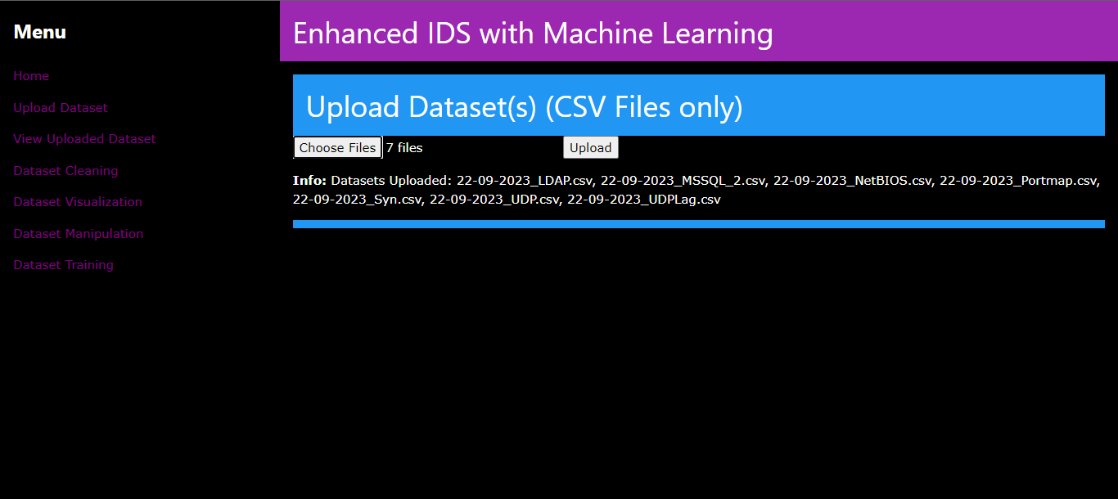

Figure 78: Upload Dataset Screenshot

**Dataset Upload:** The Dataset Upload page provides users with the capability to submit one or multiple CSV datasets to the system for analysis. Utilizing the "Choose File" button, users can opt for CSV files and perform simultaneous uploads. The system only accepts files with the ".csv" extension. Upon upload, each dataset is assigned a unique filename based on the upload date to avoid conflicts. Users receive feedback on the upload status, with success or error messages displayed on the page. This feature simplifies the process of importing datasets, making them available for analysis within the system.

### 9.1.2 View Uploaded Dataset

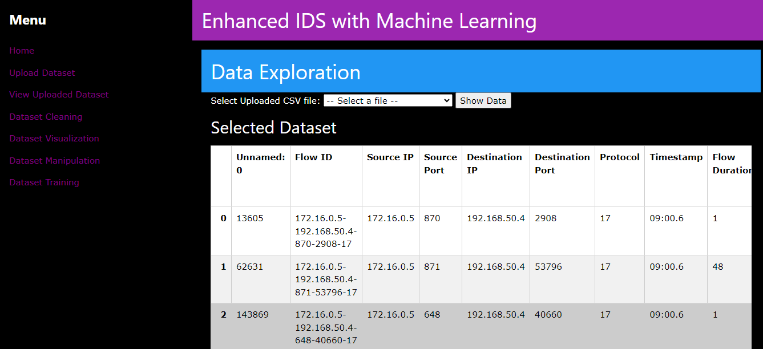

Figure 79: View Uploaded Dataset Screenshot

**View Uploaded Dataset**: The View Uploaded Dataset web page allows users to interact with their uploaded CSV datasets. It presents a dropdown menu for users to select a dataset file, and upon clicking the "Show Data" button, the page displays the first 10 rows of the chosen dataset in a user-friendly table format. Additionally, users can access information about the data types of columns within the dataset, presented in a tabular layout. If available, the page provides shape information, revealing the dataset's row and column counts. In summary, this page serves as a practical tool for users to explore and analyze their uploaded data, facilitating data understanding and analysis.

### 9.1.3 Dataset Cleaning

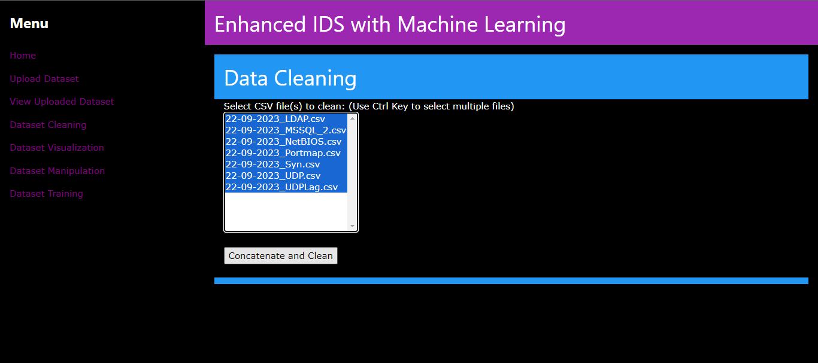

Figure 80: Dataset Cleaning (1) Screenshot

**Dataset Cleaning**: In the Data Cleaning page, users are presented within a web interface to select one or multiple CSV files for cleaning. Users can choose files using the Ctrl key for multiple selections. After file selection, they initiate the "Concatenate and Clean" process by clicking a button. If any errors occur during this process, the page provides clear error messages to inform the user. In essence, this page streamlines the data cleaning process, facilitating the preparation of datasets for further analysis or exploration.

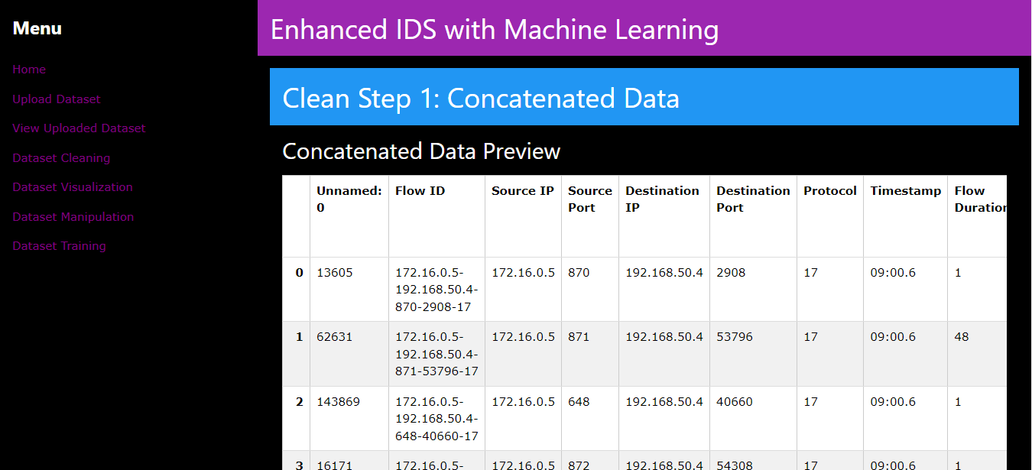

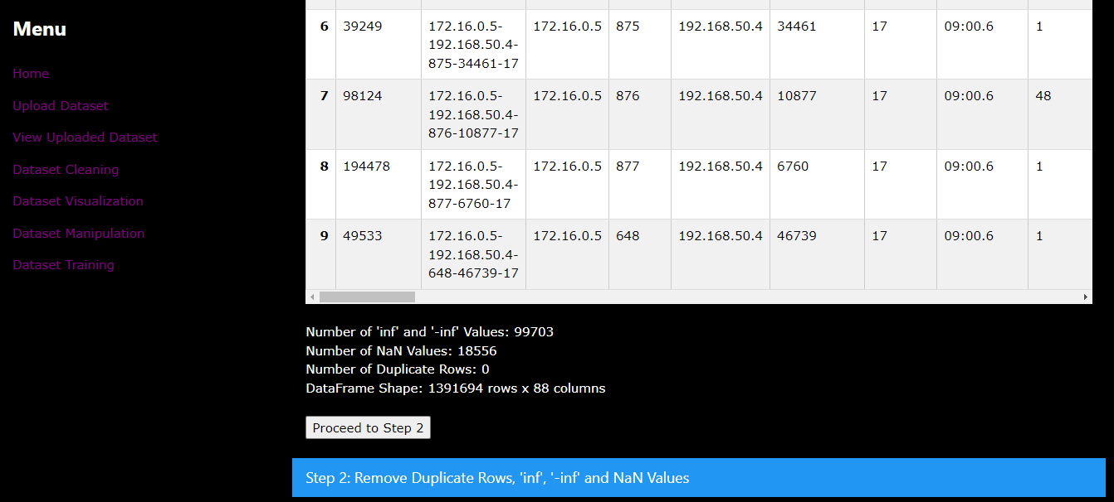

Figure 81: Dataset Cleaning (2) Screenshot

The "Clean Step 1: Concatenated Data" page is part of a data cleaning process. It presents users with a preview of the concatenated data, allowing them to inspect the data before cleaning. Users can view the first portion of the concatenated data in a responsive table format. Additionally, the page displays count of 'inf,' '-inf,' and NaN values present in the data, along with the number of duplicate rows and the data frame's shape information. Users are provided with a button to proceed to the next step of the data cleaning process.

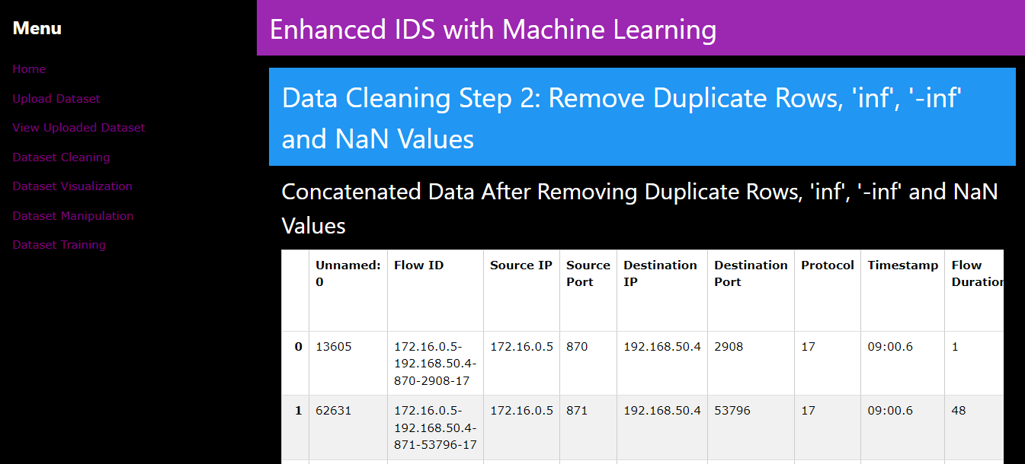

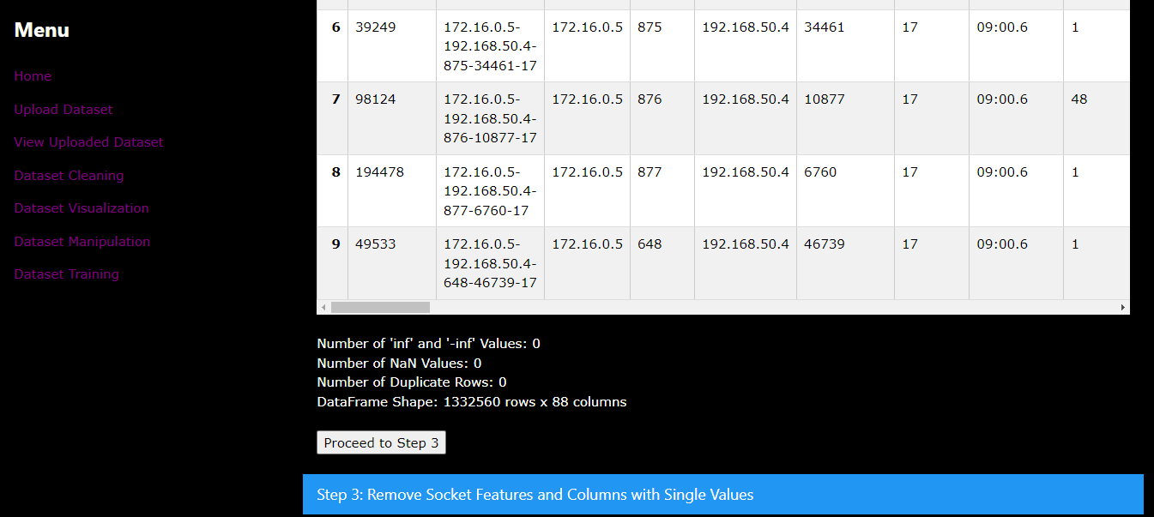

Figure 82: Dataset Cleaning (3) Screenshot

The "Clean Step 2: Removing Duplicate Rows, 'inf,' '-inf,' and NaN Values" page is the second step in the data cleaning process. It continues the data cleaning workflow by displaying the concatenated data after the removal of duplicate rows, 'inf,' '-inf,' and NaN values. Users can review the cleaned data in a responsive table format. The page also provides counts of 'inf,' '-inf,' and NaN values, the number of duplicate rows, and the data frame's shape information.

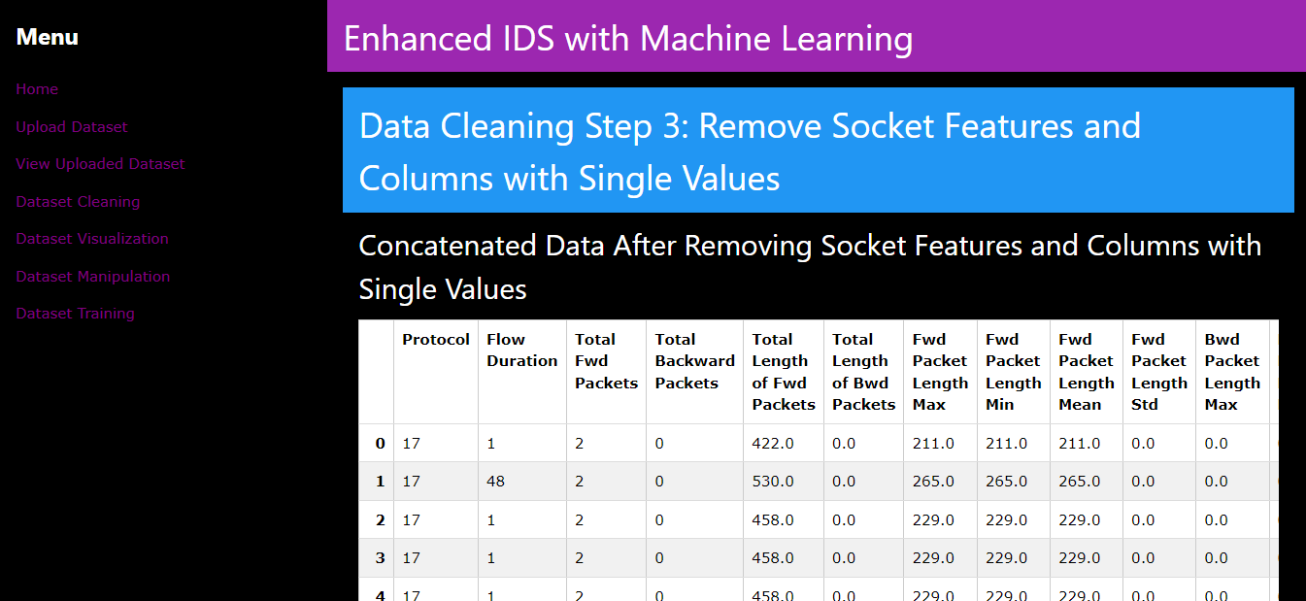

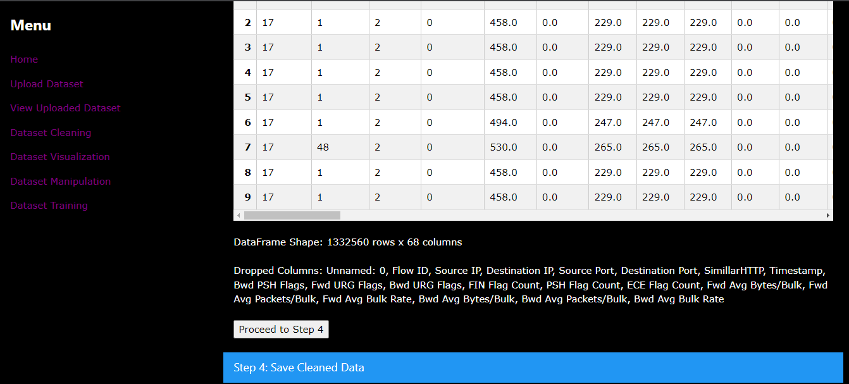

Figure 83: Dataset Cleaning (4) Screenshot

The "Data Cleaning Step 3: Remove Socket Features and Columns with Single Values" page is the third step in the data cleaning process. It showcases the concatenated data after removing socket features and columns with single values. Users can inspect the cleaned data in a responsive table format. The page also lists the dropped columns during data cleaning process.

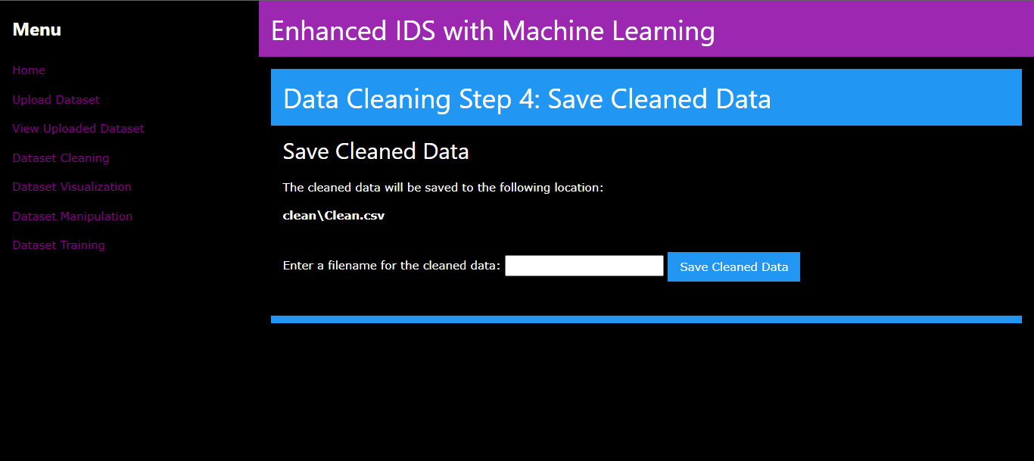

Figure 84: Dataset Cleaning (5) Screenshot

The "Data Cleaning Step 4: Save Cleaned Data" page allows user to save the cleaned dataset. To complete the data cleaning process and save the cleaned data, users simply enter a filename and click a button. This page marks the conclusion of the data cleaning workflow, ensuring that users can retain the cleaned data for further analysis or use.

### 9.1.4 Dataset Visualization

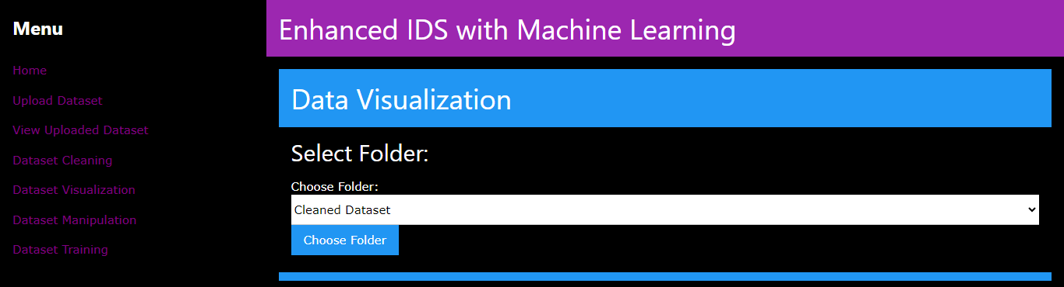

Figure 85: Dataset Visualization (1) Screenshot

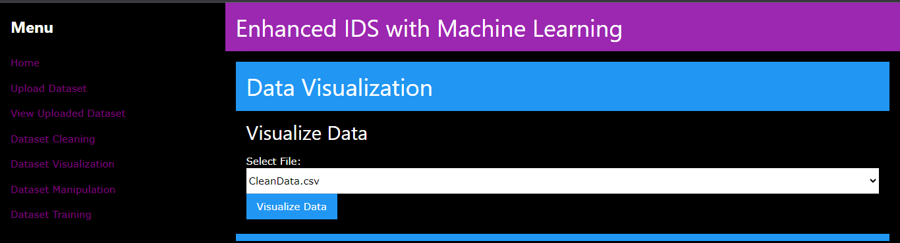

Figure 86: Dataset Visualization (2) Screenshot

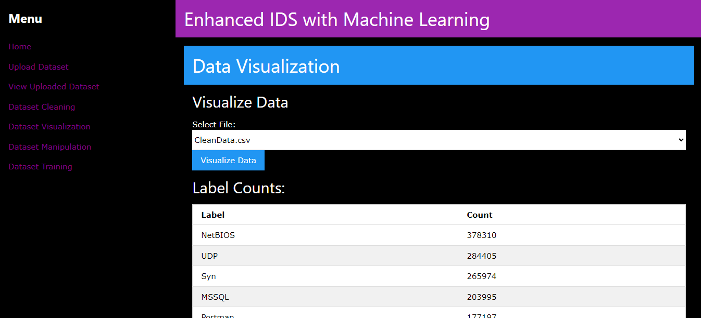

Figure 87: Dataset Visualization (3) Screenshot

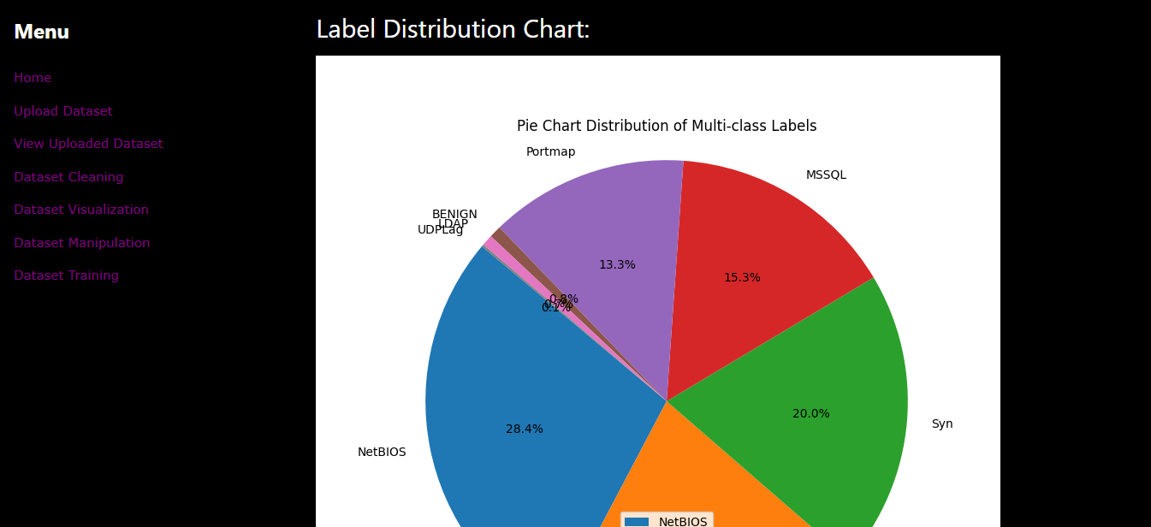

Figure 88: Dataset Visualization (4) Screenshot

**Data Visualization**: The page for Data Visualization Selection enables users to engage with their data by initially opting for a folder for data visualization. Utilizing a dropdown menu, users have the flexibility to pick either the "Uploaded Dataset" or "Cleaned Dataset" folder. Following their selection, users can advance by selecting the "Choose Folder" button. Once a folder for data visualization has been chosen, users are then able to progress with the visualization of data within the selected folder. Users have the option to select from the available files contained within the chosen folder through the drop box and select Visualize Data button.

### 9.1.5 Dataset Manipulation

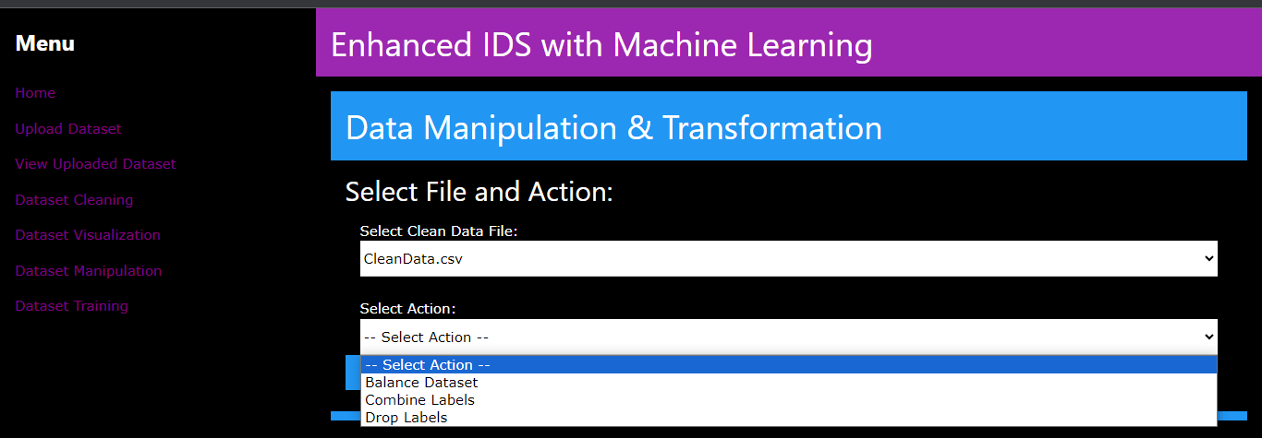

Figure 89: Dataset Manipulation Screenshot

**Dataset Manipulation**: The Data Manipulation & Transformation page empowers users to perform various data manipulation actions on cleaned data. Users first select a data file from the available options within the chosen folder. Subsequently, users can choose from a set of actions, including balancing the dataset, combining labels, or dropping labels. After making their selections, users can initiate the chosen action by clicking the "Perform Action" button.

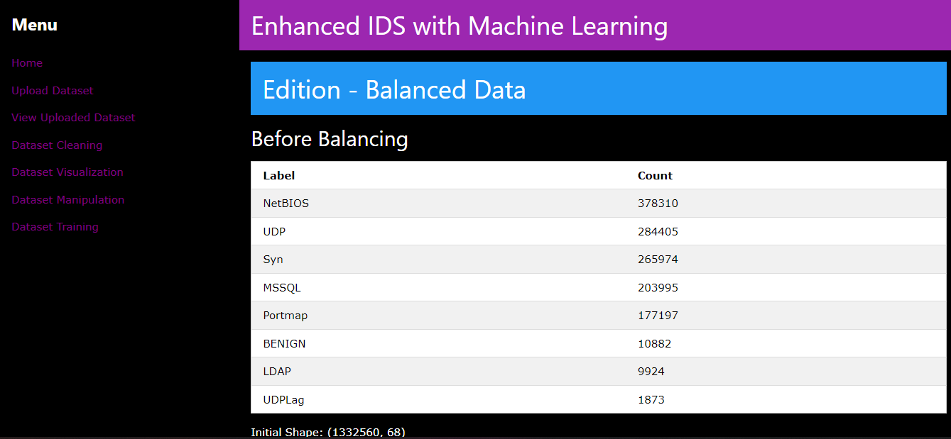

Figure 90: Dataset Manipulation (Balanced Dataset) Screenshot

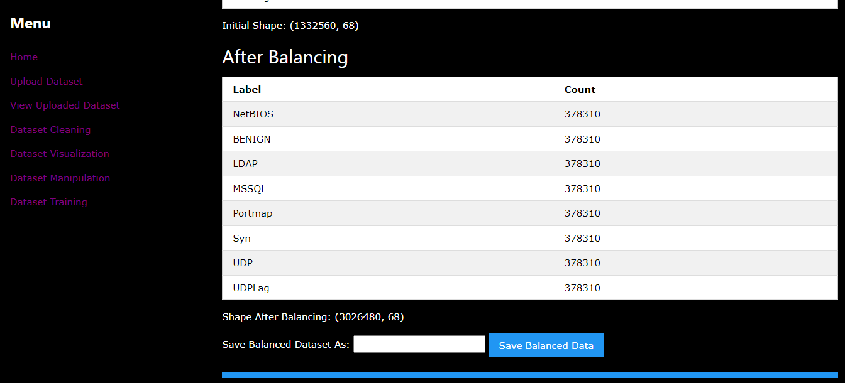

Figure 91: Dataset Manipulation (Balanced Label) Screenshot

**Balanced Data**: In the Edition - Balanced Data page, users can view the impact of balancing a dataset. Initially, the page displays label counts before balancing, presenting the labels and their respective counts. Users can also observe the initial shape of the dataset. Subsequently, the page displays label counts after balancing, including labels and their counts post-balancing, along with the dataset's new shape. Users are then prompted to save the balanced dataset with a specified name by entering it in the provided field and clicking the "Save Balanced Data" button.

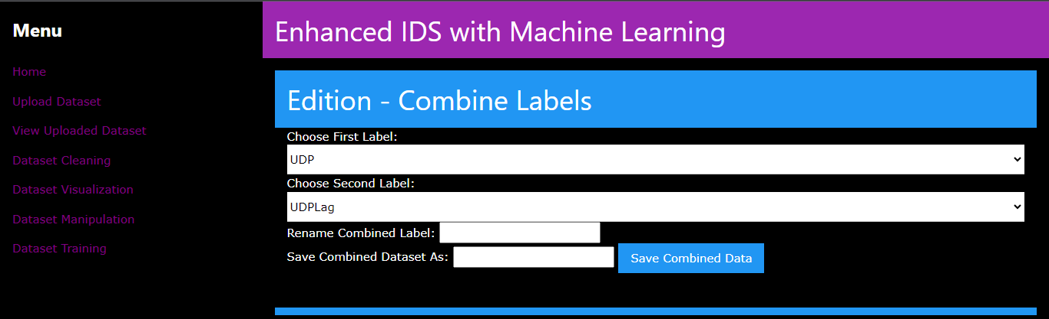

Figure 92: Dataset Manipulation (Combined Label) Screenshot

**Combine Labels**: The Edition - Combine Labels page empowers users to merge two distinct labels within their dataset. Users initiate this process by first selecting a label from the available choices in the dropdown menu labeled "Choose First Label." A similar selection process applies to the "Choose Second Label" dropdown. Furthermore, users can assign a new name to the combined label by entering it in the "Rename Combined Label" field. To complete this action, users need to specify a name for the saved combined dataset in the "Save Combined Dataset As" field. Finally, clicking the "Save Combined Data" button executes the label combining operation.

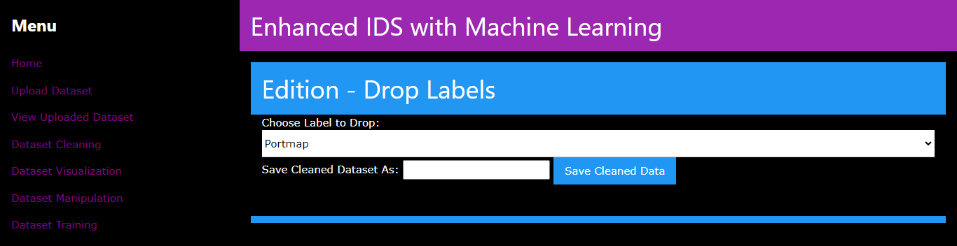

Figure 93: Dataset Manipulation (Drop Labels) Screenshot

**Drop Labels**: The Edition - Drop Labels page provides users with the ability to eliminate a specific label from their dataset by selecting the label to drop from the dropdown menu labeled "Choose Label to Drop." Additionally, users can specify a name for the saved cleaned dataset in the "Save Cleaned Dataset As" field. The process is finalized by clicking the "Save Cleaned Data" button, which initiates the label dropping operation.

### 9.1.6 Dataset Training

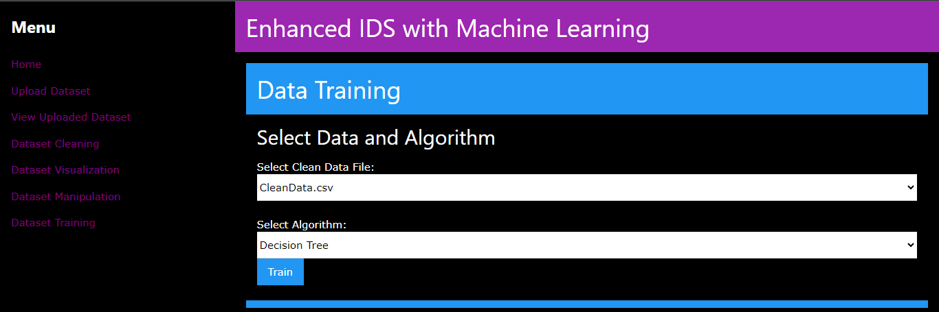

Figure 94: Dataset Training Screenshot

Dataset Training: The Machine Learning Training page provides users with the capability to instruct machine learning models using their prepared datasets within the "Choose Clean Data File" dropdown menu. Furthermore, users can designate an algorithm for the training procedure by selecting from the "Choose Algorithm" dropdown menu and selecting train button.

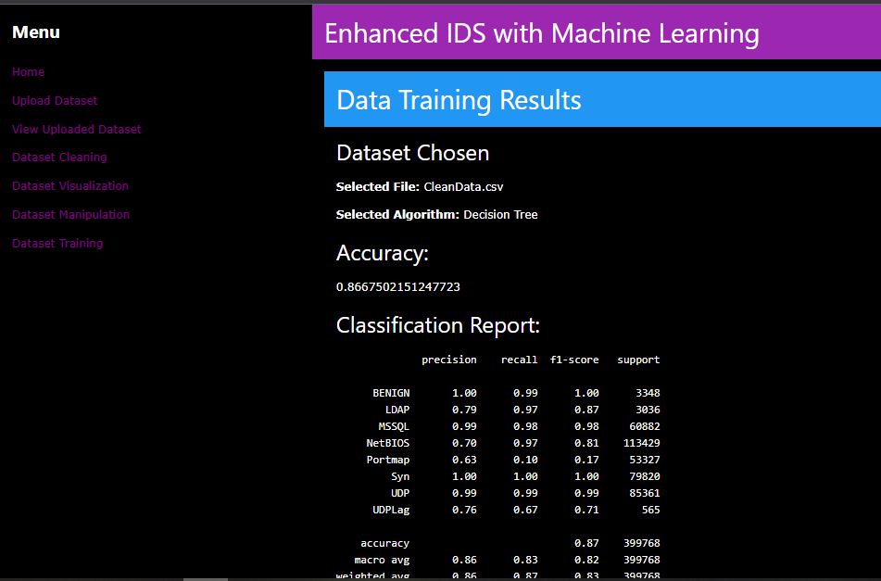

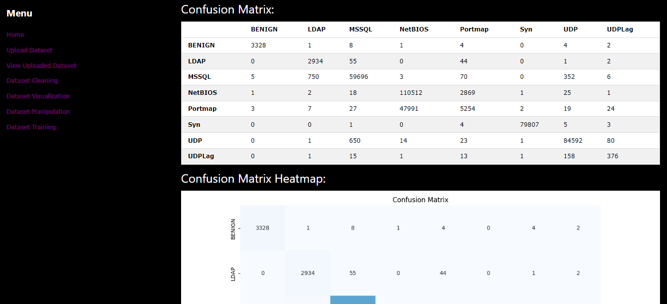

Figure 95: Dataset Training Results Screenshot

**Data Training Results**: The Data Training Results page displays the outcomes of a machine learning model's training process. It begins by presenting information about the dataset used and the selected algorithm, providing clarity on the training context. Furthermore, users can access essential training metrics such as accuracy, which highlights the model's predictive performance. Additionally, a detailed classification report offers insights into precision, recall, and F1-score for each class. The confusion matrix, both in tabular and heatmap formats, provides a visual representation of the model's performance. Users can also download the trained model by clicking the "Download Model" button, facilitating model deployment and further analysis.

### 9.1.7 Dashboard Login

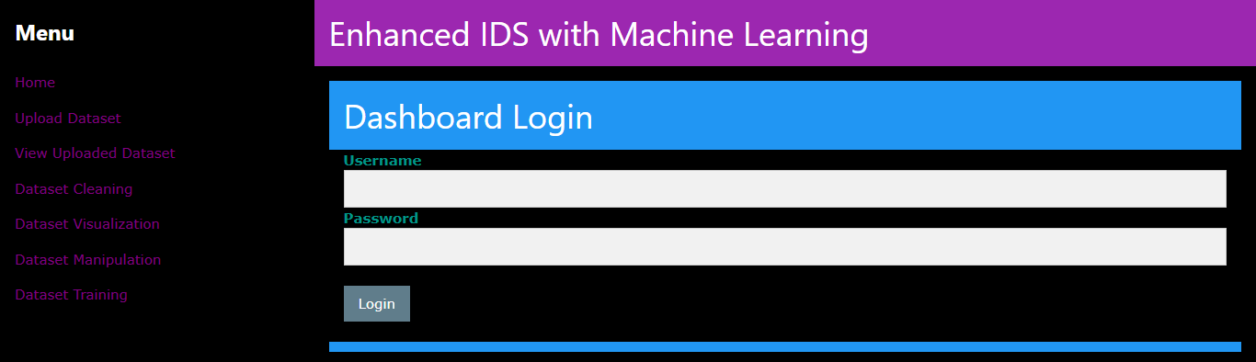

Figure 96: Dashboard Login Screenshot

**Dashboard Login**: The Dashboard Login feature streamlines user entry to the dashboard interface. Users need to input their login details into the designated fields. Upon submitting this information, users can verify their identity by selecting the "Login" button.

### 9.1.8 Dashboard Simulator

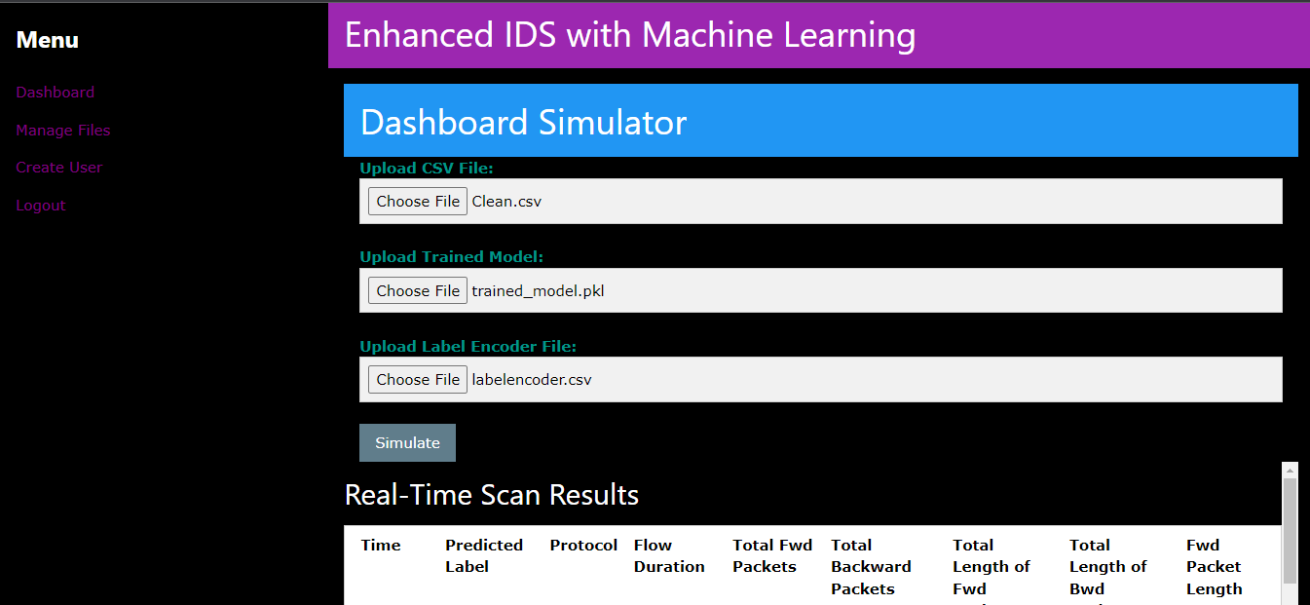

Figure 97: Dashboard Simulator Screenshot

**Dashboard Simulator**: The Dashboard Simulator page offers users a real-time monitoring tool for network data. Users can upload a CSV file containing network data, a trained machine learning model, and a label encoder file to simulate the dashboard. This simulation allows users to observe the model's predictions in real-time. The displayed data includes timestamps, predicted labels, protocol information, flow duration, packet counts, and other network-related details. The simulator enhances the understanding and evaluation of the model's performance in a dynamic context.

### 9.1.9 Manage Files

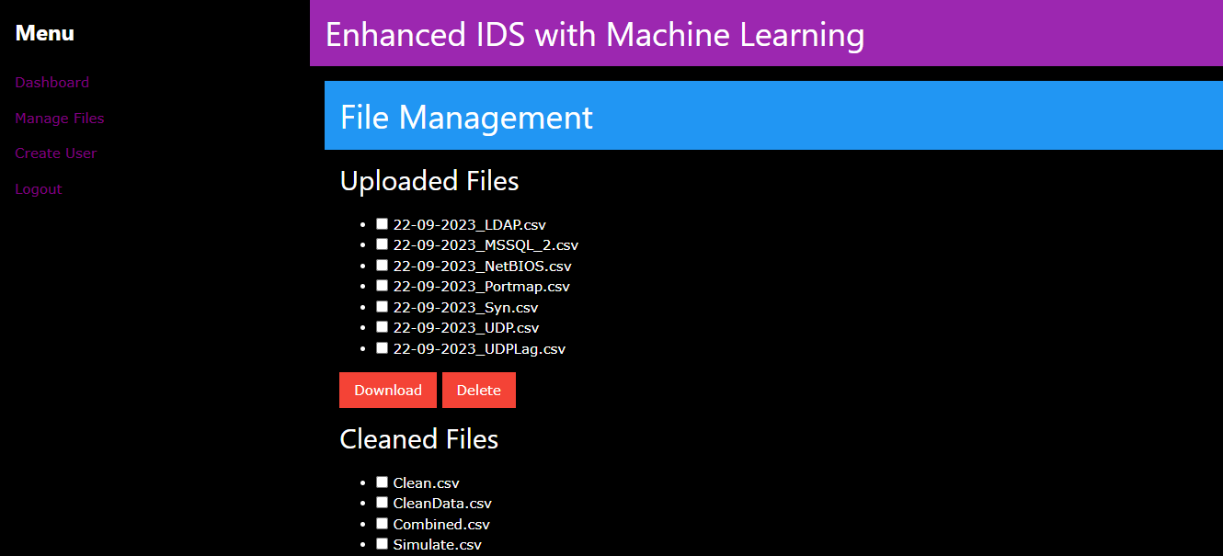

Figure 98: Manage Files Screenshot

**File Management**: The File Management page allows users to manage their uploaded and cleaned files conveniently. Users can select multiple files for download or deletion by checking the corresponding checkboxes. Actions like downloading and deleting selected files can be performed using the provided buttons. The page separates uploaded and cleaned files for efficient organization and management of data.

### 9.1.10 Create User

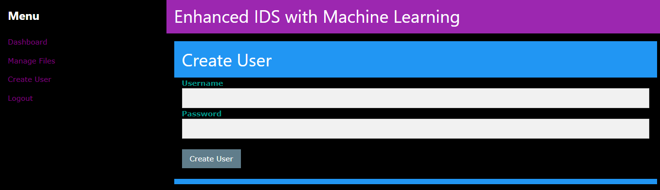

Figure 99: Create User Screenshot

**Create User**: The Create User page provides an interface for administrators to create new user accounts within the system. Administrators must input a username and a secure password adhering to specific complexity criteria. Upon submission, a new user account is created, enabling access to the system's functionalities. In case of any errors, error messages are displayed for clarification.

## 9.2 Sample Code

### 9.2.1 Upload Dataset

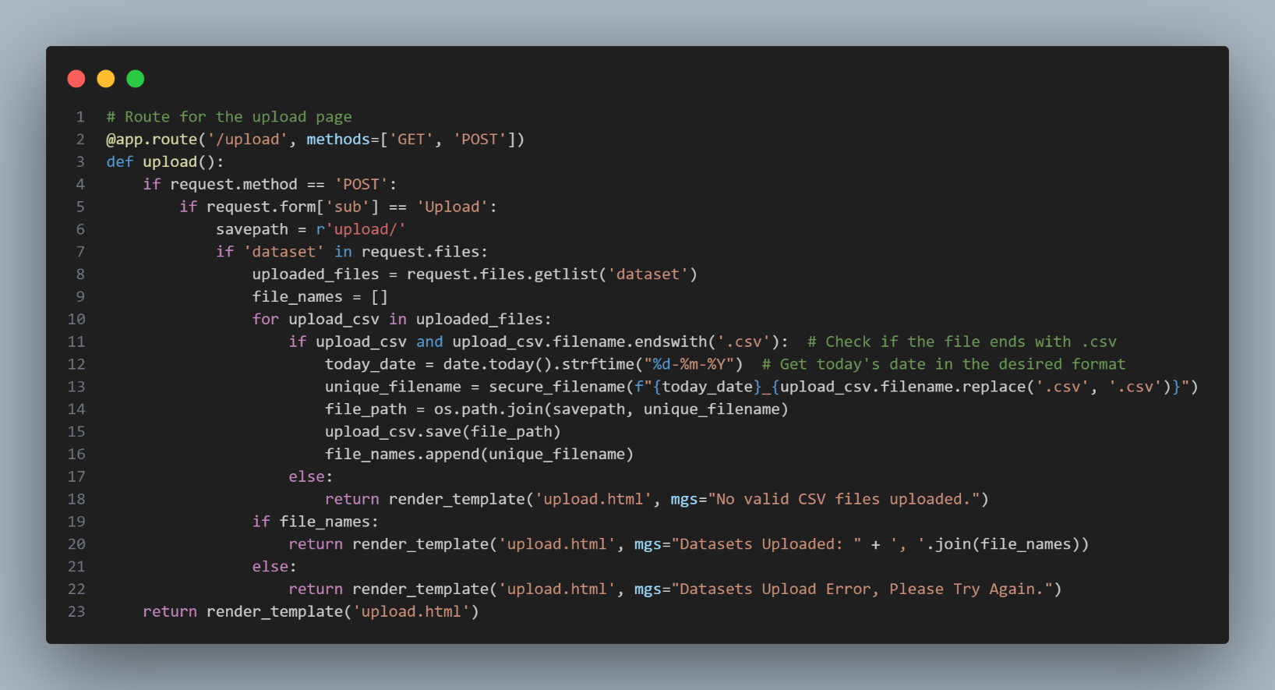

Figure 100: Upload Dataset Code

This Python code defines a route for the "/upload" URL, enabling users to upload one or more CSV datasets via a web interface built with Flask. When users submit a file upload request, the code checks if valid CSV files are included, generates unique filenames based on the current date, and saves the uploaded datasets in a designated directory. It provides feedback to users, confirming the successful upload or reporting any errors. The code simplifies the process of uploading and managing CSV datasets through a web-based application.

### 9.2.2 Dataset Cleaning

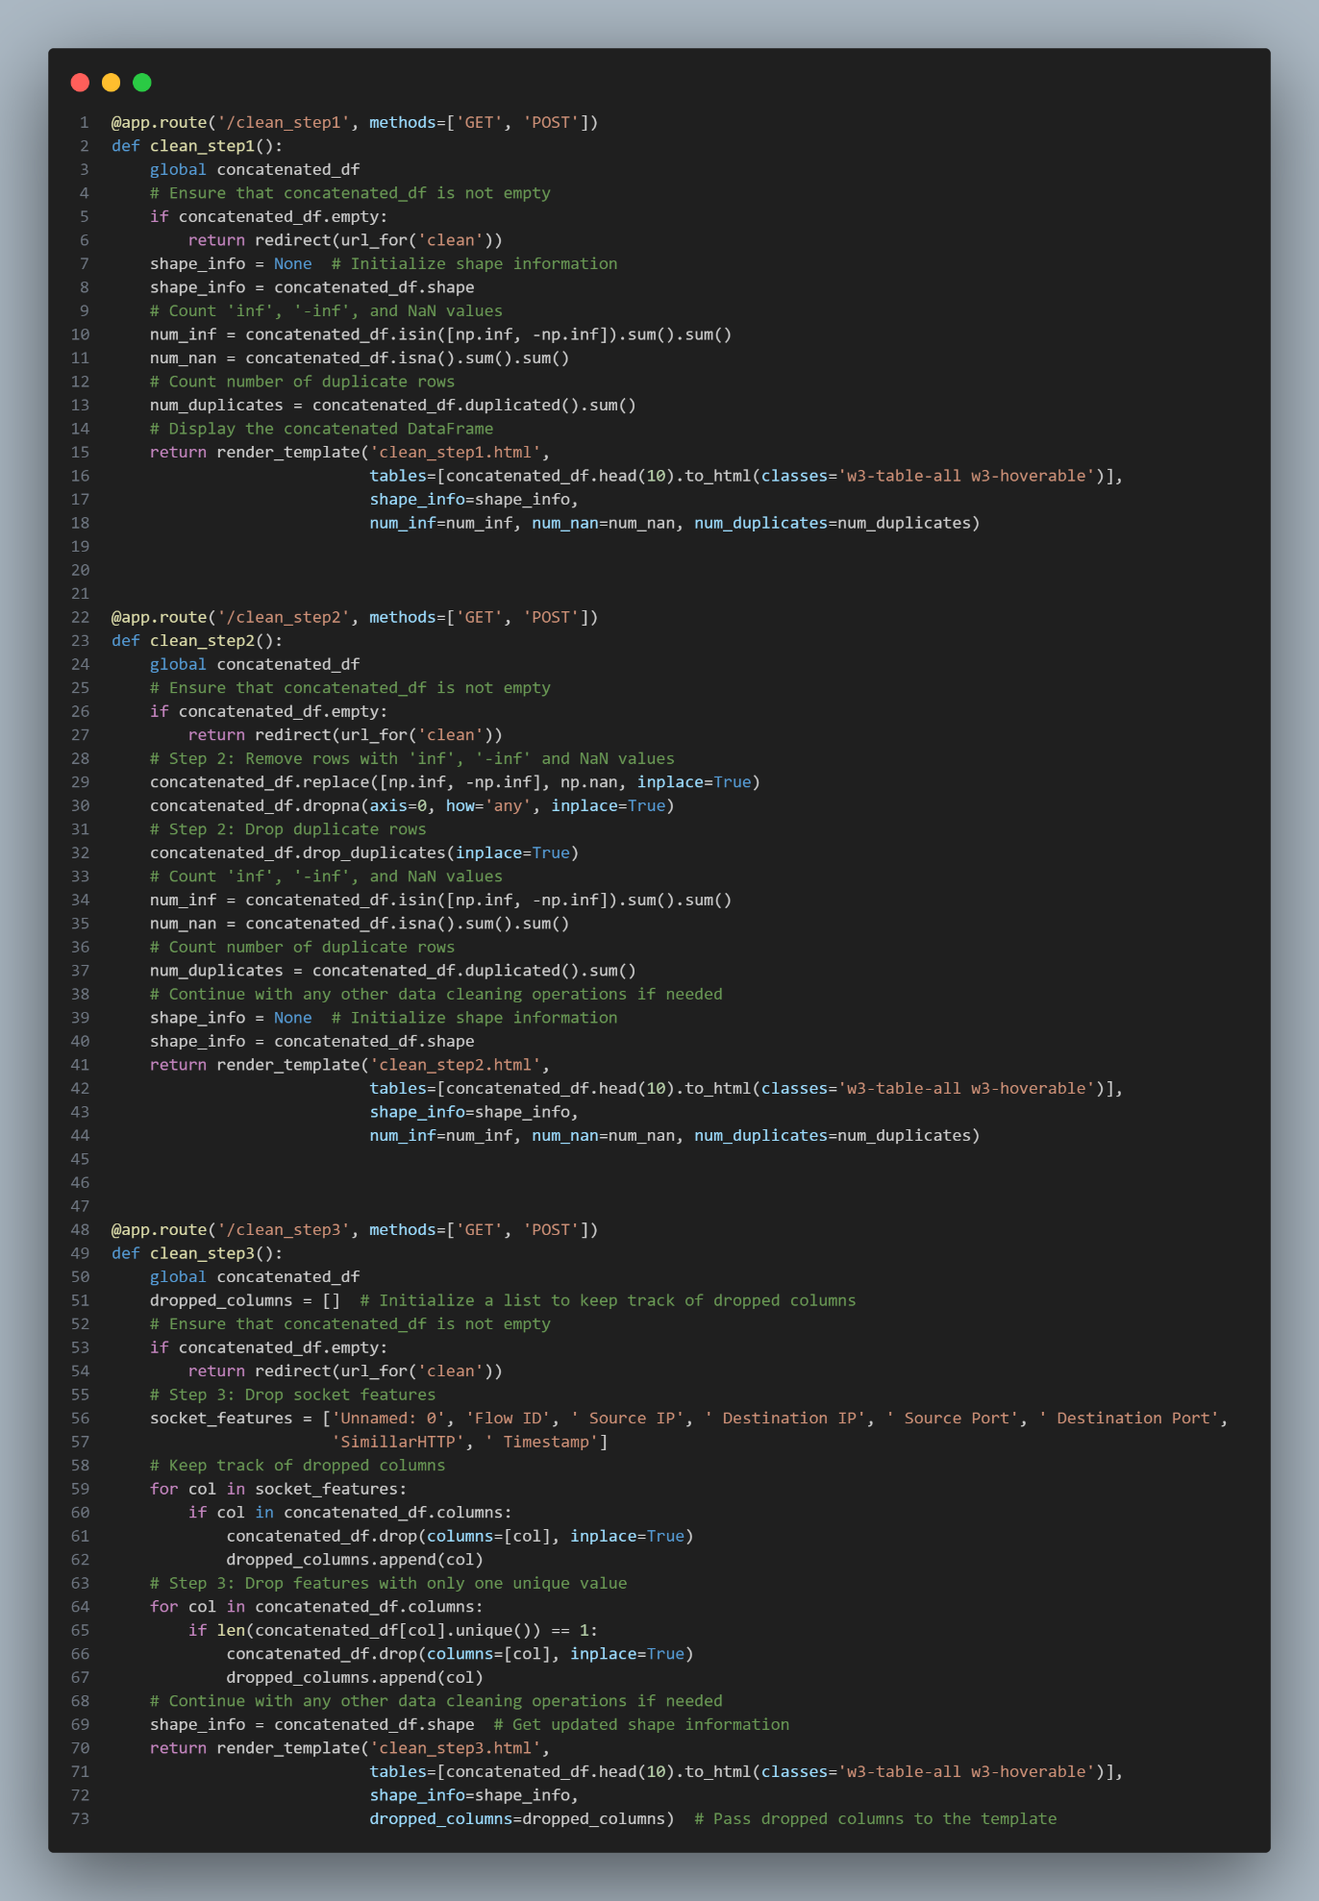

Figure 101: Dataset Cleaning Code (Partial)

This Python code defines a series of routes in a Flask web application for data cleaning. In the "/clean_step1," the code checks if `concatenated_df` is empty and then computes various data statistics. These statistics include the shape of the DataFrame, the count of 'inf,' '-inf,' and NaN values, and the number of duplicate rows. The code renders an HTML template, displaying the first 10 rows of the DataFrame along with these statistics.

In "/clean_step2," the code continues data cleaning by replacing 'inf' and '-inf' values with NaN and subsequently removing rows with any NaN values. It also drops duplicate rows from the DataFrame. Like the first step, it computes statistics on 'inf,' '-inf,' and NaN values, as well as duplicate rows. The cleaned DataFrame and statistics are then displayed in an HTML template.

In "/clean_step3," the code focuses on additional data cleaning operations. It specifically drops columns associated with socket features and columns with only one unique value. The dropped columns are tracked in a list called `dropped_columns`. As before, statistics about the DataFrame's shape are computed and displayed in an HTML template. These routes provide a step-by-step data cleaning process through a web interface, enabling users to visualize the effects of each cleaning step and monitor the DataFrame's transformation.

### 9.2.3 Dataset Training

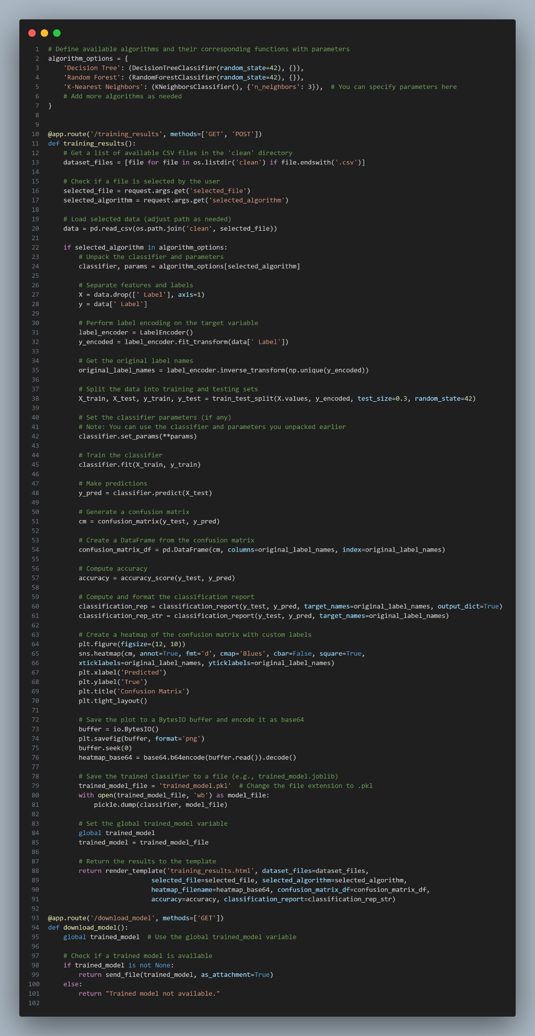

Figure 102: Dataset Training Code

This Flask code defines a route at "/training_results" that handles the presentation of machine learning training results. It first retrieves a list of available CSV files in the 'clean' directory to display them as options for selection. The selected CSV file and algorithm are obtained from the user's input. Next, the code loads the selected data and performs preprocessing steps, such as label encoding, data splitting, classifier initialization, training, and prediction. It also generates performance metrics like a confusion matrix, accuracy, and a classification report. The confusion matrix is visualized as a heatmap, encoded as a base64 image for display. The trained classifier is saved to a file, and a global variable ('trained_model') is set to store its filename. Finally, the training results, including the dataset options, selected file, algorithm, heatmap image, confusion matrix, accuracy, and classification report, are rendered on an HTML template. Additionally, there's a '/download_model' route to allow users to download the trained model file if available.

### 9.2.4 Dashboard Login

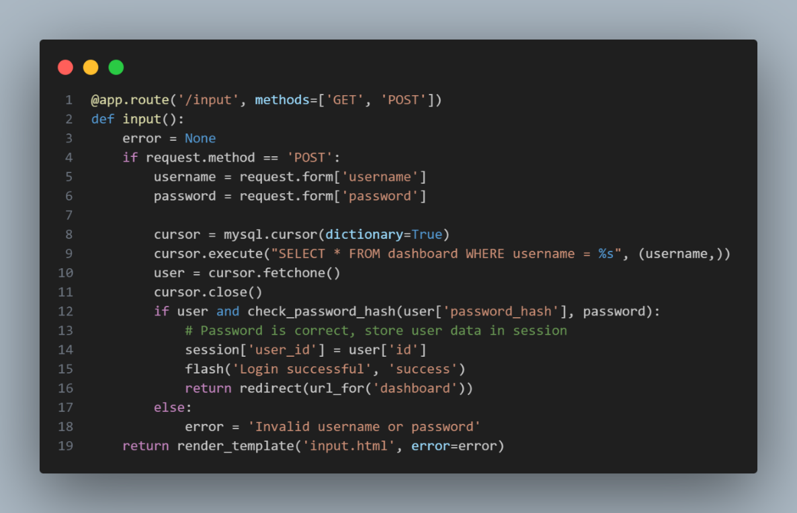

Figure 103: Dashboard Login Code

The "/input" Flask route is responsible for user authentication by verifying if the entered username and password correspond to the database records. When there is a match, the user gains authentication, and their ID is stored in the session, facilitating a successful login followed by redirection to the dashboard. Conversely, if the credentials do not align, an error message encourages the user to make another authentication attempt.

### 9.2.5 Dashboard Simulator

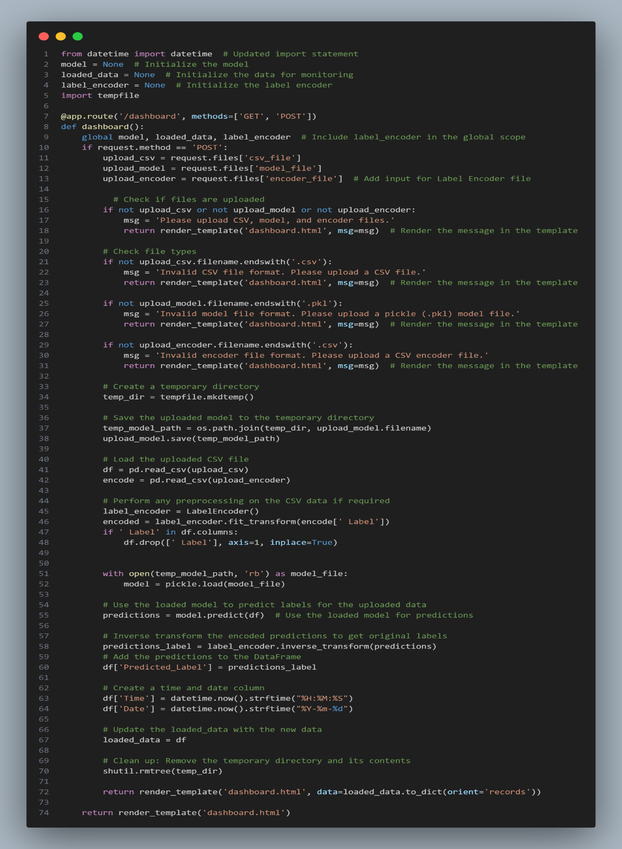

Figure 104: Dashboard Simulator Code

This Python code runs a web-based dashboard simulator using the Flask web framework. It defines a route for the "/dashboard" URL, which handles user interactions. When a user uploads a CSV data file, a machine learning model (in pickle format), and a label encoder file (in CSV format), the code checks their validity, processes the data, loads the model, makes predictions, and displays the results on the dashboard. It includes error handling, temporary storage for uploaded files, and preprocessing if required. The simulator provides a user-friendly web interface for data analysis and prediction using a pre-trained machine learning model.

# Chapter 10: System Validation

## 10.1 Unit Testing

### 10.1.1 Upload Dataset

|  |  |  |  |  |
| --- | --- | --- | --- | --- |
| Test ID | Test Case | Expected Results | Actual Results | Pass/Fail |
| 1.1 | 1. Choose one csv file from the device  2. Select “Upload” Button | **“Info:** Datasets Uploaded” is display | Match with Expected Results | Pass |
| 1.2 | 1. Choose multiple csv File from the device  2. Select “Upload” Button | **“Info:** Datasets Uploaded” is display | Match with Expected Results | Pass |
| 1.3 | 1. Select “Upload” Button without any file is chosen | “**Info:** No valid CSV files uploaded.” is display | Match with Expected Results | Pass |
| 1.4 | 1. Choose any file type besides csv file type  2. Select “Upload” Button | “**Info:** No valid CSV files uploaded.” is display | Match with Expected Results | Pass |

### 10.1.2 View Uploaded Dataset

|  |  |  |  |  |
| --- | --- | --- | --- | --- |
| Test ID | Test Case | Expected Results | Actual Results | Pass/Fail |
| 2.1 | 1. Select the drop box | 1. A list of uploaded csv file is display in the drop box if any csv file is uploaded and not delete  2. No csv file is display in the drop box if all csv files are deleted and no new csv file is uploaded | Match with Expected Results | Pass |
| 2.2 | 1. Select any uploaded CSV file from the drop box  2. Select “**Show Data**” Button | The application should display the first 10 rows of the selected CSV file correctly. | Match with Expected Results | Pass |
| 2.3 | 1. Select “**Show Data**” Button without select any uploaded CSV file from the drop box | The HTML drop box should show an informational message “Please Select an item from the list” | Match with Expected Results | Pass |

### 10.1.3 Dataset Cleaning

|  |  |  |  |  |
| --- | --- | --- | --- | --- |
| Test ID | Test Case | Expected Results | Actual Results | Pass/Fail |
| 3.1 | 1. Select “**Concatenate and Clean**” Button without select any uploaded CSV file from the drop box | The HTML drop box should show an informational message “Please Select an item from the list” | Match with Expected Results | Pass |
| 3.2 | 1. Select any uploaded CSV file from the drop box  2. Select “**Concatenate and Clean**” Button | 1. User will proceed to next page  (Clean Step 1- Concatenated Data)  2. A Concatenated Data Preview table is display with the following information  - Number of 'inf' and '-inf' values  - Number of NaN values,  - Number of Duplicate Rows  - DataFrame Shape is display correctly | Match with Expected Results | Pass |
| 3.3 | 1. Select multiple uploaded CSV file from the drop box  2. Select “**Concatenate and Clean**” Button | 1. User will proceed to next page  (Clean Step 1- Concatenated Data)  2. A Concatenated Data Preview table is display with the following information  - Number of 'inf' and '-inf' values  - Number of NaN values,  - Number of Duplicate Rows  - DataFrame Shape is display correctly | Match with Expected Results | Pass |
| 3.4 | In Clean Step 1 page, select “**Proceed to Step 2**” button. | 1. User will proceed to next page  (Clean Step 2: Remove 'inf' and '-inf' Values)  2. A Concatenated Data After Removing 'inf' and '-inf' Values table is display with the following information  - Number of 'inf' and '-inf' values should be zero  - Number of NaN values should be zero  - Number of Duplicate Rows should be zero  - DataFrame Shape is display correctly | Match with Expected Results | Pass |
| 3.5 | In Clean Step 2 page, select “**Proceed to Step 3**” button. | 1. User will proceed to next page  (Clean Step 3: Remove Socket Features and Columns with Single Values)  2. A Concatenated Data After Removing Socket Features and Columns with Single Values table is display with the following information  - DataFrame Shape is display correctly  - 'Unnamed: 0', 'Flow ID', ' Source IP', ' Destination IP', ' Source Port', ' Destination Port', 'SimillarHTTP', ' Timestamp' Column is remove | Match with Expected Results | Pass |
| 3.6 | In Clean Step 3 page, select “**Proceed to Step 4**” button. | User will proceed to next page (Clean Step 4: Save Cleaned Data) | Match with Expected Results | Pass |
| 3.7 | In Clean Step 4 page, select “**Save Cleaned Data**” button without in the text field | An informational message will be display “Please fill out this field” | Match with Expected Results | Pass |
| 3.8 | In Clean Step 4 page, input any name in the text field and select “**Save Cleaned Data**” button | “The cleaned data has been saved to the following location: clean\name.csv” is display | Match with Expected Results | Pass |

### 10.1.4 Dataset Visualization

|  |  |  |  |  |
| --- | --- | --- | --- | --- |
| Test ID | Test Case | Expected Results | Actual Results | Pass/Fail |
| 4.1 | 1. Choose “**Uploaded Dataset**” in the drop box  2. Select “**Choose Folder**” button | 1. User will proceed to next page  2. A list of uploaded csv file will be display at the drop box (without deleted) | Match with Expected Results | Pass |
| 4.2 | 1. Choose “**Cleaned Dataset**” in the drop box  2. Select “**Choose Folder**” button | 1. User will proceed to next page  2. A list of cleaned csv file will be display at the drop box (without deleted) | Match with Expected Results | Pass |
| 4.3 | 1. Choose any csv files in the drop box  2. Select “**Visualize Data**” button | 1. User will proceed to next page  2. A table will be display with label and label count and label distribution chart is display | Match with Expected Results | Pass |
| 4.4 | 1. Select “**Visualize Data**” button without select any csv file | The HTML drop box should show an informational message “Please Select an item from the list” | Match with Expected Results | Pass |

### 10.1.5 Dataset Manipulation

|  |  |  |  |  |
| --- | --- | --- | --- | --- |
| Test ID | Test Case | Expected Results | Actual Results | Pass/Fail |
| 5.1 | Select “**Perform Action**” button without select any CSV file or any action from the drop boxes | The HTML drop box should show an informational message “Please Select an item from the list” | Match with Expected Results | Pass |
| 5.2 | 1. Choose any clean csv file from the drop box and “**Balanced Dataset**” action from the drop box  2. Select “**Perform Action**” button | 1. User will proceed to Balance Data page  2. The page should display 2 tables to display before and after balance dataset alongside with appropriate data frame shape | Match with Expected Results | Pass |
| 5.3 | 1. Choose any clean csv file from the drop box and “**Combine Labels**” action from the drop box  2. Select “**Perform Action**” button | 1. User will proceed to Combine Label page  2. The page should display 2 drop boxes to allow user to select available labels based on the selected CSV file to combine | Match with Expected Results | Pass |
| 5.4 | 1. Choose any clean csv file from the drop box and “**Drop Label**” action from the drop box  2. Select “**Perform Action**” button | 1. User will proceed to Drop Label page  2. The page should display a drop box to allow user to select available label based on the selected CSV file to drop | Match with Expected Results | Pass |
| 5.5 | In Balance Data page, select “**Save Balanced Data**” without input save name | An informational message will be display “Please fill out this field” | Match with Expected Results | Pass |
| 5.6 | 1. In Combine Label page, choose first and second label, renamed new label (optional) and input any name to combine label and save name  2. Select “**Save Combined Data**” button | The chosen labels will be renamed into the combine label name and the dataset will be save | Match with Expected Results | Pass |
| 5.7 | In Combine Label page, select “**Save Combined Data**” button without choose first and second label | The HTML drop box should show an informational message “Please Select an item from the list” | Match with Expected Results | Pass |
| 5.8 | In Combine Label page, select “**Save Combined Data**” button without input any name for combine label or save name | An informational message will be display “Please fill out this field” | Match with Expected Results | Pass |
| 5.9 | 1. In Drop Label page, choose label to drop and input any name to combine label and save name for dataset  2. Select “**Save Cleaned Data**” button | The chosen label will be drop and the dataset will be saved. | Match with Expected Results | Pass |
| 5.10 | In Drop Label page, select “**Save Cleaned Data**” button without choose any label to drop | The HTML drop box should show an informational message “Please Select an item from the list” | Match with Expected Results | Pass |
| 5.11 | In Drop Label page, select “**Save Cleaned Data**” button without input any save name | An informational message will be display “Please fill out this field” | Match with Expected Results | Pass |

### 10.1.6 Dataset Training

|  |  |  |  |  |
| --- | --- | --- | --- | --- |
| Test ID | Test Case | Expected Results | Actual Results | Pass/Fail |
| 6.1 | 1. Choose any clean csv file from the drop box and select an algorithm  2. Select “Train” Button | 1. The application will proceed to train the data.  2. User will proceed to training results page and the following output will be display  - Training Accuracy  - Classification Report  - Confusion Matrix  - Confusion Heatmap | Match with Expected Results | Pass |
| 6.2 | Select “Train” Button without choosing any clean csv file from the drop box or any algorithm | The HTML drop box should show an informational message “Please Select an item from the list” | Match with Expected Results | Pass |
| 6.3 | In Training result page, Select “Download Model” Button | The model will be downloaded into user’s Download directory | Match with Expected Results | Pass |

### 10.1.7 Dashboard Login

|  |  |  |  |  |
| --- | --- | --- | --- | --- |
| Test ID | Test Case | Expected Results | Actual Results | Pass/Fail |
| 7.1 | 1. Input valid username and password  2. Select “Login” Button | User will proceed to Dashboard Simulator page | Match with Expected Results | Pass |
| 7.2 | 1. Input invalid username and password  2. Select “Login” Button | “**Error**: Invalid username or password” is displayed | Match with Expected Results | Pass |

### 10.1.8 Dashboard Simulator

|  |  |  |  |  |
| --- | --- | --- | --- | --- |
| Test ID | Test Case | Expected Results | Actual Results | Pass/Fail |
| 8.1 | 1. Choose valid csv files and valid model files  2. Select “Simulate” Button | 1. A table with real time scan results should display  2. The predicted label should fulfill the trained model accuracy (if the model has high accuracy, the model should predict the label accurately) | Match with Expected Results | Pass |
| 8.2 | 1. Selects a CSV file for evaluation that has columns different from the CSV file used to train the model.  2. Select “Simulate” Button | An error message with display | Match with Expected Results | Pass |
| 8.3 | 1. Select a label encoder CSV file for evaluation that has labels different from the CSV file used to train the model.  2. Select “Simulate” Button | An error message with display | Match with Expected Results | Pass |

### 10.1.9 Create User

|  |  |  |  |  |
| --- | --- | --- | --- | --- |
| Test ID | Test Case | Expected Results | Actual Results | Pass/Fail |
| 9.1 | 1. Input valid username and password  2. Select “Create User” Button | A successful create user message should display | Match with Expected Results | Pass |
| 9.2 | Select “Create User” Button without input any username and password | An informational message will be display “Please fill out this field” | Match with Expected Results | Pass |
| 9.3 | 1. Input inappropriate password (without at least one number and one uppercase and lowercase letter, and at least 8 or more characters)  2. Select “Create User” Button | An informational message will be display “Must contain at least one number and one uppercase and lowercase letter, and at least 8 or more characters” | Match with Expected Results | Pass |

### 10.1.10 Manage Files

|  |  |  |  |  |
| --- | --- | --- | --- | --- |
| Test ID | Test Case | Expected Results | Actual Results | Pass/Fail |
| 10.1 | Select “Download” or “Delete” button without selecting any check box. | No files will be download and delete | Match with Expected Results | Pass |
| 10.2 | 1. Select any check box on uploaded files  2. Select “Download” button below the uploaded files list | The selected csv file will be downloaded from the upload folder | Match with Expected Results | Pass |
| 10.3 | 1. Select any check box on uploaded files  2. Select “Delete” button below the uploaded files list | The selected csv file will be deleted from the upload folder after refreshing the page | Match with Expected Results | Pass |
| 10.4 | 1. Select any check box on cleaned files  2. Select “Download” button below the cleaned files list | The selected csv file will be downloaded from the clean folder | Match with Expected Results | Pass |
| 10.5 | 1. Select any check box on cleaned files  2. Select “Delete” button below the cleaned files list | The selected csv file will be deleted from the clean folder after refreshing the page | Match with Expected Results | Pass |

## 10.2 User Acceptance Testing

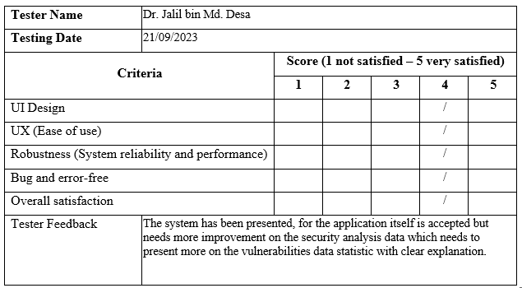



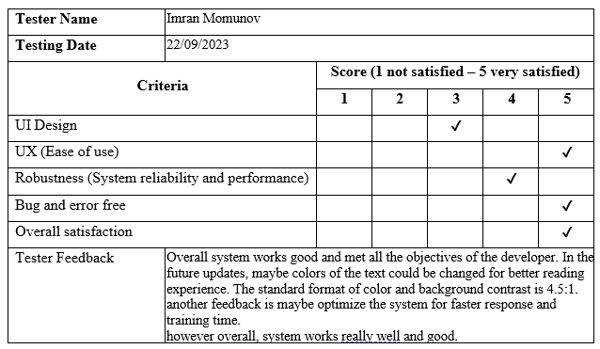

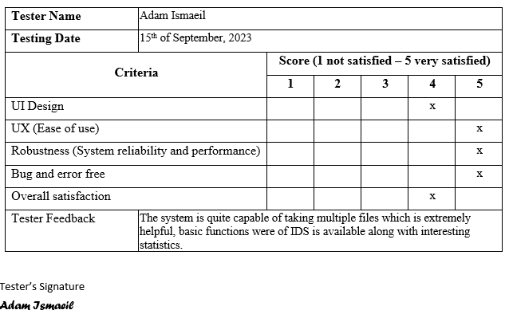

## 10.3 Summary

In summary, the unit test plan for the system provides a well-structured foundation for executing a series of categorical tests. However, it is worth noting that there are a few minor issues that require attention to guarantee the effective fulfillment of user requirements. The testing and debugging process, though time and effort-intensive, serves a crucial purpose by pinpointing and resolving errors, ultimately enhancing the system's performance. Looking ahead, the User Acceptance Testing will involve active participation from both students and any individuals with IT background. Their valuable feedback will contribute significantly to the ongoing development of the system, offering insights into its overall progress and usability. This iterative approach ensures that the system aligns closely with user needs and expectations.

# Chapter 11: Conclusion and Reflection

## 11.1 Critical Evaluation

In the Enhanced Intrusion Detection System (IDS) project, the developer had demonstrated that DDoS attacks can be detected and classified with machine learning algorithm. From the perspective of the developer, the creation of a Machine Learning-based Intrusion Detection System (IDS) arises from the critical necessity to elevate cybersecurity in our increasingly interconnected world. Conventional IDS systems have faced considerable challenges in keeping pace with the rapidly evolving landscape of cyber threats. These systems often grapple with the intricate task of distinguishing authentic threats from false alarms, leading to the inefficient allocation of resources and the potential compromise of security. The implementation of machine learning IDS stands as a new solution, relying on advanced algorithms to analyze network traffic patterns and discern anomalies. By harnessing the capabilities of machine learning, this IDS can dynamically adapt and learn from emerging threats, thereby augmenting threat detection precision and hastening response times to potential security incidents.

Within this context, the developer's system assumes a role of utmost importance. In an era characterized by increasingly sophisticated and frequent cyberattacks, the presence of a robust and adaptive intrusion detection system bears a significant role. Thus, the developer takes the opportunity to develop a system that emerges as a new tool in the quest to fortify cybersecurity postures across organizations. It endows security professionals with real-time threat detection and response capabilities to safeguarding digital infrastructures. Notably, it possesses the unique ability to identify not just established threats but also novel and emerging ones. By leveraging the advanced power of machine learning, the developer's IDS can undergo continuous evolution, enabling it to remain ahead of cyber adversaries. Consequently, this translates into enhanced safeguarding of sensitive data, reduced exposure to the risks of data breaches, and a heightened level of confidence in the digital resilience of businesses and institutions.

Embarking on the journey of developing this Machine Learning IDS project necessitates a multifaceted and comprehensive approach. The initial stages involve extensive research into existing intrusion detection methodologies and a detailed review in literature. This research foundation serves as the cornerstone for comprehending the characteristics of intrusion detection systems while pinpointing potential areas for enhancement. Subsequently, the project proceeds to the technical development phase where the system implementation and fine-tuning of machine learning algorithms are conducted. Each time a feature is completed, rigorous testing and evaluation protocols are in place to ensure that the system attains performance levels and meets the higher standards of performance to tailor with the selected system development methodology.

From the developer's perspective, the Enhanced Intrusion Detection System (IDS) project is deeply rooted in an unwavering dedication to user-friendliness and practicality. Despite the utilization of complex functions and intricate algorithms beneath its surface, the system remains firmly committed to offering an instinctive and easily accessible user interface. At the core of this vision lies the priceless insights derived from user feedback and extensive usability testing. These endeavors are conducted with unwavering diligence to ensure that security professionals can seamlessly incorporate and operate the IDS within their existing security frameworks. By embracing this user-centered philosophy, the developer enhances the system's effectiveness in real-world scenarios and nurtures a seamless collaboration between security teams and the realm of machine learning-driven threat detection. This cooperative approach plays an indispensable role in the overarching triumph of the project.

In conclusion, the Enhanced Intrusion Detection System (IDS) project, as perceived by the developer, is firmly rooted in the principles of user-friendliness and practicality. It combines sophisticated algorithms with intuitive user experience, driven by invaluable user feedback and rigorous testing. This approach aims to facilitate the seamless integration of the IDS into existing security setups, ultimately enhancing its real-world effectiveness. By prioritizing collaboration and user-centric design, the developer strives for a harmonious synergy between security professionals and the realm of machine learning-based threat detection, underscoring the project's potential for success.

## 11.2 Conclusion

In the domain of Machine Learning Intrusion Detection Systems (IDS), the developer undertakes a mission with deep awareness of the critical requirement for enhanced and effective threat detection mechanisms in the intricate cybersecurity environment of today. As cyber threats continue to evolve at an unprecedented rate, it becomes essential to utilize the potential of machine learning to maintain a proactive stance against malicious actors. Through the utilization of state-of-the-art algorithms and insights derived from data, the developer aspires to provide organizations with the means to actively recognize and prevent cyber threats.

Furthermore, the developer recognizes the paramount importance of the IDS project in enhancing cybersecurity posture. In an era where digital assets are invaluable, the system's role in fortifying network security cannot be overstated. By providing an automated, machine learning-driven approach to threat detection, the system aims to significantly reduce response times to potential threats, thereby minimizing the risk of data breaches and network compromises. The system's effectiveness in distinguishing between benign traffic and malicious activities stands as a testament to its potential to bolster cybersecurity measures.

However, the path to building a Machine Learning IDS is not without its challenges. One of the foremost challenges faced by the developer pertains to device capability issues. These limitations have occasionally hindered the development of certain functionalities within the system, demanding innovative solutions and optimizations to ensure the system's compatibility with a diverse range of devices and network environments. This highlights the need for further improvement and refinement in achieving seamless integration across various platforms. In the realm of classification, while binary classification has yielded commendable success rates, achieving multi-class classification has presented its own set of challenges. While the system boasts a moderate success rate of 87% in multi-class classification, the developer acknowledges the complexity of accurately distinguishing between various types of attacks. Some attack labels have been misclassified as other attack types, highlighting the intricacies of differentiating between nuanced threats. To address this, the developer recognizes the importance of harnessing cybersecurity expertise for precise feature selection, along with AI expertise for fine-tuning the machine learning models. Additionally, incorporating advanced data preprocessing functions holds the potential to further enhance the accuracy of multi-class classification.

In conclusion, the developer's journey in the realm of Machine Learning IDS is driven by a commitment to bolstering cybersecurity defenses and enabling organizations to navigate the ever-evolving threat landscape. While challenges such as device compatibility and multi-class classification complexities persist, they serve as opportunities for innovation and refinement. The developer remains dedicated to overcoming these challenges and further enhancing the system's capabilities through interdisciplinary collaboration and continuous improvement.

# 12.0 References

ActiveState. (2020, December 21). *What Is Numpy Used For In Python?* ActiveState. https://www.activestate.com/resources/quick-reads/what-is-numpy-used-for-in-python/

ActiveState. (2022, August 9). *What Is Pandas in Python? Everything You Need to Know*. ActiveState. https://www.activestate.com/resources/quick-reads/what-is-pandas-in-python-everything-you-need-to-know/

Aggarwal, K. (2022). Has the Future Started? The Current Growth of Artificial Intelligence, Machine Learning, and Deep Learning. *Iraqi Journal for Computer Science and Mathematics*, *3*(1), 115–123. https://doi.org/10.52866/ijcsm.2022.01.01.013

Ahmad, Z., Shahid Khan, A., Wai Shiang, C., Abdullah, J., & Ahmad, F. (2020). Network intrusion detection system: A systematic study of machine learning and deep learning approaches. *Transactions on Emerging Telecommunications Technologies*, *32*(1). https://doi.org/10.1002/ett.4150

Ali, T. E., Chong, Y.-W., & Manickam, S. (2023). Machine Learning Techniques to Detect a DDoS Attack in SDN: A Systematic Review. *Applied Sciences*, *13*(5), 3183. https://doi.org/10.3390/app13053183

Alotaibi, A., & Rassam, M. A. (2023). Adversarial Machine Learning Attacks against Intrusion Detection Systems: A Survey on Strategies and Defense. *Future Internet*, *15*(2), 62. https://doi.org/10.3390/fi15020062

Alqahtani, H., Sarker, I. H., Kalim, A., Minhaz Hossain, S. Md., Ikhlaq, S., & Hossain, S. (2020). Cyber Intrusion Detection Using Machine Learning Classification Techniques. *Communications in Computer and Information Science*, 121–131. https://doi.org/10.1007/978-981-15-6648-6_10

Aslan, Ö., Aktuğ, S. S., Ozkan-Okay, M., Yilmaz, A. A., & Akin, E. (2023). A Comprehensive Review of Cyber Security Vulnerabilities, Threats, Attacks, and Solutions. *Electronics*, *12*(6), 1333. https://doi.org/10.3390/electronics12061333

Ayo, F. E., Folorunso, S. O., Abayomi-Alli, A. A., Adekunle, A. O., & Awotunde, J. B. (2020). Network intrusion detection based on deep learning model optimized with rule-based hybrid feature selection. *Information Security Journal: A Global Perspective*, *29*(6), 267–283. https://doi.org/10.1080/19393555.2020.1767240

Bada, G. K., Nabare, W. K., & Quansah, D. K. K. (2020a). Comparative Analysis of the Performance of Network Intrusion Detection Systems: Snort, Suricata and Bro Intrusion Detection Systems in Perspective. *International Journal of Computer Applications*, *176*(40), 39–44. https://doi.org/10.5120/ijca2020920513

Bada, G. K., Nabare, W. K., & Quansah, D. K. K. (2020b). Comparative Analysis of the Performance of Network Intrusion Detection Systems: Snort, Suricata and Bro Intrusion Detection Systems in Perspective. *International Journal of Computer Applications*, *176*(40), 39–44. https://doi.org/10.5120/ijca2020920513

Bhandari, P. (2021, July 15). *Designing a Questionnaire*. Scribbr. https://www.scribbr.com/methodology/questionnaire/

Busetto, L., Wick, W., & Gumbinger, C. (2020). How to Use and Assess Qualitative Research Methods. *Neurological Research and Practice*, *2*(1), 1–10. https://doi.org/10.1186/s42466-020-00059-z

Chien, C. (2020, February 4). *What Is Rapid Application Development (RAD)?* Codebots. https://codebots.com/app-development/what-is-rapid-application-development-rad

Cleave, P. (2023, January 26). *Advantages of Questionnaires in Online Research*. SmartSurvey. https://www.smartsurvey.co.uk/blog/advantages-of-questionnaires-in-online-research

Cooper, S. (2022, August 2). *6 best HIDS tools*. Comparitech. https://www.comparitech.com/net-admin/hids-tools-software/

Cristea, L. M. (2020). Current security threats in the national and international context. *JOURNAL of ACCOUNTING and MANAGEMENT INFORMATION SYSTEMS*, *19*(2), 351–378. https://doi.org/10.24818/jamis.2020.02007

Donato, H. (2023, January 3). *What Are The Phases Of Scrum?* Www.workamajig.com. https://www.workamajig.com/blog/scrum-methodology-guide/scrum-phases#:~:text=Scrum%20is%20an%20Agile%20project

Dummanaboyina, C. (2020, December). *(PDF) CYBER SECURITY AND ITS IMPORTANCE*. ResearchGate. https://www.researchgate.net/publication/347439655_CYBER_SECURITY_AND_ITS_IMPORTANCE

Elsadai, A., Ibrahim, J., Hajjaj, F., & Jakić, P. (2019). The Overview of Intrusion Detection System Methods and Techniques. *Proceedings of the International Scientific Conference - Sinteza 2019*. https://doi.org/10.15308/sinteza-2019-155-161

Fatima, T., Bukht, N., Malik, M., Ahmad, R., & Ud, S. (2020). Importance of Cyber security and its sub-domains Importance of Cyber security and its sub-domains. *Importance of Cyber Security and Its Sub-Domains*. https://doi.org/10.12733/JICS.2020.V10I6.535569.12557

Fradkov, A. L. (2020). Early History of Machine Learning. *IFAC-PapersOnLine*, *53*(2), 1385–1390. https://doi.org/10.1016/j.ifacol.2020.12.1888

George, T. (2022, March 10). *Types of Interviews in Research | Guide & Examples*. Scribbr. https://www.scribbr.com/methodology/interviews-research/

Gold, D. (2017, March 15). *Is Signature- and Rule-Based Intrusion Detection Sufficient?* CSO Online. https://www.csoonline.com/article/560639/is-signature-and-rule-based-intrusion-detection-sufficient.html

Gulati, V., & Raheja, N. (2021, October 1). *Efficiency Enhancement of Machine Learning Approaches through the Impact of Preprocessing Techniques*. IEEE Xplore. https://doi.org/10.1109/ISPCC53510.2021.9609474

Gyamfi, E., & Jurcut, A. (2022). Intrusion Detection in Internet of Things Systems: A Review on Design Approaches Leveraging Multi-Access Edge Computing, Machine Learning, and Datasets. *Sensors*, *22*(10), 3744. https://doi.org/10.3390/s22103744

Haripriya, L., & Jabbar, M. A. (2018, March 1). *Role of Machine Learning in Intrusion Detection System: Review*. IEEE Xplore. https://doi.org/10.1109/ICECA.2018.8474576

Heidari, A., & Jabraeil Jamali, M. A. (2022). Internet of Things intrusion detection systems: a comprehensive review and future directions. *Cluster Computing*. https://doi.org/10.1007/s10586-022-03776-z

Hunt-Walker, N. (2018). *An introduction to the Flask Python web app framework*. Opensource.com. https://opensource.com/article/18/4/flask

imbalanced-learn.org. (2023, July 8). *imbalanced-learn documentation — Version 0.8.1*. Imbalanced-Learn.org. https://imbalanced-learn.org/stable/

Jemili, F., & Korbaa, O. (2023). Hybrid Collaborative Intrusion Detection System Based on Blockchain & Machine Learning. *Hybrid Collaborative Intrusion Detection System Based on Blockchain & Machine Learning*. https://doi.org/10.21203/rs.3.rs-2963689/v1

Jiang, D., Lin, W., & Raghavan, N. (2020). A Novel Framework for Semiconductor Manufacturing Final Test Yield Classification Using Machine Learning Techniques. *IEEE Access*, *8*, 197885–197895. https://doi.org/10.1109/ACCESS.2020.3034680

Khoirom, M., Sonia, M., Laikhuram, B., Laishram, J., & Singh, D. (2020). Comparative Analysis of Python and Java for Beginners. In *International Research Journal of Engineering and Technology*.

kissflow. (n.d.). *RAD Methodology | Rapid Application Development Phases - Kissflow*. Kissflow.com. https://kissflow.com/application-development/rad/rapid-application-development-methodology-essentials/

Kumar, N., Sen, A., Hordiichuk, V., Teresa, M., Jaramillo, E., Molodetskyi, B., Amol, D., & Kasture, B. (2023). AI in Cybersecurity: Threat Detection and Response with Machine Learning. *Tuijin Jishu/Journal of Propulsion Technology*, *44*(3), 1001–4055.

Laurens D’hooge, Miel Verkerken, Volckaert, B., Wauters, T., & Filip De Turck. (2022). Establishing the Contaminating Effect of Metadata Feature Inclusion in Machine-Learned Network Intrusion Detection Models. *Lecture Notes in Computer Science*, 23–41. https://doi.org/10.1007/978-3-031-09484-2_2

Li, P., Liu, Q., Zhao, W., Wang, D., & Wang, S. (2018). Chronic Poisoning against Machine Learning Based IDSs Using Edge Pattern Detection. *2018 IEEE International Conference on Communications (ICC)*. https://doi.org/10.1109/icc.2018.8422328

Li, Y., & Liu, Q. (2021). A Comprehensive Review Study of cyber-attacks and Cyber security; Emerging Trends and Recent Developments. *Energy Reports*, *7*(7), 8176–8186. Sciencedirect. https://doi.org/10.1016/j.egyr.2021.08.126

Lin, J., Dang, L., Rahouti, M., & Xiong, K. (2021). *ML Attack Models: Adversarial Attacks and Data Poisoning Attacks*. https://arxiv.org/ftp/arxiv/papers/2112/2112.02797.pdf

Liu, H., & Lang, B. (2019). Machine Learning and Deep Learning Methods for Intrusion Detection Systems: A Survey. *Applied Sciences*, *9*(20), 4396. https://doi.org/10.3390/app9204396

Mahesh, B. (2019). Machine Learning Algorithms -A Review. *International Journal of Science and Research (IJSR)*, *9*(1). https://doi.org/10.21275/ART20203995

MarketsandMarkets. (2019). *Artificial Intelligence in Cybersecurity Market | Trend and Forecast to 2026 | MarketsandMarkets*. Marketsandmarkets.com. https://www.marketsandmarkets.com/Market-Reports/artificial-intelligence-security-market-220634996.html

Maseno, E. M., Wang, Z., & Xing, H. (2022). A Systematic Review on Hybrid Intrusion Detection System. *Security and Communication Networks*, *2022*, e9663052. https://doi.org/10.1155/2022/9663052

Megantara, A. A., & Ahmad, T. (2021). A hybrid machine learning method for increasing the performance of network intrusion detection systems. *Journal of Big Data*, *8*(1). https://doi.org/10.1186/s40537-021-00531-w

Mohammadi, S., Mirvaziri, H., Ghazizadeh-Ahsaee, M., & Karimipour, H. (2019). Cyber intrusion detection by combined feature selection algorithm. *Journal of Information Security and Applications*, *44*, 80–88. https://doi.org/10.1016/j.jisa.2018.11.007

Murphey, D. (2019, June 27). *A history of information security*. IFSEC Global | Security and Fire News and Resources. https://www.ifsecglobal.com/cyber-security/a-history-of-information-security/#:~:text=Cybersecurity

Naglieri, J. (2023, February 13). *The State of Threat Detection and Response*. Security Boulevard. https://securityboulevard.com/2023/02/the-state-of-threat-detection-and-response/

Nalini, N., Chaudhary, A., Surendran, S., Muthuraja, M., Ahmed, I., & J, N. T. (2023, August 1). *Network Intrusion Detection System for Feature Extraction Based on Machine Learning Techniques*. IEEE Xplore. https://doi.org/10.1109/ICIRCA57980.2023.10220789

nimble. (2022, December 23). *What Is Scrum Methodology? & Scrum Project Management*. Nimble. https://www.nimblework.com/agile/scrum-methodology/

Office of the Comptroller of Currency. (n.d.). *Examination Process Sampling Methodologies*. https://www.occ.gov/publications-and-resources/publications/comptrollers-handbook/files/sampling-methodologies/pub-ch-sampling-methodologies.pdf

Peek, S. (2023, February 22). *What Is Agile Scrum Methodology?* Business News Daily. https://www.businessnewsdaily.com/4987-what-is-agile-scrum-methodology.html

Prasanna. (2022, February 1). *Interviews Advantages And Disadvantages | What is an Interview? 6 Merits and Demerits of Interview*. A plus Topper. https://www.aplustopper.com/interviews-advantages-and-disadvantages/

Pu, G., Wang, L., Shen, J., & Dong, F. (2021). A hybrid unsupervised clustering-based anomaly detection method. *Tsinghua Science and Technology*, *26*(2), 146–153. https://doi.org/10.26599/tst.2019.9010051

Publication, I. (2020). ADVANTAGES AND DISADVANTAGES OF ARTIFICIAL INTELLIGENCE AND MACHINE LEARNING: A LITERATURE REVIEW. *IAEME PUBLICATION*. https://www.academia.edu/44895767/ADVANTAGES_AND_DISADVANTAGES_OF_ARTIFICIAL_INTELLIGENCE_AND_MACHINE_LEARNING_A_LITERATURE_REVIEW

Rajasekaran, K., & Nirmala, K. (2020). *Classification and Importance of Intrusion Detection System Classification and Importance of Intrusion Detection System*.

Saabith, A., Fareez, M., & Vinothraj, T. (2019). Python current trend applications-an overview PYTHON CURRENT TREND APPLICATIONS-AN OVERVIEW POPULAR WEB DEVELOPMENT FRAMEWORKS IN PYTHON. *International Journal of Advance Engineering and Research Development*, *6*(10).

Safana Hyder Abbas, Wedad Abdul Khuder Naser, & Amal Abbas Kadhim. (2023). Subject review: Intrusion Detection System (IDS) and Intrusion Prevention System (IPS). *Global Journal of Engineering and Technology Advances*, *14*(2), 155–158. https://doi.org/10.30574/gjeta.2023.14.2.0031

Sen, K. (2023a, January 8). *Top 6 Free Network Intrusion Detection Systems (NIDS) Software in 2023 | UpGuard*. Www.upguard.com. https://www.upguard.com/blog/top-free-network-based-intrusion-detection-systems-ids-for-the-enterprise#:~:text=NIDS%20can%20incorporate%20one%20or

Sen, K. (2023b, January 8). *Top 6 Free Network Intrusion Detection Systems (NIDS) Software in 2023 | UpGuard*. Www.upguard.com. https://www.upguard.com/blog/top-free-network-based-intrusion-detection-systems-ids-for-the-enterprise#:~:text=NIDS%20can%20incorporate%20one%20or

Shah, S. A. R., & Issac, B. (2018). Performance comparison of intrusion detection systems and application of machine learning to Snort system. *Future Generation Computer Systems*, *80*, 157–170. https://doi.org/10.1016/j.future.2017.10.016

simplilearn. (2023, January 30). *An Introduction to Scikit-Learn: Machine Learning in Python*. Simplilearn.com. https://www.simplilearn.com/tutorials/python-tutorial/scikit-learn

Sotikare, T. (2023, February 14). *How AI and Machine Learning Are Improving Fraud Detection in Fintech*. Entrepreneur. https://www.entrepreneur.com/science-technology/how-ai-and-machine-learning-are-improving-fraud-detection/442018

Stevens, E. (2022, February 2). *Quantitative vs. Qualitative Data: What’s the Difference?* Careerfoundry.com. https://careerfoundry.com/en/blog/data-analytics/difference-between-quantitative-and-qualitative-data/

Talaei Khoei, T., & Kaabouch, N. (2023). A Comparative Analysis of Supervised and Unsupervised Models for Detecting Attacks on the Intrusion Detection Systems. *Information*, *14*(2), 103. https://doi.org/10.3390/info14020103

Taylor, H. (2022, January 7). *How to use Timeboxing for Time Management*. Www.forecast.app. https://www.forecast.app/blog/how-to-use-timeboxing-for-time-management#:~:text=Timeboxing%20is%20a%20time%20management

University of New Brunswick. (n.d.). *DDoS 2019 | Datasets | Research | Canadian Institute for Cybersecurity | UNB*. Www.unb.ca. https://www.unb.ca/cic/datasets/ddos-2019.html

University of Texas Arlington. (2023, March 15). *Subject and Course Guides: Quantitative and Qualitative Research: Understand What Quantitative Research Is*. Uta.edu. https://libguides.uta.edu/quantitative_and_qualitative_research/quant

Wei, P., Zhang, Z., & Chen, B. (2018). A method of eliminating false alarm based on deep learning. *Journal of Physics: Conference Series*, *1087*, 062037. https://doi.org/10.1088/1742-6596/1087/6/062037

Whitfield, B. (2023, February 16). *Python Data Visualization With Seaborn & Matplotlib | Built In*. Builtin.com. https://builtin.com/data-science/data-visualization-tutorial#:~:text=Matplotlib%20is%20a%20library%20in

Zhong, W., Yu, N., & Ai, C. (2020). Applying big data based deep learning system to intrusion detection. *Big Data Mining and Analytics*, *3*(3), 181–195. https://doi.org/10.26599/bdma.2020.9020003

# 13.0 Appendices

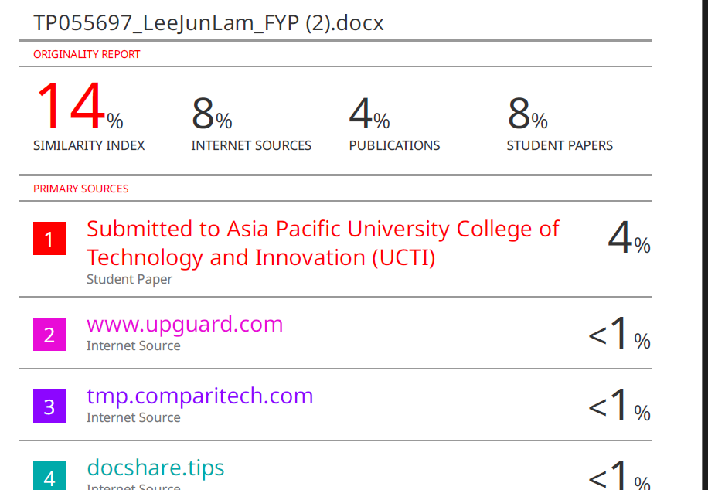



## Poster



## Log Sheet







## A black background with a white line Description automatically generatedA black background with a white line Description automatically generatedA black background with a white line Description automatically generatedPPF



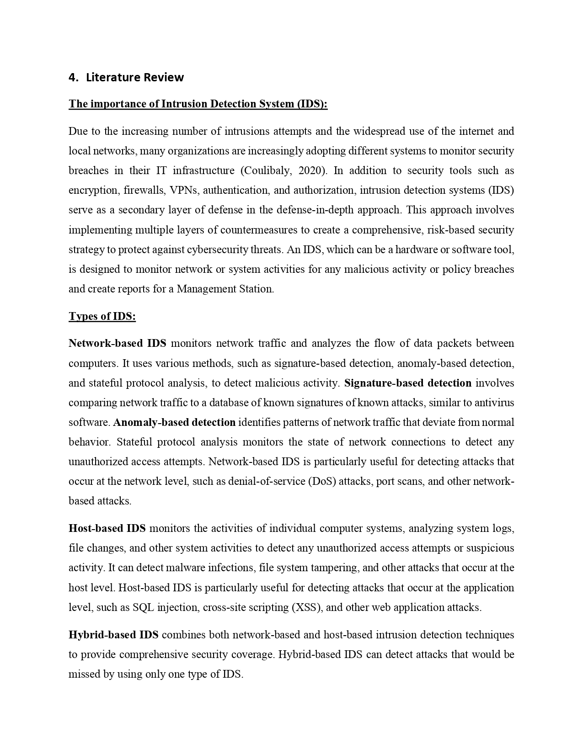

## Ethics Form





## Gantt Chart

